  Year 3 · Multiplication and division B · Step 4  Multiply 2-digit by 1-digit, no exchange | 
  Year 3 · Multiplication and division B · Step 4
  Multiply 2-digit by 1-digit, no exchange
  1 | Work out the multiplications.  a) 13 × 2 =  b) 41 × 2 =  c) 12 × 3 =
  1 | Work out the multiplications.  a) 13 × 2 =  b) 41 × 2 =  c) 12 × 3 =
  2 | Write the missing digits in the multiplication 32 × 3.  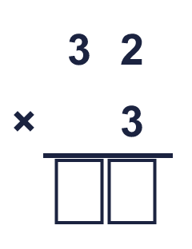  Missing digits, from top to bottom and left to right:
  2 | Write the missing digits in the multiplication 32 × 3.  Missing digits, from top to bottom and left to right:
  3 | Work out the multiplications.  a) 21 × 3 =  b) 31 × 2 =
  3 | Work out the multiplications.  a) 21 × 3 =  b) 31 × 2 =
  4 | A box holds 44 pencils. A shop has 2 boxes.  How many pencils are there?
  4 | A box holds 44 pencils. A shop has 2 boxes.  How many pencils are there?
  5 | Work out the multiplications.  a) 11 × 3 =  b) 43 × 2 =
  5 | Work out the multiplications.  a) 11 × 3 =  b) 43 × 2 =
  6 | Write the missing digits in the multiplication 12 × 4.  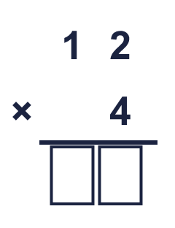  Missing digits, from top to bottom and left to right:
  6 | Write the missing digits in the multiplication 12 × 4.  Missing digits, from top to bottom and left to right:
  7 | A bus carries 24 children. There are 2 buses.  How many children are there?
  7 | A bus carries 24 children. There are 2 buses.  How many children are there?
  8 | Work out the multiplications.  a) 22 × 4 =  b) 12 × 4 =
  8 | Work out the multiplications.  a) 22 × 4 =  b) 12 × 4 =

  9 | Is Boba correct? Circle yes or no.  Yes / No  Explain how you know.
     | 
  9 | Is Boba correct? Circle yes or no.  Yes / No  Explain how you know.
  10 | What number did I start with?
     | 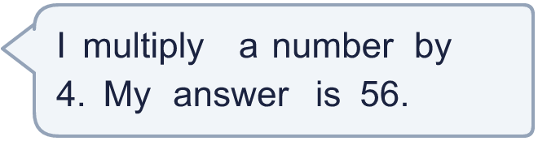
  10 | What number did I start with?
  11 | Use this fact to work out the other multiplications. You do not need to use the column method.  a) 68 × 5 =  b) 68 × 7 =
    
  11 | Use this fact to work out the other multiplications. You do not need to use the column method.  a) 68 × 5 =  b) 68 × 7 =
  12 | Is each statement correct? Circle yes or no.  a) 35 × 4 < 77 × 6  Yes / No  b) 60 × 5 < 54 × 3  Yes / No
  12 | Is each statement correct? Circle yes or no.  a) 35 × 4 < 77 × 6  Yes / No  b) 60 × 5 < 54 × 3  Yes / No
  13 | A bus carries 14 children. There are 2 buses.  How many children are there?
  13 | A bus carries 14 children. There are 2 buses.  How many children are there?
  14 | Is Boba correct? Circle yes or no.  Yes / No  Explain how you know.
    
  14 | Is Boba correct? Circle yes or no.  Yes / No  Explain how you know.

Year 3 · Multiplication and division B · Step 4
Multiply 2-digit by 1-digit, no exchange
Answers (teacher copy)

  1 | Work out the multiplications.  a) 13 × 2 = 26  b) 41 × 2 = 82  c) 12 × 3 = 36
  2 | Write the missing digits in the multiplication 32 × 3.  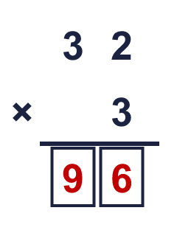  Missing digits, from top to bottom and left to right: 9 6
  3 | Work out the multiplications.  a) 21 × 3 = 63  b) 31 × 2 = 62
  4 | A box holds 44 pencils. A shop has 2 boxes.  How many pencils are there? 88
  5 | Work out the multiplications.  a) 11 × 3 = 33  b) 43 × 2 = 86
  6 | Write the missing digits in the multiplication 12 × 4.  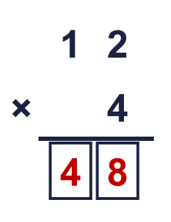  Missing digits, from top to bottom and left to right: 4 8
  7 | A bus carries 24 children. There are 2 buses.  How many children are there? 48
  8 | Work out the multiplications.  a) 22 × 4 = 88  b) 12 × 4 = 48
  9 | Is Boba correct? Circle yes or no.  Yes / No  Explain how you know.  4 × 2 = 8, so the ones digit of the answer should be 8. The correct answer is 34 × 2 = 68, not 78.
  10 | What number did I start with? 14
  11 | Use this fact to work out the other multiplications. You do not need to use the column method.  a) 68 × 5 = 340  b) 68 × 7 = 476
  12 | Is each statement correct? Circle yes or no.  a) 35 × 4 < 77 × 6  Yes / No  b) 60 × 5 < 54 × 3  Yes / No
  13 | A bus carries 14 children. There are 2 buses.  How many children are there? 28
  14 | Is Boba correct? Circle yes or no.  Yes / No  Explain how you know.  1 × 3 = 3, so the ones digit of the answer should be 3. The correct answer is 11 × 3 = 33, not 23.

