  Year 3 · Multiplication and division B · Step 1  Multiples of 10 | 
  Year 3 · Multiplication and division B · Step 1
  Multiples of 10
  1 | Complete the number track. It counts up in 10s.  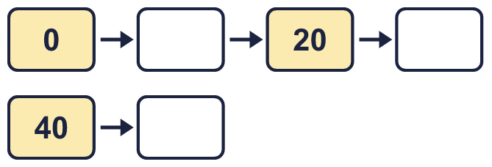
  1 | Complete the number track. It counts up in 10s.
  2 | Complete the number track. It counts down in 10s.  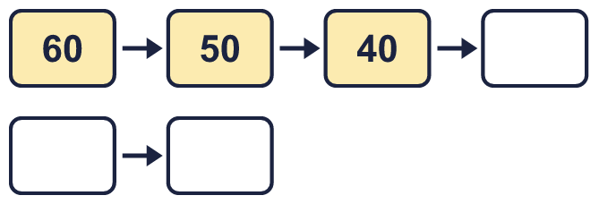
  2 | Complete the number track. It counts down in 10s.
  3 | Work out the multiplications.  a) 13 × 10 =  b) 10 × 55 =  c) 67 × 10 =
  3 | Work out the multiplications.  a) 13 × 10 =  b) 10 × 55 =  c) 67 × 10 =
  4 | Write the missing number in each calculation.
    a) | 10 × |  | = | 40
    b) |  | × 10 | = | 80
    c) |  | ÷ 10 | = | 3
  4 | Write the missing number in each calculation.
    a) | 10 × |  | = | 40
    b) |  | × 10 | = | 80
    c) |  | ÷ 10 | = | 3
  5 | Circle the multiples of 10. Write them below.  70 88 22 10 80 76
  5 | Circle the multiples of 10. Write them below.  70 88 22 10 80 76
  6 | A baker makes 5 trays of buns. Each tray has 10 buns.  a) How many buns are there?  b) 3 buns are eaten. How many buns are left?
  6 | A baker makes 5 trays of buns. Each tray has 10 buns.  a) How many buns are there?  b) 3 buns are eaten. How many buns are left?
  7 | How many multiples of 10 are there from 10 up to 60?
  7 | How many multiples of 10 are there from 10 up to 60?
  8 | Work out the divisions.  a) 270 ÷ 10 =  b) 510 ÷ 10 =  c) 470 ÷ 10 =
  8 | Work out the divisions.  a) 270 ÷ 10 =  b) 510 ÷ 10 =  c) 470 ÷ 10 =

  9 | Write true or false for each statement.
    a) | 4 × 10 = 10 × 4
    b) | 8 × 10 = 4 × 20
    c) | 4 × 10 = 3 × 10 + 4
    d) | 4 × 10 = 10 × 5
  9 | Write true or false for each statement.
    a) | 4 × 10 = 10 × 4
    b) | 8 × 10 = 4 × 20
    c) | 4 × 10 = 3 × 10 + 4
    d) | 4 × 10 = 10 × 5
  10 | Is Boba correct? Circle yes or no.  Yes / No  What is the correct answer?  Explain Boba’s mistake.
    
  10 | Is Boba correct? Circle yes or no.  Yes / No  What is the correct answer?  Explain Boba’s mistake.
  11 | a) How long is the yellow ribbon?  b) How much longer is the yellow ribbon than the red ribbon?
     | 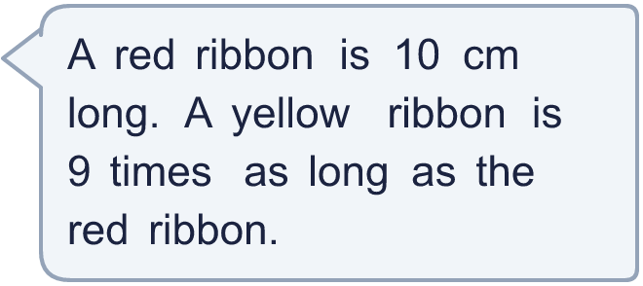
  11 | a) How long is the yellow ribbon?  b) How much longer is the yellow ribbon than the red ribbon?
  12 | There are 10 players in a team. 6 teams have signed up for a tournament.  a) How many players have signed up?  b) The tournament needs 110 players. How many more teams are needed?
  12 | There are 10 players in a team. 6 teams have signed up for a tournament.  a) How many players have signed up?  b) The tournament needs 110 players. How many more teams are needed?
  13 | Write three different multiples of 10 that are between 20 and 70.
  13 | Write three different multiples of 10 that are between 20 and 70.
  14 | Which number is the odd one out?  40 73 80 90  The odd one out is  Explain why it is the odd one out.
  14 | Which number is the odd one out?  40 73 80 90  The odd one out is  Explain why it is the odd one out.

Year 3 · Multiplication and division B · Step 1
Multiples of 10
Answers (teacher copy)

  1 | Complete the number track. It counts up in 10s.  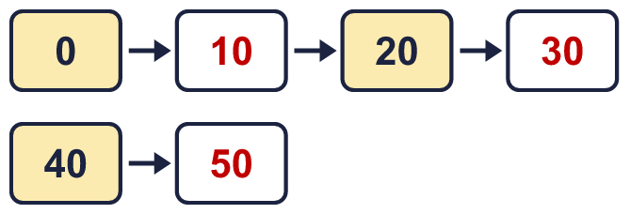
  2 | Complete the number track. It counts down in 10s.  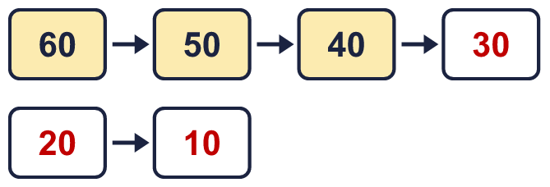
  3 | Work out the multiplications.  a) 13 × 10 = 130  b) 10 × 55 = 550  c) 67 × 10 = 670
  4 | Write the missing number in each calculation.  a) 10 × 4 = 40  b) 8 × 10 = 80  c) 30 ÷ 10 = 3
  5 | Circle the multiples of 10. Write them below.  70 88 22 10 80 76  10, 70, 80
  6 | A baker makes 5 trays of buns. Each tray has 10 buns.  a) How many buns are there? 50  b) 3 buns are eaten. How many buns are left? 47
  7 | How many multiples of 10 are there from 10 up to 60?  6
  8 | Work out the divisions.  a) 270 ÷ 10 = 27  b) 510 ÷ 10 = 51  c) 470 ÷ 10 = 47
  9 | Write true or false for each statement.  a) 4 × 10 = 10 × 4 True  b) 8 × 10 = 4 × 20 True  c) 4 × 10 = 3 × 10 + 4 False  d) 4 × 10 = 10 × 5 False
  10 | Is Boba correct? Circle yes or no.  Yes / No  What is the correct answer? 60  Explain Boba’s mistake.  6 × 10 = 60. Boba’s answer is not 6 groups of 10: 6 groups of 10 make 60.
  11 | a) How long is the yellow ribbon? 90 cm  b) How much longer is the yellow ribbon than the red ribbon? 80 cm
  12 | There are 10 players in a team. 6 teams have signed up for a tournament.  a) How many players have signed up? 60  b) The tournament needs 110 players. How many more teams are needed? 5
  13 | Write three different multiples of 10 that are between 20 and 70.  for example 30, 40, 50
  14 | Which number is the odd one out?  40 73 80 90  The odd one out is 73  Explain why it is the odd one out.  73 is not a multiple of 10. The other three numbers are multiples of 10.

