  Year 3 · Multiplication and division B · Step 6  Link multiplication and division | 
  Year 3 · Multiplication and division B · Step 6
  Link multiplication and division
  1 | 4 × 3 = 12. Use this fact to complete the others.  a) 3 × 4 =  b) 12 ÷ 3 =  c) 12 ÷ 4 =  d) 4 × 30 =
  1 | 4 × 3 = 12. Use this fact to complete the others.  a) 3 × 4 =  b) 12 ÷ 3 =  c) 12 ÷ 4 =  d) 4 × 30 =
  2 | 7 × 4 = 28. Use this fact to complete the others.  a) 7 × 40 =  b) 70 × 4 =  c) 280 ÷ 4 =  d) 280 ÷ 70 =
  2 | 7 × 4 = 28. Use this fact to complete the others.  a) 7 × 40 =  b) 70 × 4 =  c) 280 ÷ 4 =  d) 280 ÷ 70 =
  3 | Work out the multiplications.  a) 11 × 6 =  b) 10 × 6 =
  3 | Work out the multiplications.  a) 11 × 6 =  b) 10 × 6 =
  4 | 3 × 8 = 24. Use this fact to complete the others.  a) 8 × 3 =  b) 24 ÷ 8 =  c) 24 ÷ 3 =  d) 3 × 80 =
  4 | 3 × 8 = 24. Use this fact to complete the others.  a) 8 × 3 =  b) 24 ÷ 8 =  c) 24 ÷ 3 =  d) 3 × 80 =
  5 | Work out the divisions.  a) 36 ÷ 6 =  b) 48 ÷ 6 =
  5 | Work out the divisions.  a) 36 ÷ 6 =  b) 48 ÷ 6 =
  6 | Write the missing number in each calculation.
    a) |  | ÷ 6 | = | 10
    b) | 72 ÷ 6 | =
    c) |  | × 6 | = | 36
  6 | Write the missing number in each calculation.
    a) |  | ÷ 6 | = | 10
    b) | 72 ÷ 6 | =
    c) |  | × 6 | = | 36
  7 | 54 strawberries are shared equally between 6 bowls.  a) How many strawberries are in each bowl?  24 children sit in rows. There are 6 children in each row.  b) How many rows are there?
  7 | 54 strawberries are shared equally between 6 bowls.  a) How many strawberries are in each bowl?  24 children sit in rows. There are 6 children in each row.  b) How many rows are there?
  8 | Work out the divisions.  a) 54 ÷ 6 =  b) 18 ÷ 6 =
  8 | Work out the divisions.  a) 54 ÷ 6 =  b) 18 ÷ 6 =

  9 | Write true or false for each statement.
    a) | 7 × 6 = 6 × 6 + 6
    b) | 14 × 6 = 7 × 12
    c) | 7 × 6 = 8 × 6 + 6
    d) | 7 × 6 = 7 × 7 - 6
  9 | Write true or false for each statement.
    a) | 7 × 6 = 6 × 6 + 6
    b) | 14 × 6 = 7 × 12
    c) | 7 × 6 = 8 × 6 + 6
    d) | 7 × 6 = 7 × 7 - 6
  10 | Is Boba correct? Circle yes or no.  Yes / No  What is the correct answer?  Explain Boba’s mistake.
    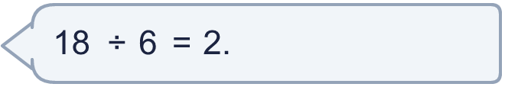
  10 | Is Boba correct? Circle yes or no.  Yes / No  What is the correct answer?  Explain Boba’s mistake.
  11 | Write <, > or = in each box.
    a) | 9 × 6 |  | 12 × 6
    b) | 6 × 7 |  | 7 × 6
    c) | 54 ÷ 6 |  | 72 ÷ 6
  11 | Write <, > or = in each box.
    a) | 9 × 6 |  | 12 × 6
    b) | 6 × 7 |  | 7 × 6
    c) | 54 ÷ 6 |  | 72 ÷ 6
  12 | There are 6 players in a team. 4 teams have signed up for a tournament.  a) How many players have signed up?  b) The tournament needs 54 players. How many more teams are needed?
  12 | There are 6 players in a team. 4 teams have signed up for a tournament.  a) How many players have signed up?  b) The tournament needs 54 players. How many more teams are needed?
  13 | a) How long is the yellow ribbon?  b) How much longer is the yellow ribbon than the red ribbon?
     | 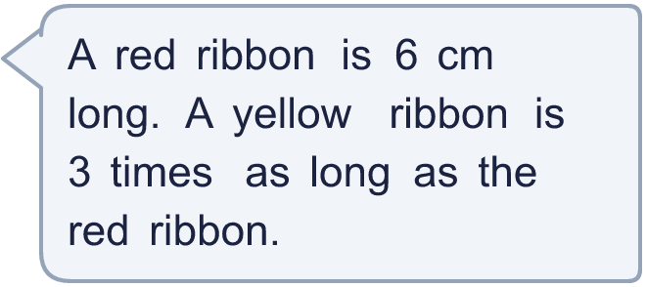
  13 | a) How long is the yellow ribbon?  b) How much longer is the yellow ribbon than the red ribbon?
  14 | Mia is thinking of three different multiples of 6 that are less than 60. The sum of the numbers is 72.  What could the numbers be?
  14 | Mia is thinking of three different multiples of 6 that are less than 60. The sum of the numbers is 72.  What could the numbers be?

Year 3 · Multiplication and division B · Step 6
Link multiplication and division
Answers (teacher copy)

  1 | 4 × 3 = 12. Use this fact to complete the others.  a) 3 × 4 = 12  b) 12 ÷ 3 = 4  c) 12 ÷ 4 = 3  d) 4 × 30 = 120
  2 | 7 × 4 = 28. Use this fact to complete the others.  a) 7 × 40 = 280  b) 70 × 4 = 280  c) 280 ÷ 4 = 70  d) 280 ÷ 70 = 4
  3 | Work out the multiplications.  a) 11 × 6 = 66  b) 10 × 6 = 60
  4 | 3 × 8 = 24. Use this fact to complete the others.  a) 8 × 3 = 24  b) 24 ÷ 8 = 3  c) 24 ÷ 3 = 8  d) 3 × 80 = 240
  5 | Work out the divisions.  a) 36 ÷ 6 = 6  b) 48 ÷ 6 = 8
  6 | Write the missing number in each calculation.  a) 60 ÷ 6 = 10  b) 72 ÷ 6 = 12  c) 6 × 6 = 36
  7 | 54 strawberries are shared equally between 6 bowls.  a) How many strawberries are in each bowl? 9  24 children sit in rows. There are 6 children in each row.  b) How many rows are there? 4
  8 | Work out the divisions.  a) 54 ÷ 6 = 9  b) 18 ÷ 6 = 3
  9 | Write true or false for each statement.  a) 7 × 6 = 6 × 6 + 6 True  b) 14 × 6 = 7 × 12 True  c) 7 × 6 = 8 × 6 + 6 False  d) 7 × 6 = 7 × 7 - 6 False
  10 | Is Boba correct? Circle yes or no.  Yes / No  What is the correct answer? 3  Explain Boba’s mistake.  18 ÷ 6 = 3, because 3 groups of 6 make 18.
  11 | Write <, > or = in each box.  a) 9 × 6 < 12 × 6  b) 6 × 7 = 7 × 6  c) 54 ÷ 6 < 72 ÷ 6
  12 | There are 6 players in a team. 4 teams have signed up for a tournament.  a) How many players have signed up? 24  b) The tournament needs 54 players. How many more teams are needed? 5
  13 | a) How long is the yellow ribbon? 18 cm  b) How much longer is the yellow ribbon than the red ribbon? 12 cm
  14 | Mia is thinking of three different multiples of 6 that are less than 60. The sum of the numbers is 72.  What could the numbers be?  for example 6 + 30 + 36

