  Year 3 · Multiplication and division B · Step 9  Divide 2-digit by 1-digit with remainders | 
  Year 3 · Multiplication and division B · Step 9
  Divide 2-digit by 1-digit with remainders
  1 | Work out the divisions. Write any remainder like this: 56 r 3.  a) 22 ÷ 3 =  b) 25 ÷ 4 =  c) 79 ÷ 2 =
  1 | Work out the divisions. Write any remainder like this: 56 r 3.  a) 22 ÷ 3 =  b) 25 ÷ 4 =  c) 79 ÷ 2 =
  2 | Work out the divisions. Write any remainder.  a) 43 ÷ 4 =  b) 54 ÷ 4 =  c) 41 ÷ 4 =
  2 | Work out the divisions. Write any remainder.  a) 43 ÷ 4 =  b) 54 ÷ 4 =  c) 41 ÷ 4 =
  3 | Write the remainder for each division. You do not need the whole answer.  a) 14 ÷ 3: remainder  b) 35 ÷ 4: remainder  c) 91 ÷ 8: remainder
  3 | Write the remainder for each division. You do not need the whole answer.  a) 14 ÷ 3: remainder  b) 35 ÷ 4: remainder  c) 91 ÷ 8: remainder
  4 | Which is greater: 14 ÷ 4 or 95 ÷ 4?  Write a or b. (a is the first calculation.)
  4 | Which is greater: 14 ÷ 4 or 95 ÷ 4?  Write a or b. (a is the first calculation.)
  5 | Pencils are packed in boxes of 3. There are 49 pencils.  a) How many full boxes can be made?  b) How many pencils are left over?
  5 | Pencils are packed in boxes of 3. There are 49 pencils.  a) How many full boxes can be made?  b) How many pencils are left over?
  6 | Work out the divisions.  a) 77 ÷ 5 =  b) 21 ÷ 2 =
  6 | Work out the divisions.  a) 77 ÷ 5 =  b) 21 ÷ 2 =
  7 | Each minibus seats 4 people. 51 people want to go on a trip.  How many minibuses are needed?
  7 | Each minibus seats 4 people. 51 people want to go on a trip.  How many minibuses are needed?
  8 | 40 ÷ 5 = 8. Use this fact to work out the divisions.  a) 400 ÷ 5 =  b) 400 ÷ 50 =  c) 40 ÷ 5 =
  8 | 40 ÷ 5 = 8. Use this fact to work out the divisions.  a) 400 ÷ 5 =  b) 400 ÷ 50 =  c) 40 ÷ 5 =

  9 | Is Boba correct? Circle yes or no.  Yes / No  Explain how you know.
     | 
  9 | Is Boba correct? Circle yes or no.  Yes / No  Explain how you know.
  10 | What number did I start with?
     | 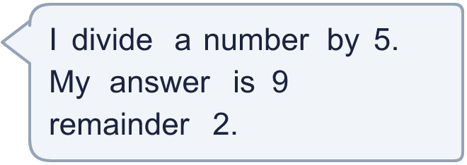
  10 | What number did I start with?
  11 | a) How many times must the ride go round so that everyone rides once?  b) How many people are on the last ride?
     | 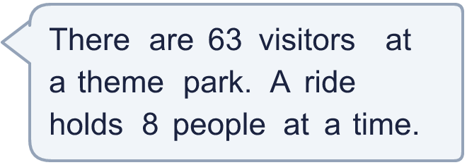
  11 | a) How many times must the ride go round so that everyone rides once?  b) How many people are on the last ride?
  12 | Write the remainder when 91 is divided by each number.  ÷ 2, ÷ 3, ÷ 4, ÷ 5, ÷ 6:
  12 | Write the remainder when 91 is divided by each number.  ÷ 2, ÷ 3, ÷ 4, ÷ 5, ÷ 6:
  13 | a) How many stickers does each friend get?  b) How many stickers does Dani keep?
    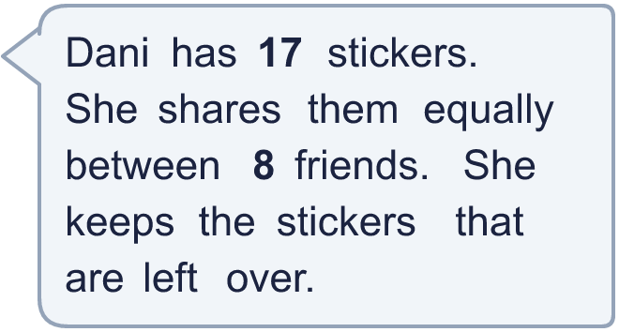
  13 | a) How many stickers does each friend get?  b) How many stickers does Dani keep?
  14 | Write three different 2-digit numbers that leave a remainder of 1 when divided by 2.
  14 | Write three different 2-digit numbers that leave a remainder of 1 when divided by 2.

Year 3 · Multiplication and division B · Step 9
Divide 2-digit by 1-digit with remainders
Answers (teacher copy)

  1 | Work out the divisions. Write any remainder like this: 56 r 3.  a) 22 ÷ 3 = 7 r 1  b) 25 ÷ 4 = 6 r 1  c) 79 ÷ 2 = 39 r 1
  2 | Work out the divisions. Write any remainder.  a) 43 ÷ 4 = 10 r 3  b) 54 ÷ 4 = 13 r 2  c) 41 ÷ 4 = 10 r 1
  3 | Write the remainder for each division. You do not need the whole answer.  a) 14 ÷ 3: remainder 2  b) 35 ÷ 4: remainder 3  c) 91 ÷ 8: remainder 3
  4 | Which is greater: 14 ÷ 4 or 95 ÷ 4?  Write a or b. (a is the first calculation.) b
  5 | Pencils are packed in boxes of 3. There are 49 pencils.  a) How many full boxes can be made? 16  b) How many pencils are left over? 1
  6 | Work out the divisions.  a) 77 ÷ 5 = 15 r 2  b) 21 ÷ 2 = 10 r 1
  7 | Each minibus seats 4 people. 51 people want to go on a trip.  How many minibuses are needed? 13
  8 | 40 ÷ 5 = 8. Use this fact to work out the divisions.  a) 400 ÷ 5 = 80  b) 400 ÷ 50 = 8  c) 40 ÷ 5 = 8
  9 | Is Boba correct? Circle yes or no.  Yes / No  Explain how you know.  The remainder 3 is bigger than 2, so another group of 2 can be made. 79 ÷ 2 = 39 r 1.
  10 | What number did I start with? 47
  11 | a) How many times must the ride go round so that everyone rides once? 8  b) How many people are on the last ride? 7
  12 | Write the remainder when 91 is divided by each number.  ÷ 2, ÷ 3, ÷ 4, ÷ 5, ÷ 6: 1, 1, 3, 1, 1
  13 | a) How many stickers does each friend get? 2  b) How many stickers does Dani keep? 1
  14 | Write three different 2-digit numbers that leave a remainder of 1 when divided by 2.  Any three 2-digit numbers with remainder 1 when divided by 2, for example 33, 55, 77

