  Year 3 · Multiplication and division B · Step 8  Divide 2-digit by 1-digit, partitioning | 
  Year 3 · Multiplication and division B · Step 8
  Divide 2-digit by 1-digit, partitioning
  1 | Work out the divisions.  a) 16 ÷ 8 =  b) 48 ÷ 3 =  c) 12 ÷ 4 =
  1 | Work out the divisions.  a) 16 ÷ 8 =  b) 48 ÷ 3 =  c) 12 ÷ 4 =
  2 | Work out the divisions. Watch for the zeros.  a) 87 ÷ 3 =  b) 78 ÷ 3 =  c) 18 ÷ 3 =
  2 | Work out the divisions. Watch for the zeros.  a) 87 ÷ 3 =  b) 78 ÷ 3 =  c) 18 ÷ 3 =
  3 | Write the missing number.
    a) |  | ÷ 6 | = | 12
    b) |  | ÷ 8 | = | 8
  3 | Write the missing number.
    a) |  | ÷ 6 | = | 12
    b) |  | ÷ 8 | = | 8
  4 | Write <, > or = in each box.
    a) | 12 ÷ 2 |  | 16 ÷ 8
    b) | 80 ÷ 5 |  | 84 ÷ 3
  4 | Write <, > or = in each box.
    a) | 12 ÷ 2 |  | 16 ÷ 8
    b) | 80 ÷ 5 |  | 84 ÷ 3
  5 | 40 sweets are shared equally between 8 schools.  How many sweets does each school get?
  5 | 40 sweets are shared equally between 8 schools.  How many sweets does each school get?
  6 | Work out the divisions.  a) 90 ÷ 2 =  b) 20 ÷ 4 =
  6 | Work out the divisions.  a) 90 ÷ 2 =  b) 20 ÷ 4 =
  7 | £5.60 is shared equally between 4 children.  How much does each child get?
  7 | £5.60 is shared equally between 4 children.  How much does each child get?
  8 | 24 ÷ 8 = 3. Use this fact to work out the divisions.  a) 240 ÷ 8 =  b) 240 ÷ 80 =  c) 24 ÷ 8 =
  8 | 24 ÷ 8 = 3. Use this fact to work out the divisions.  a) 240 ÷ 8 =  b) 240 ÷ 80 =  c) 24 ÷ 8 =

  9 | Is Boba correct? Circle yes or no.  Yes / No  Explain how you know.
     | 
  9 | Is Boba correct? Circle yes or no.  Yes / No  Explain how you know.
  10 | What number did I start with?
     | 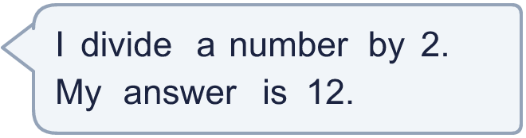
  10 | What number did I start with?
  11 | a) How many trays are filled?  b) How much money does the farm get for all the trays?
     | 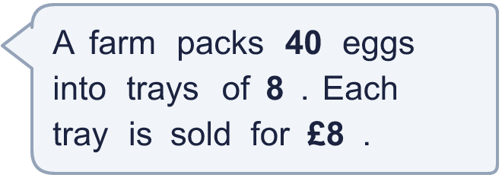
  11 | a) How many trays are filled?  b) How much money does the farm get for all the trays?
  12 | Which is greater: 45 ÷ 5 or 60 ÷ 5?  Write a or b. (a is the first calculation.)
  12 | Which is greater: 45 ÷ 5 or 60 ÷ 5?  Write a or b. (a is the first calculation.)
  13 | How many books does each library have now?
    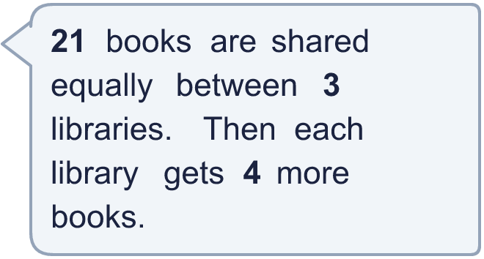
  13 | How many books does each library have now?
  14 | Write three different 2-digit numbers that can be divided by 8 with no remainder.
  14 | Write three different 2-digit numbers that can be divided by 8 with no remainder.

Year 3 · Multiplication and division B · Step 8
Divide 2-digit by 1-digit, partitioning
Answers (teacher copy)

  1 | Work out the divisions.  a) 16 ÷ 8 = 2  b) 48 ÷ 3 = 16  c) 12 ÷ 4 = 3
  2 | Work out the divisions. Watch for the zeros.  a) 87 ÷ 3 = 29  b) 78 ÷ 3 = 26  c) 18 ÷ 3 = 6
  3 | Write the missing number.  a) 72 ÷ 6 = 12  b) 64 ÷ 8 = 8
  4 | Write <, > or = in each box.  a) 12 ÷ 2 > 16 ÷ 8  b) 80 ÷ 5 < 84 ÷ 3
  5 | 40 sweets are shared equally between 8 schools.  How many sweets does each school get? 5
  6 | Work out the divisions.  a) 90 ÷ 2 = 45  b) 20 ÷ 4 = 5
  7 | £5.60 is shared equally between 4 children.  How much does each child get? £1.40
  8 | 24 ÷ 8 = 3. Use this fact to work out the divisions.  a) 240 ÷ 8 = 30  b) 240 ÷ 80 = 3  c) 24 ÷ 8 = 3
  9 | Is Boba correct? Circle yes or no.  Yes / No  Explain how you know.  19 × 4 = 76, not 36. The correct answer is 36 ÷ 4 = 9.
  10 | What number did I start with? 24
  11 | a) How many trays are filled? 5  b) How much money does the farm get for all the trays? £40
  12 | Which is greater: 45 ÷ 5 or 60 ÷ 5?  Write a or b. (a is the first calculation.) b
  13 | How many books does each library have now? 11
  14 | Write three different 2-digit numbers that can be divided by 8 with no remainder.  Any three 2-digit numbers with remainder 0 when divided by 8, for example 32, 56, 72

