  Year 3 · Multiplication and division B · Step 7  Divide 2-digit by 1-digit, no exchange | 
  Year 3 · Multiplication and division B · Step 7
  Divide 2-digit by 1-digit, no exchange
  1 | Work out the divisions.  a) 80 ÷ 8 =  b) 84 ÷ 4 =  c) 26 ÷ 2 =
  1 | Work out the divisions.  a) 80 ÷ 8 =  b) 84 ÷ 4 =  c) 26 ÷ 2 =
  2 | Work out the divisions. Watch for the zeros.  a) 60 ÷ 2 =  b) 66 ÷ 3 =  c) 80 ÷ 8 =
  2 | Work out the divisions. Watch for the zeros.  a) 60 ÷ 2 =  b) 66 ÷ 3 =  c) 80 ÷ 8 =
  3 | Write the missing number.
    a) |  | ÷ 3 | = | 33
    b) |  | ÷ 2 | = | 38
  3 | Write the missing number.
    a) |  | ÷ 3 | = | 33
    b) |  | ÷ 2 | = | 38
  4 | Write <, > or = in each box.
    a) | 69 ÷ 3 |  | 20 ÷ 2
    b) | 48 ÷ 4 |  | 50 ÷ 5
  4 | Write <, > or = in each box.
    a) | 69 ÷ 3 |  | 20 ÷ 2
    b) | 48 ÷ 4 |  | 50 ÷ 5
  5 | 88 sweets are shared equally between 4 schools.  How many sweets does each school get?
  5 | 88 sweets are shared equally between 4 schools.  How many sweets does each school get?
  6 | Work out the divisions.  a) 40 ÷ 4 =  b) 80 ÷ 2 =
  6 | Work out the divisions.  a) 40 ÷ 4 =  b) 80 ÷ 2 =
  7 | £1.20 is shared equally between 3 children.  How much does each child get?
  7 | £1.20 is shared equally between 3 children.  How much does each child get?
  8 | 16 ÷ 8 = 2. Use this fact to work out the divisions.  a) 160 ÷ 8 =  b) 160 ÷ 80 =  c) 16 ÷ 8 =
  8 | 16 ÷ 8 = 2. Use this fact to work out the divisions.  a) 160 ÷ 8 =  b) 160 ÷ 80 =  c) 16 ÷ 8 =

  9 | Is Boba correct? Circle yes or no.  Yes / No  Explain how you know.
     | 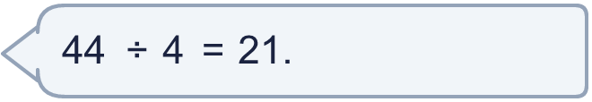
  9 | Is Boba correct? Circle yes or no.  Yes / No  Explain how you know.
  10 | What number did I start with?
     | 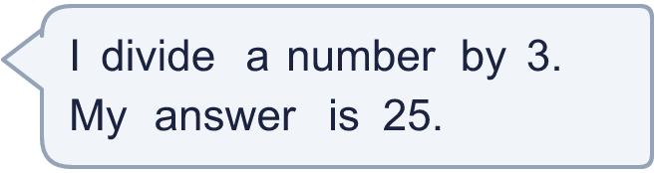
  10 | What number did I start with?
  11 | a) How many trays are filled?  b) How much money does the farm get for all the trays?
     | 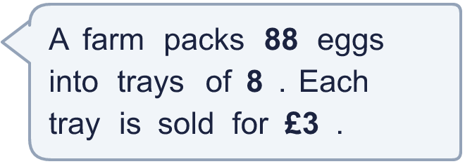
  11 | a) How many trays are filled?  b) How much money does the farm get for all the trays?
  12 | Which is greater: 40 ÷ 2 or 50 ÷ 5?  Write a or b. (a is the first calculation.)
  12 | Which is greater: 40 ÷ 2 or 50 ÷ 5?  Write a or b. (a is the first calculation.)
  13 | How many books does each library have now?
    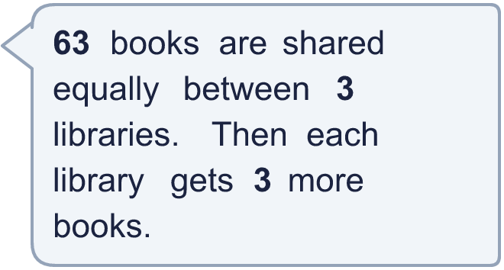
  13 | How many books does each library have now?
  14 | Write three different 2-digit numbers that can be divided by 8 with no remainder.
  14 | Write three different 2-digit numbers that can be divided by 8 with no remainder.

Year 3 · Multiplication and division B · Step 7
Divide 2-digit by 1-digit, no exchange
Answers (teacher copy)

  1 | Work out the divisions.  a) 80 ÷ 8 = 10  b) 84 ÷ 4 = 21  c) 26 ÷ 2 = 13
  2 | Work out the divisions. Watch for the zeros.  a) 60 ÷ 2 = 30  b) 66 ÷ 3 = 22  c) 80 ÷ 8 = 10
  3 | Write the missing number.  a) 99 ÷ 3 = 33  b) 76 ÷ 2 = 38
  4 | Write <, > or = in each box.  a) 69 ÷ 3 > 20 ÷ 2  b) 48 ÷ 4 > 50 ÷ 5
  5 | 88 sweets are shared equally between 4 schools.  How many sweets does each school get? 22
  6 | Work out the divisions.  a) 40 ÷ 4 = 10  b) 80 ÷ 2 = 40
  7 | £1.20 is shared equally between 3 children.  How much does each child get? £0.40
  8 | 16 ÷ 8 = 2. Use this fact to work out the divisions.  a) 160 ÷ 8 = 20  b) 160 ÷ 80 = 2  c) 16 ÷ 8 = 2
  9 | Is Boba correct? Circle yes or no.  Yes / No  Explain how you know.  21 × 4 = 84, not 44. The correct answer is 44 ÷ 4 = 11.
  10 | What number did I start with? 75
  11 | a) How many trays are filled? 11  b) How much money does the farm get for all the trays? £33
  12 | Which is greater: 40 ÷ 2 or 50 ÷ 5?  Write a or b. (a is the first calculation.) a
  13 | How many books does each library have now? 24
  14 | Write three different 2-digit numbers that can be divided by 8 with no remainder.  Any three 2-digit numbers with remainder 0 when divided by 8, for example 32, 56, 72

