  Year 3 · Mass and capacity · Step 1  Use scales | 
  Year 3 · Mass and capacity · Step 1
  Use scales
  1 | What mass do the scales show? Write the reading in grams.  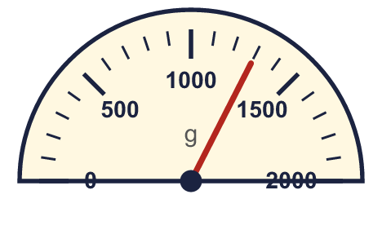  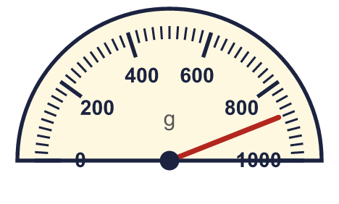
    a) |  | g
    b) |  | g
  1 | What mass do the scales show? Write the reading in grams.
    a) |  | g
    b) |  | g
  2 | Which unit would you use to measure each? Write grams or kilograms.
    a) | a pair of socks
    b) | a slice of bread
    c) | a child
    d) | a bag of potatoes
  2 | Which unit would you use to measure each? Write grams or kilograms.
    a) | a pair of socks
    b) | a slice of bread
    c) | a child
    d) | a bag of potatoes
  3 | Write the short form (abbreviation) for each unit.
    a) | grams
    b) | kilograms
  3 | Write the short form (abbreviation) for each unit.
    a) | grams
    b) | kilograms
  4 | What mass do the scales show? Write the reading in grams.  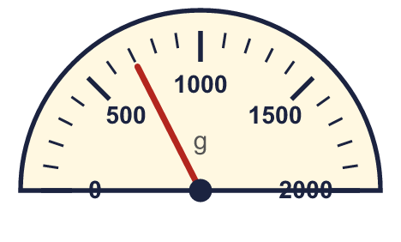
    a) |  | g
  4 | What mass do the scales show? Write the reading in grams.
    a) |  | g
  5 | Complete the statements.
    a) | 9 kg = |  | g
    b) | 3 kg = |  | g
    c) | 5 kg = |  | g
  5 | Complete the statements.
    a) | 9 kg = |  | g
    b) | 3 kg = |  | g
    c) | 5 kg = |  | g
  6 | Write <, > or = in each box.
    a) | 500 g |  | 1 kg
    b) | 2 kg |  | 1,500 g
  6 | Write <, > or = in each box.
    a) | 500 g |  | 1 kg
    b) | 2 kg |  | 1,500 g
  7 | There are 1,000 grams in 1 kilogram. Use this to complete the statements.
    a) | 6 kg = |  | g
    b) | 6,000 g = |  | kg
  7 | There are 1,000 grams in 1 kilogram. Use this to complete the statements.
    a) | 6 kg = |  | g
    b) | 6,000 g = |  | kg
  8 | Write the masses in order. Start with the lightest.  3 kg 250 g 1,100 g 2 kg 200 g 1,600 g
  8 | Write the masses in order. Start with the lightest.  3 kg 250 g 1,100 g 2 kg 200 g 1,600 g

  9 | Is Boba correct? Circle yes or no.  Yes / No  Explain how you know.
     | 
  9 | Is Boba correct? Circle yes or no.  Yes / No  Explain how you know.
  10 | Filip has a bag of rice of 1 kg 250 g. Dora has a bag of rice of 3,250 g.  a) Whose bag of rice is heavier?
    b) | How much heavier? Write the difference in grams.
    g
  10 | Filip has a bag of rice of 1 kg 250 g. Dora has a bag of rice of 3,250 g.  a) Whose bag of rice is heavier?
    b) | How much heavier? Write the difference in grams.
    g
  11 | Leo has two bag of sugars. One weighs 850 g and the other weighs 750 g.  How much is that altogether? Write the answer in kilograms and grams.
  11 | Leo has two bag of sugars. One weighs 850 g and the other weighs 750 g.  How much is that altogether? Write the answer in kilograms and grams.
  12 | Write <, > or = in each box.
    a) | 450 g |  | 1 kg
    b) | 2 kg 50 g |  | 2,500 g
    c) | 1 kg 500 g |  | 1,050 g
  12 | Write <, > or = in each box.
    a) | 450 g |  | 1 kg
    b) | 2 kg 50 g |  | 2,500 g
    c) | 1 kg 500 g |  | 1,050 g
  13 | Is Boba correct? Circle yes or no.  Yes / No  Explain how you know.
    
  13 | Is Boba correct? Circle yes or no.  Yes / No  Explain how you know.
  14 | Write the masses in order. Start with the lightest.  3,700 g 1 kg 900 g 1,050 g 1,550 g
  14 | Write the masses in order. Start with the lightest.  3,700 g 1 kg 900 g 1,050 g 1,550 g

Year 3 · Mass and capacity · Step 1
Use scales
Answers (teacher copy)

  1 | What mass do the scales show? Write the reading in grams.  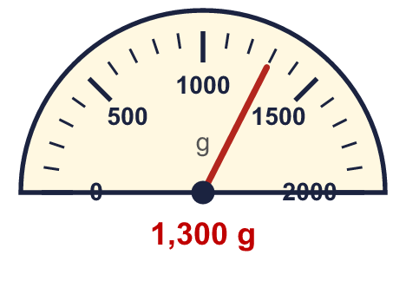  a) 1,300 g  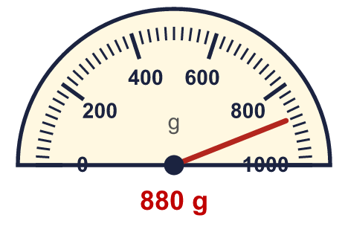  b) 880 g
  2 | Which unit would you use to measure each? Write grams or kilograms.  a) a pair of socks grams  b) a slice of bread grams  c) a child kilograms  d) a bag of potatoes kilograms
  3 | Write the short form (abbreviation) for each unit.  a) grams g  b) kilograms kg
  4 | What mass do the scales show? Write the reading in grams.  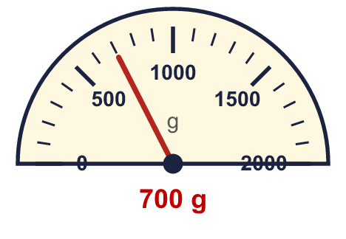  a) 700 g
  5 | Complete the statements.  a) 9 kg = 9,000 g  b) 3 kg = 3,000 g  c) 5 kg = 5,000 g
  6 | Write <, > or = in each box.  a) 500 g < 1 kg  b) 2 kg > 1,500 g
  7 | There are 1,000 grams in 1 kilogram. Use this to complete the statements.  a) 6 kg = 6,000 g  b) 6,000 g = 6 kg
  8 | Write the masses in order. Start with the lightest.  3 kg 250 g 1,100 g 2 kg 200 g 1,600 g  1,100 g, 1,600 g, 2 kg 200 g, 3 kg 250 g
  9 | Is Boba correct? Circle yes or no.  Yes / No  Explain how you know.  There are 1,000 grams in 1 kilogram, so 5 kg = 5,000 g, not 500 g.
  10 | Filip has a bag of rice of 1 kg 250 g. Dora has a bag of rice of 3,250 g.  a) Whose bag of rice is heavier? Dora  b) How much heavier? Write the difference in grams. 2,000 g
  11 | Leo has two bag of sugars. One weighs 850 g and the other weighs 750 g.  How much is that altogether? Write the answer in kilograms and grams. 1 kg 600 g
  12 | Write <, > or = in each box.  a) 450 g < 1 kg  b) 2 kg 50 g < 2,500 g  c) 1 kg 500 g > 1,050 g
  13 | Is Boba correct? Circle yes or no.  Yes / No  Explain how you know.  There are 1,000 grams in 1 kilogram, so 7 kg = 7,000 g, not 700 g.
  14 | Write the masses in order. Start with the lightest.  3,700 g 1 kg 900 g 1,050 g 1,550 g  1,050 g, 1,550 g, 1 kg 900 g, 3,700 g

