  Year 3 · Mass and capacity · Step 3  Measure mass in kilograms and grams | 
  Year 3 · Mass and capacity · Step 3
  Measure mass in kilograms and grams
  1 | What mass do the scales show? Write the reading in kilograms and grams.  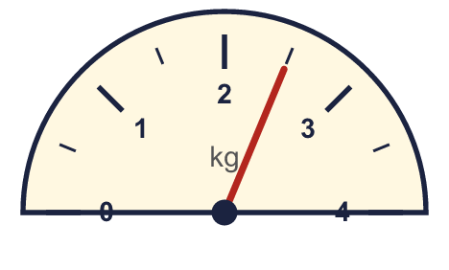  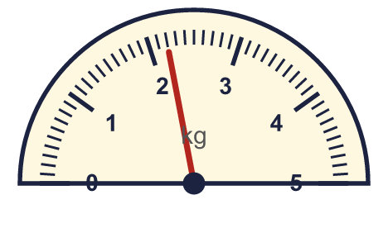
    a) |  | kg |  | g
    b) |  | kg |  | g
  1 | What mass do the scales show? Write the reading in kilograms and grams.
    a) |  | kg |  | g
    b) |  | kg |  | g
  2 | Complete the statements.
    a) | 8 kg 300 g = |  | g
    b) | 7,750 g = |  | kg |  | g
    c) | 4,100 g = |  | kg |  | g
  2 | Complete the statements.
    a) | 8 kg 300 g = |  | g
    b) | 7,750 g = |  | kg |  | g
    c) | 4,100 g = |  | kg |  | g
  3 | What mass do the scales show? Write the reading in kilograms.  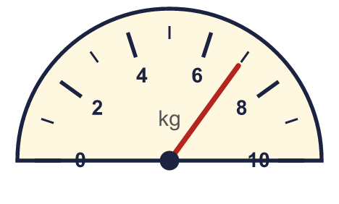
    a) |  | kg
  3 | What mass do the scales show? Write the reading in kilograms.
    a) |  | kg
  4 | There are 1,000 grams in 1 kilogram. Use this to complete the statements.
    a) | 6 kg = |  | g
    b) | 6,000 g = |  | kg
  4 | There are 1,000 grams in 1 kilogram. Use this to complete the statements.
    a) | 6 kg = |  | g
    b) | 6,000 g = |  | kg
  5 | Complete the statements.
    a) | 5,800 g = |  | kg |  | g
    b) | 5,600 g = |  | kg |  | g
    c) | 3,600 g = |  | kg |  | g
  5 | Complete the statements.
    a) | 5,800 g = |  | kg |  | g
    b) | 5,600 g = |  | kg |  | g
    c) | 3,600 g = |  | kg |  | g
  6 | Write <, > or = in each box.
    a) | 2 kg |  | 1,500 g
    b) | 500 g |  | 1 kg
    c) | 2 kg 50 g |  | 2,500 g
  6 | Write <, > or = in each box.
    a) | 2 kg |  | 1,500 g
    b) | 500 g |  | 1 kg
    c) | 2 kg 50 g |  | 2,500 g
  7 | What mass do the scales show? Write the reading in kilograms and grams.  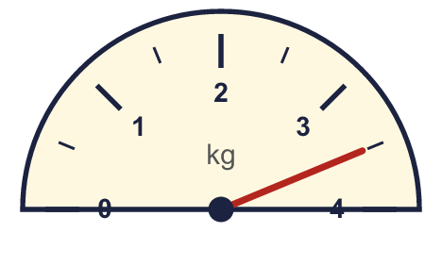
    a) |  | kg |  | g
  7 | What mass do the scales show? Write the reading in kilograms and grams.
    a) |  | kg |  | g
  8 | Write the masses in order. Start with the lightest.  3,900 g 3,750 g 3 kg 450 g 1,000 g
  8 | Write the masses in order. Start with the lightest.  3,900 g 3,750 g 3 kg 450 g 1,000 g

  9 | Is Boba correct? Circle yes or no.  Yes / No  Explain how you know.
     | 
  9 | Is Boba correct? Circle yes or no.  Yes / No  Explain how you know.
  10 | Write the masses in order. Start with the lightest.  500 g 1 kg 850 g 2,400 g 3 kg 400 g
  10 | Write the masses in order. Start with the lightest.  500 g 1 kg 850 g 2,400 g 3 kg 400 g
  11 | Jo has a bag of rice of 3 kg 750 g. Nina has a bag of rice of 3,250 g.  a) Whose bag of rice is heavier?
    b) | How much heavier? Write the difference in grams.
    g
  11 | Jo has a bag of rice of 3 kg 750 g. Nina has a bag of rice of 3,250 g.  a) Whose bag of rice is heavier?
    b) | How much heavier? Write the difference in grams.
    g
  12 | Kim has two bag of sugars. One weighs 400 g and the other weighs 600 g.  How much is that altogether? Write the answer in kilograms and grams.
  12 | Kim has two bag of sugars. One weighs 400 g and the other weighs 600 g.  How much is that altogether? Write the answer in kilograms and grams.
  13 | Is Boba correct? Circle yes or no.  Yes / No  Explain how you know.
    
  13 | Is Boba correct? Circle yes or no.  Yes / No  Explain how you know.
  14 | Work out the calculations. Write each answer in the form shown.
    a) | 1 kg 100 g + 200 g =
    b) | 2 kg 250 g + 550 g =
  14 | Work out the calculations. Write each answer in the form shown.
    a) | 1 kg 100 g + 200 g =
    b) | 2 kg 250 g + 550 g =

Year 3 · Mass and capacity · Step 3
Measure mass in kilograms and grams
Answers (teacher copy)

  1 | What mass do the scales show? Write the reading in kilograms and grams.  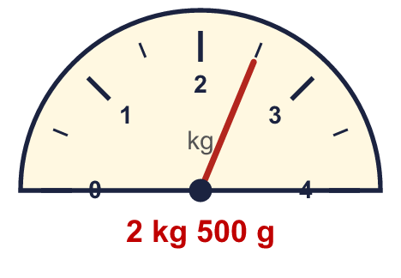  a) 2 kg 500 g  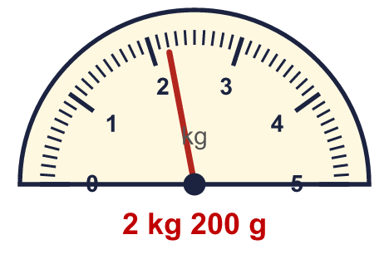  b) 2 kg 200 g
  2 | Complete the statements.  a) 8 kg 300 g = 8,300 g  b) 7,750 g = 7 kg 750 g  c) 4,100 g = 4 kg 100 g
  3 | What mass do the scales show? Write the reading in kilograms.  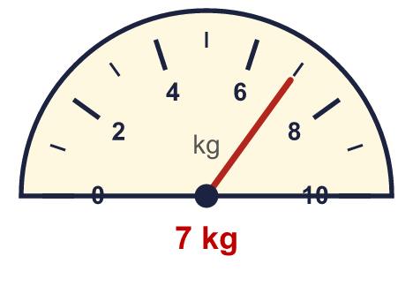  a) 7 kg
  4 | There are 1,000 grams in 1 kilogram. Use this to complete the statements.  a) 6 kg = 6,000 g  b) 6,000 g = 6 kg
  5 | Complete the statements.  a) 5,800 g = 5 kg 800 g  b) 5,600 g = 5 kg 600 g  c) 3,600 g = 3 kg 600 g
  6 | Write <, > or = in each box.  a) 2 kg > 1,500 g  b) 500 g < 1 kg  c) 2 kg 50 g < 2,500 g
  7 | What mass do the scales show? Write the reading in kilograms and grams.  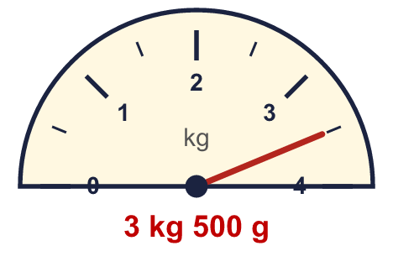  a) 3 kg 500 g
  8 | Write the masses in order. Start with the lightest.  3,900 g 3,750 g 3 kg 450 g 1,000 g  1,000 g, 3 kg 450 g, 3,750 g, 3,900 g
  9 | Is Boba correct? Circle yes or no.  Yes / No  Explain how you know.  There are 1,000 grams in 1 kilogram, so 4 kg = 4,000 g, not 400 g.
  10 | Write the masses in order. Start with the lightest.  500 g 1 kg 850 g 2,400 g 3 kg 400 g  500 g, 1 kg 850 g, 2,400 g, 3 kg 400 g
  11 | Jo has a bag of rice of 3 kg 750 g. Nina has a bag of rice of 3,250 g.  a) Whose bag of rice is heavier? Jo  b) How much heavier? Write the difference in grams. 500 g
  12 | Kim has two bag of sugars. One weighs 400 g and the other weighs 600 g.  How much is that altogether? Write the answer in kilograms and grams. 1 kg 0 g
  13 | Is Boba correct? Circle yes or no.  Yes / No  Explain how you know.  There are 1,000 grams in 1 kilogram, so 5 kg = 5,000 g, not 50 g.
  14 | Work out the calculations. Write each answer in the form shown.  a) 1 kg 100 g + 200 g = 1 kg 300 g  b) 2 kg 250 g + 550 g = 2 kg 800 g

