  Year 3 · Mass and capacity · Step 2  Measure mass in grams | 
  Year 3 · Mass and capacity · Step 2
  Measure mass in grams
  1 | What mass do the scales show? Write the reading in grams.  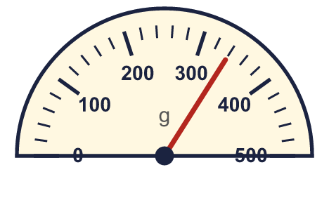  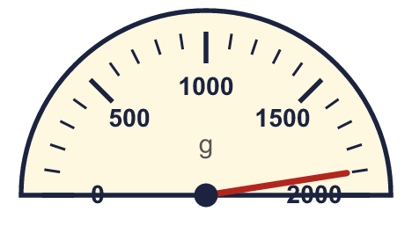
    a) |  | g
    b) |  | g
  1 | What mass do the scales show? Write the reading in grams.
    a) |  | g
    b) |  | g
  2 | Write the short form (abbreviation) for each unit.
    a) | kilograms
    b) | grams
  2 | Write the short form (abbreviation) for each unit.
    a) | kilograms
    b) | grams
  3 | Work out the calculations. Write each answer in the form shown.
    a) | 300 g + 520 g =
    b) | 320 g + 300 g =
    c) | 770 g + 240 g = |  | g
  3 | Work out the calculations. Write each answer in the form shown.
    a) | 300 g + 520 g =
    b) | 320 g + 300 g =
    c) | 770 g + 240 g = |  | g
  4 | What mass do the scales show? Write the reading in grams.  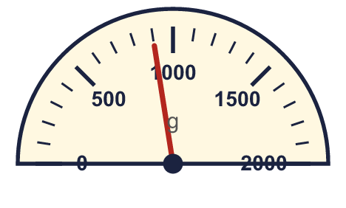
    a) |  | g
  4 | What mass do the scales show? Write the reading in grams.
    a) |  | g
  5 | Write <, > or = in each box.
    a) | 450 g |  | 1 kg
    b) | 1 kg 500 g |  | 1,050 g
    c) | 2 kg 50 g |  | 2,500 g
  5 | Write <, > or = in each box.
    a) | 450 g |  | 1 kg
    b) | 1 kg 500 g |  | 1,050 g
    c) | 2 kg 50 g |  | 2,500 g
  6 | Work out the calculations. Write each answer in the form shown.
    a) | 640 g − 500 g =
    b) | 770 g − 680 g = |  | g
    c) | 460 g − 380 g = |  | g
  6 | Work out the calculations. Write each answer in the form shown.
    a) | 640 g − 500 g =
    b) | 770 g − 680 g = |  | g
    c) | 460 g − 380 g = |  | g
  7 | Write the masses in order. Start with the lightest.  1,700 g 3 kg 950 g 3,650 g 1 kg 400 g
  7 | Write the masses in order. Start with the lightest.  1,700 g 3 kg 950 g 3,650 g 1 kg 400 g
  8 | Work out the calculations. Write each answer in the form shown.
    a) | 720 g + 380 g = |  | g
    b) | 610 g + 230 g = |  | g
  8 | Work out the calculations. Write each answer in the form shown.
    a) | 720 g + 380 g = |  | g
    b) | 610 g + 230 g = |  | g

  9 | Is Boba correct? Circle yes or no.  Yes / No  Explain how you know.
     | 
  9 | Is Boba correct? Circle yes or no.  Yes / No  Explain how you know.
  10 | Sam has two bag of sugars. One weighs 850 g and the other weighs 750 g.  How much is that altogether? Write the answer in kilograms and grams.
  10 | Sam has two bag of sugars. One weighs 850 g and the other weighs 750 g.  How much is that altogether? Write the answer in kilograms and grams.
  11 | Zach has a bag of rice of 2 kg 500 g. Ron has a bag of rice of 3,950 g.  a) Whose bag of rice is heavier?
    b) | How much heavier? Write the difference in grams.
    g
  11 | Zach has a bag of rice of 2 kg 500 g. Ron has a bag of rice of 3,950 g.  a) Whose bag of rice is heavier?
    b) | How much heavier? Write the difference in grams.
    g
  12 | Work out the calculations. Write each answer in the form shown.
    a) | 830 g + 620 g =
    b) | 740 g + 120 g =
  12 | Work out the calculations. Write each answer in the form shown.
    a) | 830 g + 620 g =
    b) | 740 g + 120 g =
  13 | Is Boba correct? Circle yes or no.  Yes / No  Explain how you know.
    
  13 | Is Boba correct? Circle yes or no.  Yes / No  Explain how you know.
  14 | A bag of sugar weighs 1 kg 550 g. Rosie uses 400 g.  How much is left? Write the answer in kilograms and grams.
  14 | A bag of sugar weighs 1 kg 550 g. Rosie uses 400 g.  How much is left? Write the answer in kilograms and grams.

Year 3 · Mass and capacity · Step 2
Measure mass in grams
Answers (teacher copy)

  1 | What mass do the scales show? Write the reading in grams.  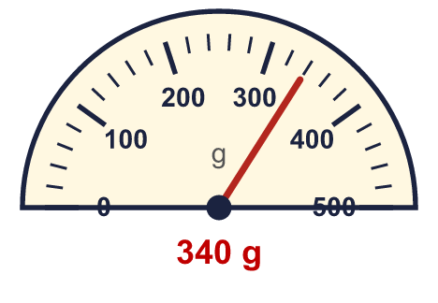  a) 340 g  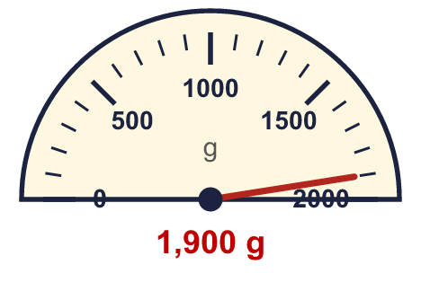  b) 1,900 g
  2 | Write the short form (abbreviation) for each unit.  a) kilograms kg  b) grams g
  3 | Work out the calculations. Write each answer in the form shown.  a) 300 g + 520 g = 0 kg 820 g  b) 320 g + 300 g = 0 kg 620 g  c) 770 g + 240 g = 1,010 g
  4 | What mass do the scales show? Write the reading in grams.  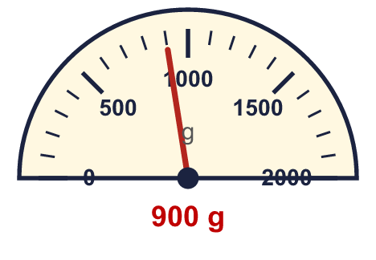  a) 900 g
  5 | Write <, > or = in each box.  a) 450 g < 1 kg  b) 1 kg 500 g > 1,050 g  c) 2 kg 50 g < 2,500 g
  6 | Work out the calculations. Write each answer in the form shown.  a) 640 g − 500 g = 0 kg 140 g  b) 770 g − 680 g = 90 g  c) 460 g − 380 g = 80 g
  7 | Write the masses in order. Start with the lightest.  1,700 g 3 kg 950 g 3,650 g 1 kg 400 g  1 kg 400 g, 1,700 g, 3,650 g, 3 kg 950 g
  8 | Work out the calculations. Write each answer in the form shown.  a) 720 g + 380 g = 1,100 g  b) 610 g + 230 g = 840 g
  9 | Is Boba correct? Circle yes or no.  Yes / No  Explain how you know.  There are 1,000 grams in 1 kilogram, so 2 kg = 2,000 g, not 200 g.
  10 | Sam has two bag of sugars. One weighs 850 g and the other weighs 750 g.  How much is that altogether? Write the answer in kilograms and grams. 1 kg 600 g
  11 | Zach has a bag of rice of 2 kg 500 g. Ron has a bag of rice of 3,950 g.  a) Whose bag of rice is heavier? Ron  b) How much heavier? Write the difference in grams. 1,450 g
  12 | Work out the calculations. Write each answer in the form shown.  a) 830 g + 620 g = 1 kg 450 g  b) 740 g + 120 g = 0 kg 860 g
  13 | Is Boba correct? Circle yes or no.  Yes / No  Explain how you know.  There are 1,000 grams in 1 kilogram, so 5 kg = 5,000 g, not 500 g.
  14 | A bag of sugar weighs 1 kg 550 g. Rosie uses 400 g.  How much is left? Write the answer in kilograms and grams. 1 kg 150 g

