  Year 3 · Mass and capacity · Step 7  Measure capacity and volume in millilitres | 
  Year 3 · Mass and capacity · Step 7
  Measure capacity and volume in millilitres
  1 | How much water is in each jug? Write the amount in millilitres.  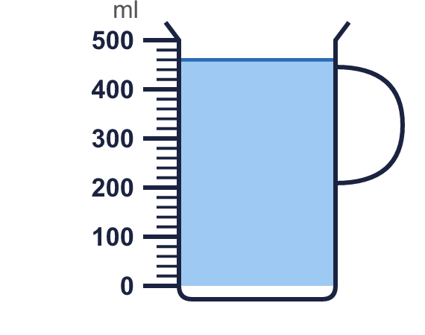  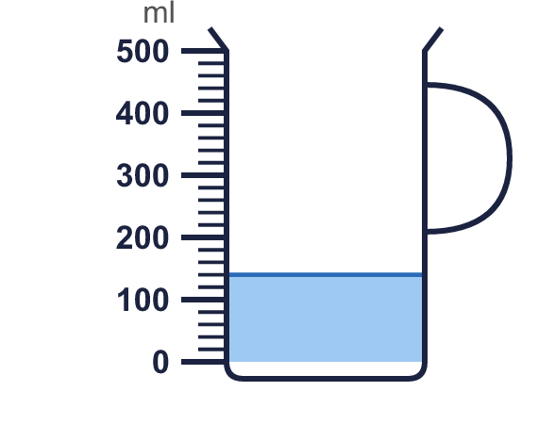
    a) |  | ml
    b) |  | ml
  1 | How much water is in each jug? Write the amount in millilitres.
    a) |  | ml
    b) |  | ml
  2 | Which unit would you use to measure each? Write millilitres or litres.
    a) | a tube of glue
    b) | a paddling pool
    c) | a can of cola
    d) | a fish tank
  2 | Which unit would you use to measure each? Write millilitres or litres.
    a) | a tube of glue
    b) | a paddling pool
    c) | a can of cola
    d) | a fish tank
  3 | Write the short form (abbreviation) for each unit.
    a) | millilitres
    b) | litres
  3 | Write the short form (abbreviation) for each unit.
    a) | millilitres
    b) | litres
  4 | How much water is in each jug? Write the amount in millilitres.  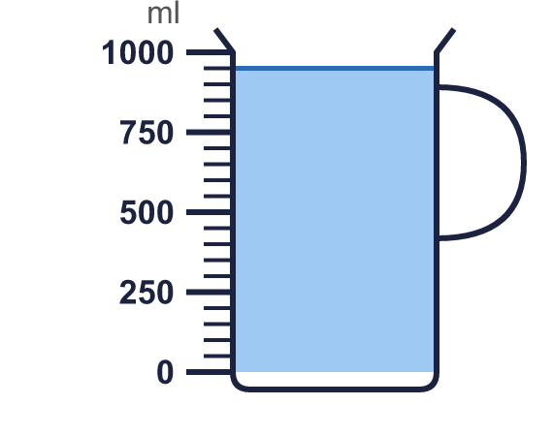
    a) |  | ml
  4 | How much water is in each jug? Write the amount in millilitres.
    a) |  | ml
  5 | Write <, > or = in each box.
    a) | 2 l |  | 1,500 ml
    b) | 450 ml |  | 1 l
    c) | 2 l 100 ml |  | 2,010 ml
  5 | Write <, > or = in each box.
    a) | 2 l |  | 1,500 ml
    b) | 450 ml |  | 1 l
    c) | 2 l 100 ml |  | 2,010 ml
  6 | Work out the calculations. Write each answer in the form shown.
    a) | 120 ml + 860 ml =
    b) | 810 ml + 390 ml =
    c) | 470 ml + 790 ml =
  6 | Work out the calculations. Write each answer in the form shown.
    a) | 120 ml + 860 ml =
    b) | 810 ml + 390 ml =
    c) | 470 ml + 790 ml =
  7 | Write the capacities in order. Start with the smallest.  2 l 250 ml 2,100 ml 2 l 200 ml 950 ml
  7 | Write the capacities in order. Start with the smallest.  2 l 250 ml 2,100 ml 2 l 200 ml 950 ml
  8 | Work out the calculations. Write each answer in the form shown.
    a) | 790 ml − 480 ml =
    b) | 240 ml − 160 ml = |  | ml
  8 | Work out the calculations. Write each answer in the form shown.
    a) | 790 ml − 480 ml =
    b) | 240 ml − 160 ml = |  | ml

  9 | Is Boba correct? Circle yes or no.  Yes / No  Explain how you know.
     | 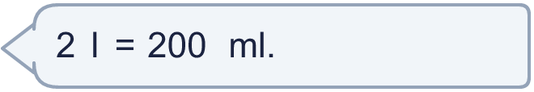
  9 | Is Boba correct? Circle yes or no.  Yes / No  Explain how you know.
  10 | Sam has two bottles. One holds 900 ml and the other holds 850 ml.  How much is that altogether? Write the answer in litres and millilitres.
  10 | Sam has two bottles. One holds 900 ml and the other holds 850 ml.  How much is that altogether? Write the answer in litres and millilitres.
  11 | Mia has a bottle of juice of 2 l 500 ml. Rosie has a bottle of juice of 1,200 ml.  a) Whose bottle of juice is greater?
    b) | How much more? Write the difference in millilitres.
    ml
  11 | Mia has a bottle of juice of 2 l 500 ml. Rosie has a bottle of juice of 1,200 ml.  a) Whose bottle of juice is greater?
    b) | How much more? Write the difference in millilitres.
    ml
  12 | Work out the calculations. Write each answer in the form shown.
    a) | 470 ml − 340 ml = |  | ml
    b) | 820 ml − 230 ml = |  | ml
  12 | Work out the calculations. Write each answer in the form shown.
    a) | 470 ml − 340 ml = |  | ml
    b) | 820 ml − 230 ml = |  | ml
  13 | Is Boba correct? Circle yes or no.  Yes / No  Explain how you know.
    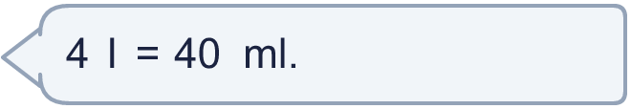
  13 | Is Boba correct? Circle yes or no.  Yes / No  Explain how you know.
  14 | A bottle holds 1 l 500 ml. Tom uses 350 ml.  How much is left? Write the answer in litres and millilitres.
  14 | A bottle holds 1 l 500 ml. Tom uses 350 ml.  How much is left? Write the answer in litres and millilitres.

Year 3 · Mass and capacity · Step 7
Measure capacity and volume in millilitres
Answers (teacher copy)

  1 | How much water is in each jug? Write the amount in millilitres.  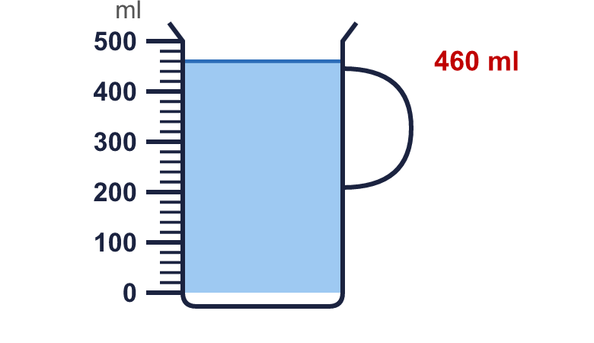  a) 460 ml  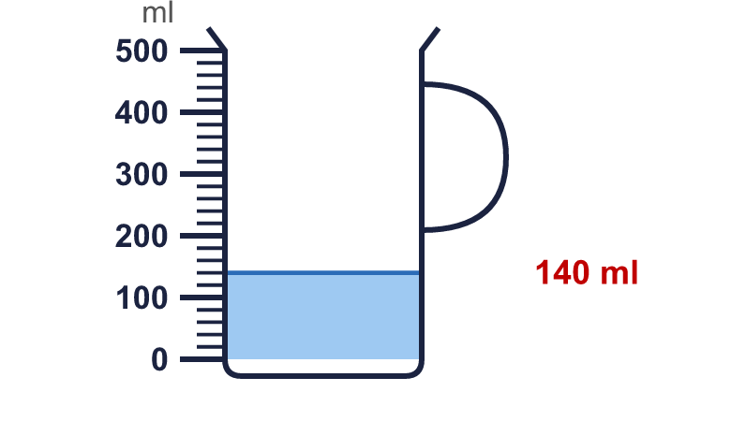  b) 140 ml
  2 | Which unit would you use to measure each? Write millilitres or litres.  a) a tube of glue millilitres  b) a paddling pool litres  c) a can of cola millilitres  d) a fish tank litres
  3 | Write the short form (abbreviation) for each unit.  a) millilitres ml  b) litres l
  4 | How much water is in each jug? Write the amount in millilitres.  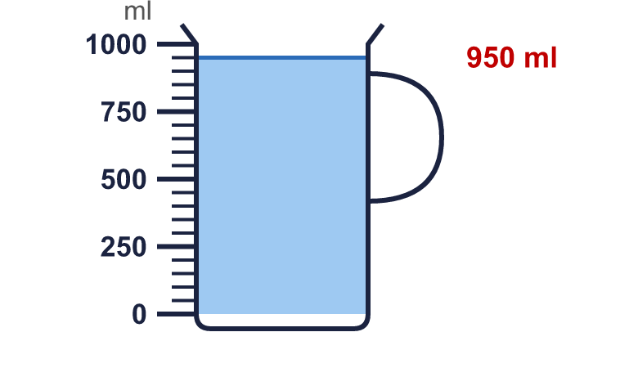  a) 950 ml
  5 | Write <, > or = in each box.  a) 2 l > 1,500 ml  b) 450 ml < 1 l  c) 2 l 100 ml > 2,010 ml
  6 | Work out the calculations. Write each answer in the form shown.  a) 120 ml + 860 ml = 0 l 980 ml  b) 810 ml + 390 ml = 1 l 200 ml  c) 470 ml + 790 ml = 1 l 260 ml
  7 | Write the capacities in order. Start with the smallest.  2 l 250 ml 2,100 ml 2 l 200 ml 950 ml  950 ml, 2,100 ml, 2 l 200 ml, 2 l 250 ml
  8 | Work out the calculations. Write each answer in the form shown.  a) 790 ml − 480 ml = 0 l 310 ml  b) 240 ml − 160 ml = 80 ml
  9 | Is Boba correct? Circle yes or no.  Yes / No  Explain how you know.  There are 1,000 millilitres in 1 litre, so 2 l = 2,000 ml, not 200 ml.
  10 | Sam has two bottles. One holds 900 ml and the other holds 850 ml.  How much is that altogether? Write the answer in litres and millilitres. 1 l 750 ml
  11 | Mia has a bottle of juice of 2 l 500 ml. Rosie has a bottle of juice of 1,200 ml.  a) Whose bottle of juice is greater? Mia  b) How much more? Write the difference in millilitres. 1,300 ml
  12 | Work out the calculations. Write each answer in the form shown.  a) 470 ml − 340 ml = 130 ml  b) 820 ml − 230 ml = 590 ml
  13 | Is Boba correct? Circle yes or no.  Yes / No  Explain how you know.  There are 1,000 millilitres in 1 litre, so 4 l = 4,000 ml, not 40 ml.
  14 | A bottle holds 1 l 500 ml. Tom uses 350 ml.  How much is left? Write the answer in litres and millilitres. 1 l 150 ml

