  Year 3 · Mass and capacity · Step 8  Measure capacity and volume in litres and millilitres | 
  Year 3 · Mass and capacity · Step 8
  Measure capacity and volume in litres and millilitres
  1 | How much water is in each jug? Write the amount in litres and millilitres.  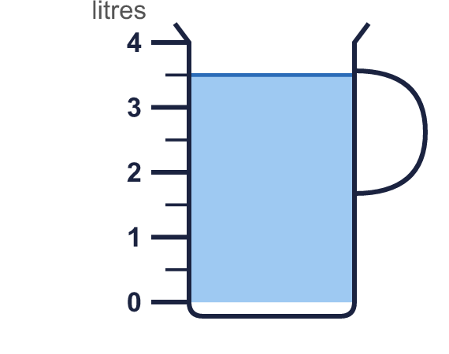  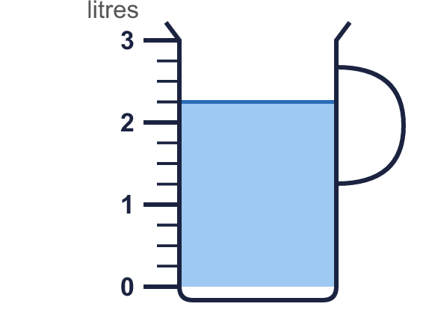
    a) |  | l |  | ml
    b) |  | l |  | ml
  1 | How much water is in each jug? Write the amount in litres and millilitres.
    a) |  | l |  | ml
    b) |  | l |  | ml
  2 | Complete the statements.
    a) | 7,050 ml = |  | l |  | ml
    b) | 4 l 50 ml = |  | ml
    c) | 7,500 ml = |  | l |  | ml
  2 | Complete the statements.
    a) | 7,050 ml = |  | l |  | ml
    b) | 4 l 50 ml = |  | ml
    c) | 7,500 ml = |  | l |  | ml
  3 | How much water is in each jug? Write the amount in litres.  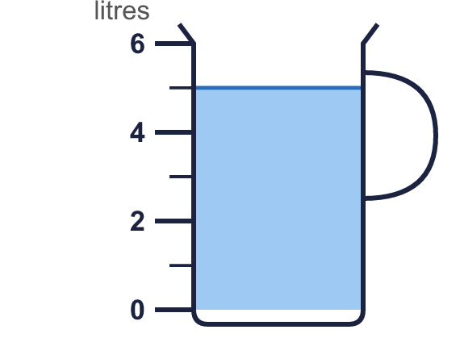
    a) |  | l
  3 | How much water is in each jug? Write the amount in litres.
    a) |  | l
  4 | There are 1,000 millilitres in 1 litre. Use this to complete the statements.
    a) | 4 l = |  | ml
    b) | 4,000 ml = |  | l
  4 | There are 1,000 millilitres in 1 litre. Use this to complete the statements.
    a) | 4 l = |  | ml
    b) | 4,000 ml = |  | l
  5 | Complete the statements.
    a) | 9,800 ml = |  | l |  | ml
    b) | 4,400 ml = |  | l |  | ml
    c) | 4,100 ml = |  | l |  | ml
  5 | Complete the statements.
    a) | 9,800 ml = |  | l |  | ml
    b) | 4,400 ml = |  | l |  | ml
    c) | 4,100 ml = |  | l |  | ml
  6 | Write <, > or = in each box.
    a) | 4 l |  | 3,900 ml
    b) | 2 l 50 ml |  | 2,500 ml
    c) | 2 l |  | 1,500 ml
  6 | Write <, > or = in each box.
    a) | 4 l |  | 3,900 ml
    b) | 2 l 50 ml |  | 2,500 ml
    c) | 2 l |  | 1,500 ml
  7 | How much water is in each jug? Write the amount in litres and millilitres.  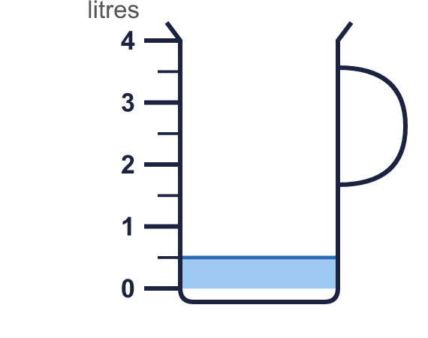
    a) |  | l |  | ml
  7 | How much water is in each jug? Write the amount in litres and millilitres.
    a) |  | l |  | ml
  8 | Write the capacities in order. Start with the smallest.  750 ml 3 l 500 ml 450 ml 1,100 ml
  8 | Write the capacities in order. Start with the smallest.  750 ml 3 l 500 ml 450 ml 1,100 ml

  9 | Is Boba correct? Circle yes or no.  Yes / No  Explain how you know.
     | 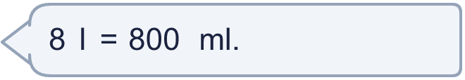
  9 | Is Boba correct? Circle yes or no.  Yes / No  Explain how you know.
  10 | Write the capacities in order. Start with the smallest.  3,600 ml 1,900 ml 3 l 200 ml 1,400 ml
  10 | Write the capacities in order. Start with the smallest.  3,600 ml 1,900 ml 3 l 200 ml 1,400 ml
  11 | Kim has a bottle of juice of 1 l 500 ml. Dora has a bottle of juice of 2,450 ml.  a) Whose bottle of juice is greater?
    b) | How much more? Write the difference in millilitres.
    ml
  11 | Kim has a bottle of juice of 1 l 500 ml. Dora has a bottle of juice of 2,450 ml.  a) Whose bottle of juice is greater?
    b) | How much more? Write the difference in millilitres.
    ml
  12 | Mia has two bottles. One holds 900 ml and the other holds 250 ml.  How much is that altogether? Write the answer in litres and millilitres.
  12 | Mia has two bottles. One holds 900 ml and the other holds 250 ml.  How much is that altogether? Write the answer in litres and millilitres.
  13 | Is Boba correct? Circle yes or no.  Yes / No  Explain how you know.
    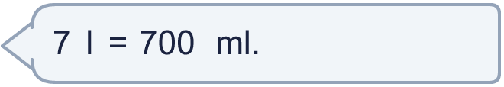
  13 | Is Boba correct? Circle yes or no.  Yes / No  Explain how you know.
  14 | Work out the calculations. Write each answer in the form shown.
    a) | 5 l 150 ml + 400 ml =
    b) | 2 l 800 ml + 700 ml =
  14 | Work out the calculations. Write each answer in the form shown.
    a) | 5 l 150 ml + 400 ml =
    b) | 2 l 800 ml + 700 ml =

Year 3 · Mass and capacity · Step 8
Measure capacity and volume in litres and millilitres
Answers (teacher copy)

  1 | How much water is in each jug? Write the amount in litres and millilitres.  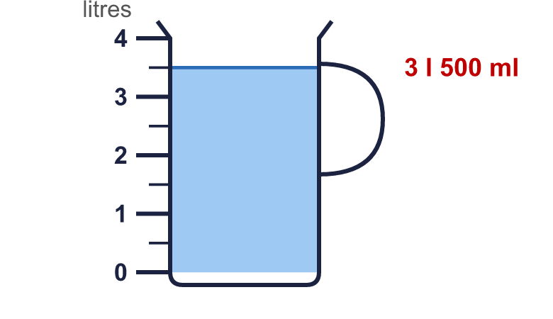  a) 3 l 500 ml  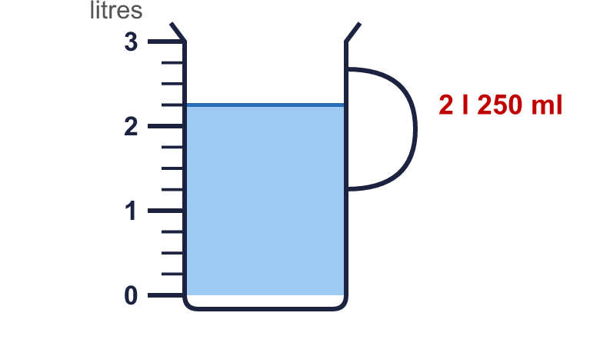  b) 2 l 250 ml
  2 | Complete the statements.  a) 7,050 ml = 7 l 50 ml  b) 4 l 50 ml = 4,050 ml  c) 7,500 ml = 7 l 500 ml
  3 | How much water is in each jug? Write the amount in litres.  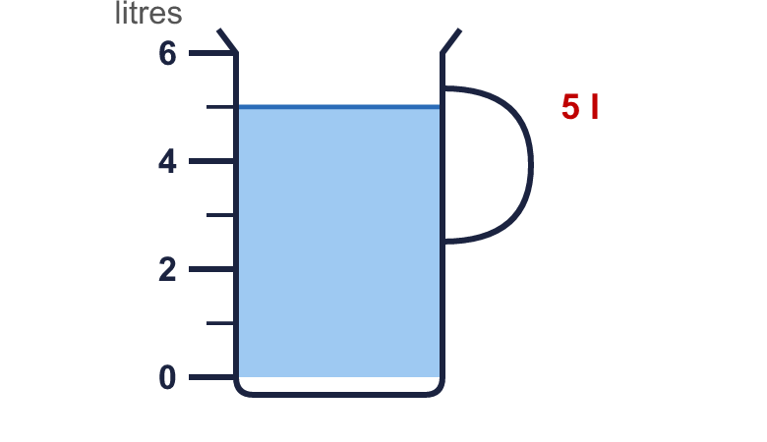  a) 5 l
  4 | There are 1,000 millilitres in 1 litre. Use this to complete the statements.  a) 4 l = 4,000 ml  b) 4,000 ml = 4 l
  5 | Complete the statements.  a) 9,800 ml = 9 l 800 ml  b) 4,400 ml = 4 l 400 ml  c) 4,100 ml = 4 l 100 ml
  6 | Write <, > or = in each box.  a) 4 l > 3,900 ml  b) 2 l 50 ml < 2,500 ml  c) 2 l > 1,500 ml
  7 | How much water is in each jug? Write the amount in litres and millilitres.  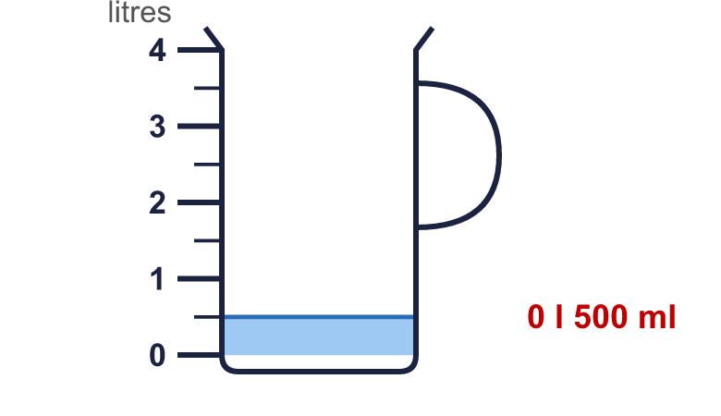  a) 0 l 500 ml
  8 | Write the capacities in order. Start with the smallest.  750 ml 3 l 500 ml 450 ml 1,100 ml  450 ml, 750 ml, 1,100 ml, 3 l 500 ml
  9 | Is Boba correct? Circle yes or no.  Yes / No  Explain how you know.  There are 1,000 millilitres in 1 litre, so 8 l = 8,000 ml, not 800 ml.
  10 | Write the capacities in order. Start with the smallest.  3,600 ml 1,900 ml 3 l 200 ml 1,400 ml  1,400 ml, 1,900 ml, 3 l 200 ml, 3,600 ml
  11 | Kim has a bottle of juice of 1 l 500 ml. Dora has a bottle of juice of 2,450 ml.  a) Whose bottle of juice is greater? Dora  b) How much more? Write the difference in millilitres. 950 ml
  12 | Mia has two bottles. One holds 900 ml and the other holds 250 ml.  How much is that altogether? Write the answer in litres and millilitres. 1 l 150 ml
  13 | Is Boba correct? Circle yes or no.  Yes / No  Explain how you know.  There are 1,000 millilitres in 1 litre, so 7 l = 7,000 ml, not 700 ml.
  14 | Work out the calculations. Write each answer in the form shown.  a) 5 l 150 ml + 400 ml = 5 l 550 ml  b) 2 l 800 ml + 700 ml = 3 l 500 ml

