  Year 3 · Length and perimeter · Step 10  What is perimeter | 
  Year 3 · Length and perimeter · Step 10
  What is perimeter
  1 | Count the lengths of the edges to work out the perimeter of the shape.  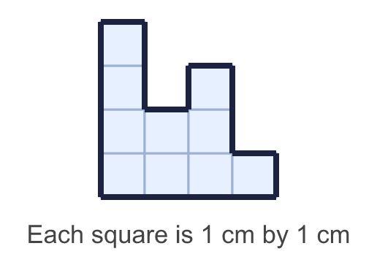
    Perimeter = |  | cm.
  1 | Count the lengths of the edges to work out the perimeter of the shape.
    Perimeter = |  | cm.
  2 | Work out the perimeter of the rectangle.  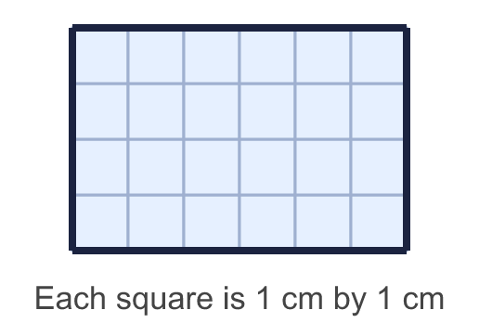
    Perimeter = |  | cm.
  2 | Work out the perimeter of the rectangle.
    Perimeter = |  | cm.
  3 | A rectangle is 11 cm long and 5 cm wide.
    Perimeter = |  | cm.
  3 | A rectangle is 11 cm long and 5 cm wide.
    Perimeter = |  | cm.
  4 | Count the lengths of the edges to work out the perimeter of the shape.  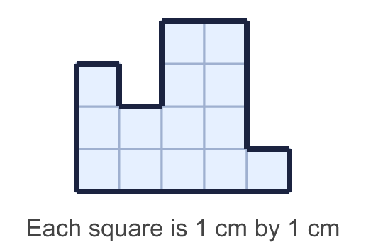
    Perimeter = |  | cm.
  4 | Count the lengths of the edges to work out the perimeter of the shape.
    Perimeter = |  | cm.
  5 | A square has a perimeter of 24 cm.
    Length of one side = |  | cm.
  5 | A square has a perimeter of 24 cm.
    Length of one side = |  | cm.
  6 | A rectangle is 15 cm long and 6 cm wide.
    Perimeter = |  | cm.
  6 | A rectangle is 15 cm long and 6 cm wide.
    Perimeter = |  | cm.
  7 | Work out the perimeter of the square.  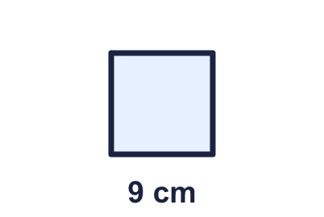
    Perimeter = |  | cm.
  7 | Work out the perimeter of the square.
    Perimeter = |  | cm.
  8 | This rectangle has a perimeter of 24 cm. Find the missing width.  
    Width = |  | cm.
  8 | This rectangle has a perimeter of 24 cm. Find the missing width.
    Width = |  | cm.

  9 | Rectangles have sides that are whole numbers of centimetres. A 2 cm by 5 cm rectangle is the same as a 5 cm by 2 cm rectangle.  How many different rectangles have a perimeter of 16 cm?
    rectangles
  9 | Rectangles have sides that are whole numbers of centimetres. A 2 cm by 5 cm rectangle is the same as a 5 cm by 2 cm rectangle.  How many different rectangles have a perimeter of 16 cm?
    rectangles
  10 | A rectangle is 11 cm long and 4 cm wide. Which calculations give its perimeter? Write the letters.  A: 11 × 4  B: 11 × 2 + 4 × 2  C: 11 × 4 × 2  D: 11 + 4  E: 2 × 11 + 2 × 4
  10 | A rectangle is 11 cm long and 4 cm wide. Which calculations give its perimeter? Write the letters.  A: 11 × 4  B: 11 × 2 + 4 × 2  C: 11 × 4 × 2  D: 11 + 4  E: 2 × 11 + 2 × 4
  11 | 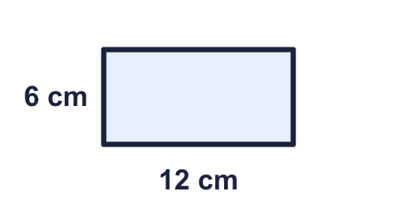  Is Sam correct? Circle yes or no.  Yes / No  Explain how you know.
     | 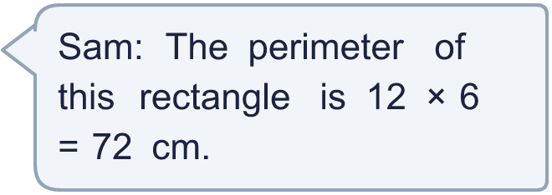
  11 | Is Sam correct? Circle yes or no.  Yes / No  Explain how you know.
  12 | Work out the perimeter of each shape. Which shape has the greater perimeter?  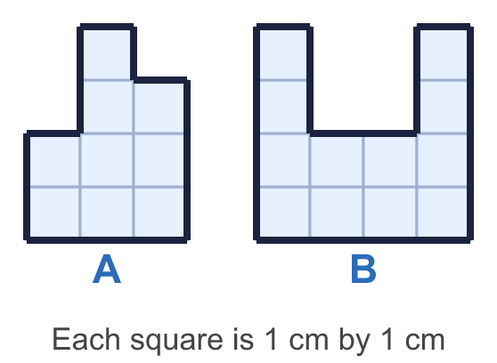
    a) Shape A: |  | cm.
    b) Shape B: |  | cm.
    Greater perimeter: shape
  12 | Work out the perimeter of each shape. Which shape has the greater perimeter?
    a) Shape A: |  | cm.
    b) Shape B: |  | cm.
    Greater perimeter: shape
  13 | Rectangles have sides that are whole numbers of centimetres. A 2 cm by 5 cm rectangle is the same as a 5 cm by 2 cm rectangle.  How many different rectangles have a perimeter of 12 cm?
    rectangles
  13 | Rectangles have sides that are whole numbers of centimetres. A 2 cm by 5 cm rectangle is the same as a 5 cm by 2 cm rectangle.  How many different rectangles have a perimeter of 12 cm?
    rectangles
  14 | 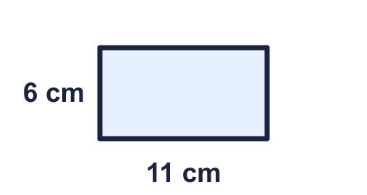  Is Ron correct? Circle yes or no.  Yes / No  Explain how you know.
    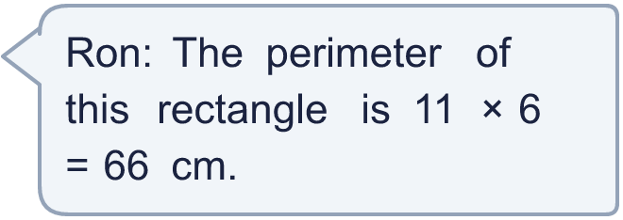
  14 | Is Ron correct? Circle yes or no.  Yes / No  Explain how you know.

Year 3 · Length and perimeter · Step 10
What is perimeter
Answers (teacher copy)

  1 | Count the lengths of the edges to work out the perimeter of the shape.  Perimeter = 18 cm.
  2 | Work out the perimeter of the rectangle.  Perimeter = 20 cm.
  3 | A rectangle is 11 cm long and 5 cm wide.  Perimeter = 32 cm.
  4 | Count the lengths of the edges to work out the perimeter of the shape.  Perimeter = 20 cm.
  5 | A square has a perimeter of 24 cm.  Length of one side = 6 cm.
  6 | A rectangle is 15 cm long and 6 cm wide.  Perimeter = 42 cm.
  7 | Work out the perimeter of the square.  Perimeter = 36 cm.
  8 | This rectangle has a perimeter of 24 cm. Find the missing width.  Width = 3 cm.
  9 | Rectangles have sides that are whole numbers of centimetres. A 2 cm by 5 cm rectangle is the same as a 5 cm by 2 cm rectangle.  How many different rectangles have a perimeter of 16 cm?  4 rectangles
  10 | A rectangle is 11 cm long and 4 cm wide. Which calculations give its perimeter? Write the letters.  A: 11 × 4  B: 11 × 2 + 4 × 2  C: 11 × 4 × 2  D: 11 + 4  E: 2 × 11 + 2 × 4  B, E
  11 | Is Sam correct? Circle yes or no.  Yes / No  Explain how you know.  No. 12 × 6 = 72 is the area, not the perimeter. The perimeter is 12 + 6 + 12 + 6 = 36 cm.
  12 | Work out the perimeter of each shape. Which shape has the greater perimeter?  a) Shape A: 14 cm.  b) Shape B: 20 cm.  Greater perimeter: shape B
  13 | Rectangles have sides that are whole numbers of centimetres. A 2 cm by 5 cm rectangle is the same as a 5 cm by 2 cm rectangle.  How many different rectangles have a perimeter of 12 cm?  3 rectangles
  14 | Is Ron correct? Circle yes or no.  Yes / No  Explain how you know.  No. 11 × 6 = 66 is the area, not the perimeter. The perimeter is 11 + 6 + 11 + 6 = 34 cm.

