  Year 3 · Length and perimeter · Step 4  Metres, centimetres and millimetres | 
  Year 3 · Length and perimeter · Step 4
  Metres, centimetres and millimetres
  1 | Which unit would you use to measure each? Write metres, centimetres or millimetres.
    a) | the height of a tree
    b) | the length of a crayon
    c) | the thickness of a coin
  1 | Which unit would you use to measure each? Write metres, centimetres or millimetres.
    a) | the height of a tree
    b) | the length of a crayon
    c) | the thickness of a coin
  2 | Write the short form (abbreviation) for each unit.
    a) | millimetres
    b) | centimetres
    c) | metres
  2 | Write the short form (abbreviation) for each unit.
    a) | millimetres
    b) | centimetres
    c) | metres
  3 | Which unit would you use to measure each? Write metres, centimetres or millimetres.
    a) | the length of an ant
    b) | the width of a door
    c) | the length of a school hall
  3 | Which unit would you use to measure each? Write metres, centimetres or millimetres.
    a) | the length of an ant
    b) | the width of a door
    c) | the length of a school hall
  4 | Complete the statements.
    a) | 3 m = |  | cm
    b) | 5 cm = |  | mm
    c) | 900 cm = |  | m
  4 | Complete the statements.
    a) | 3 m = |  | cm
    b) | 5 cm = |  | mm
    c) | 900 cm = |  | m
  5 | Write <, > or = in each box.
    a) | 1 cm |  | 1 m
    b) | 50 cm |  | 500 mm
    c) | 2 m |  | 250 cm
  5 | Write <, > or = in each box.
    a) | 1 cm |  | 1 m
    b) | 50 cm |  | 500 mm
    c) | 2 m |  | 250 cm
  6 | Complete the statements.
    a) | 70 mm = |  | cm
    b) | 900 cm = |  | m
  6 | Complete the statements.
    a) | 70 mm = |  | cm
    b) | 900 cm = |  | m
  7 | Use the ruler to measure each line.  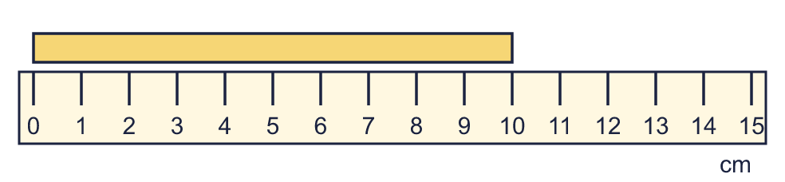
    a) | The line is |  | cm long.
  7 | Use the ruler to measure each line.
    a) | The line is |  | cm long.
  8 | Write <, > or = in each box.
    a) | 2 m |  | 150 cm
    b) | 1 m 50 cm |  | 115 cm
  8 | Write <, > or = in each box.
    a) | 2 m |  | 150 cm
    b) | 1 m 50 cm |  | 115 cm

  9 | Is Boba correct? Circle yes or no.  Yes / No  Explain how you know.
     | 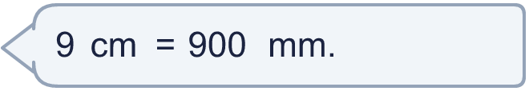
  9 | Is Boba correct? Circle yes or no.  Yes / No  Explain how you know.
  10 | Write the lengths in order. Start with the shortest.  135 cm 326 cm 168 cm 2 m 87 cm
  10 | Write the lengths in order. Start with the shortest.  135 cm 326 cm 168 cm 2 m 87 cm
  11 | Write the lengths in order. Start with the shortest.  6 cm 4 mm 141 mm 16 cm 8 mm 11 cm 3 mm
  11 | Write the lengths in order. Start with the shortest.  6 cm 4 mm 141 mm 16 cm 8 mm 11 cm 3 mm
  12 | Dora is 107 cm tall. Mia is 25 cm taller than Dora.  How tall is Mia? Write the answer in m and cm.
  12 | Dora is 107 cm tall. Mia is 25 cm taller than Dora.  How tall is Mia? Write the answer in m and cm.
  13 | Is Boba correct? Circle yes or no.  Yes / No  Explain how you know.
    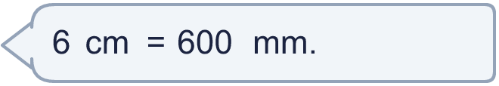
  13 | Is Boba correct? Circle yes or no.  Yes / No  Explain how you know.
  14 | Nina is 1 m 10 cm tall. Dora is 114 cm tall.  a) Who is taller?
    b) | How much taller? Write the difference in centimetres.
    cm
  14 | Nina is 1 m 10 cm tall. Dora is 114 cm tall.  a) Who is taller?
    b) | How much taller? Write the difference in centimetres.
    cm

Year 3 · Length and perimeter · Step 4
Metres, centimetres and millimetres
Answers (teacher copy)

  1 | Which unit would you use to measure each? Write metres, centimetres or millimetres.  a) the height of a tree metres  b) the length of a crayon centimetres  c) the thickness of a coin millimetres
  2 | Write the short form (abbreviation) for each unit.  a) millimetres mm  b) centimetres cm  c) metres m
  3 | Which unit would you use to measure each? Write metres, centimetres or millimetres.  a) the length of an ant millimetres  b) the width of a door centimetres  c) the length of a school hall metres
  4 | Complete the statements.  a) 3 m = 300 cm  b) 5 cm = 50 mm  c) 900 cm = 9 m
  5 | Write <, > or = in each box.  a) 1 cm < 1 m  b) 50 cm = 500 mm  c) 2 m < 250 cm
  6 | Complete the statements.  a) 70 mm = 7 cm  b) 900 cm = 9 m
  7 | Use the ruler to measure each line.  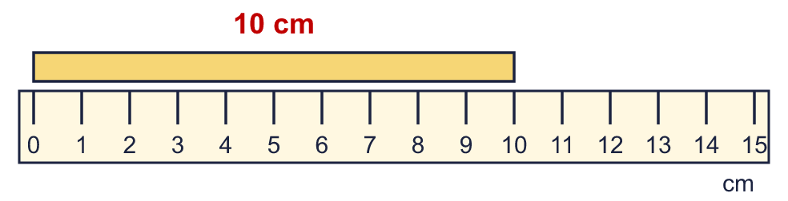  a) The line is 10 cm long.
  8 | Write <, > or = in each box.  a) 2 m > 150 cm  b) 1 m 50 cm > 115 cm
  9 | Is Boba correct? Circle yes or no.  Yes / No  Explain how you know.  There are 10 millimetres in 1 centimetre, so 9 cm = 90 mm, not 900 mm.
  10 | Write the lengths in order. Start with the shortest.  135 cm 326 cm 168 cm 2 m 87 cm  135 cm, 168 cm, 2 m 87 cm, 326 cm
  11 | Write the lengths in order. Start with the shortest.  6 cm 4 mm 141 mm 16 cm 8 mm 11 cm 3 mm  6 cm 4 mm, 11 cm 3 mm, 141 mm, 16 cm 8 mm
  12 | Dora is 107 cm tall. Mia is 25 cm taller than Dora.  How tall is Mia? Write the answer in m and cm. 1 m 32 cm
  13 | Is Boba correct? Circle yes or no.  Yes / No  Explain how you know.  There are 10 millimetres in 1 centimetre, so 6 cm = 60 mm, not 600 mm.
  14 | Nina is 1 m 10 cm tall. Dora is 114 cm tall.  a) Who is taller? Dora  b) How much taller? Write the difference in centimetres. 4 cm

