  Year 3 · Length and perimeter · Step 11  Measure perimeter | 
  Year 3 · Length and perimeter · Step 11
  Measure perimeter
  1 | Use the ruler to measure each line.  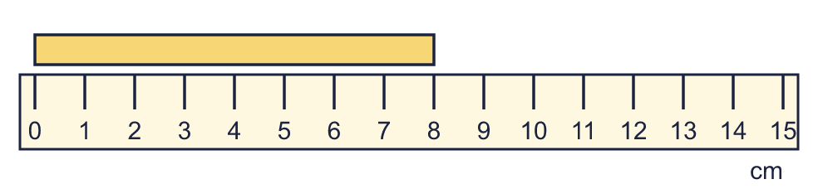  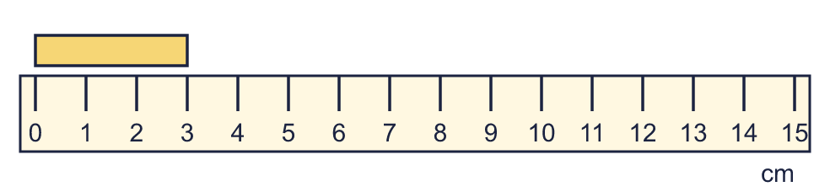
    a) | The line is |  | cm long.
    b) | The line is |  | cm long.
  1 | Use the ruler to measure each line.
    a) | The line is |  | cm long.
    b) | The line is |  | cm long.
  2 | Work out the perimeter of the rectangle.  
    Perimeter = |  | cm.
  2 | Work out the perimeter of the rectangle.
    Perimeter = |  | cm.
  3 | Use the ruler to measure each line.  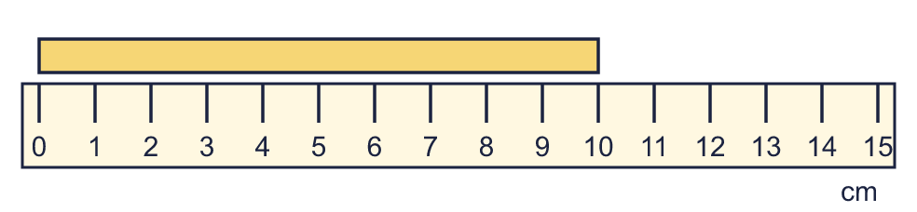
    a) | The line is |  | cm long.
  3 | Use the ruler to measure each line.
    a) | The line is |  | cm long.
  4 | A rectangle is 10 cm long and 6 cm wide.
    Perimeter = |  | cm.
  4 | A rectangle is 10 cm long and 6 cm wide.
    Perimeter = |  | cm.
  5 | A square has a perimeter of 16 cm.
    Length of one side = |  | cm.
  5 | A square has a perimeter of 16 cm.
    Length of one side = |  | cm.
  6 | A rectangle is 12 cm long and 5 cm wide.
    Perimeter = |  | cm.
  6 | A rectangle is 12 cm long and 5 cm wide.
    Perimeter = |  | cm.
  7 | Work out the perimeter of the rectangle.
    Perimeter = |  | cm.
  7 | Work out the perimeter of the rectangle.
    Perimeter = |  | cm.
  8 | A square has a perimeter of 32 cm.
    Length of one side = |  | cm.
  8 | A square has a perimeter of 32 cm.
    Length of one side = |  | cm.

  9 | 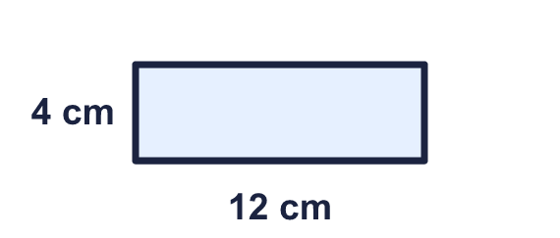  Is Mia correct? Circle yes or no.  Yes / No  Explain how you know.
     | 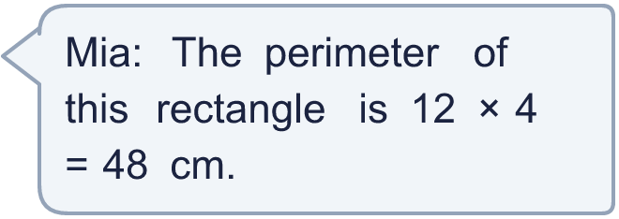
  9 | Is Mia correct? Circle yes or no.  Yes / No  Explain how you know.
  10 | A rectangle is 9 cm long and 5 cm wide. Which calculations give its perimeter? Write the letters.  A: 9 + 5  B: 4 × 9  C: 2 × 9 + 5  D: 2 × 9 + 2 × 5  E: 9 + 5 + 9 + 5
  10 | A rectangle is 9 cm long and 5 cm wide. Which calculations give its perimeter? Write the letters.  A: 9 + 5  B: 4 × 9  C: 2 × 9 + 5  D: 2 × 9 + 2 × 5  E: 9 + 5 + 9 + 5
  11 | Rectangles have sides that are whole numbers of centimetres. A 2 cm by 5 cm rectangle is the same as a 5 cm by 2 cm rectangle.  How many different rectangles have a perimeter of 14 cm?
    rectangles
  11 | Rectangles have sides that are whole numbers of centimetres. A 2 cm by 5 cm rectangle is the same as a 5 cm by 2 cm rectangle.  How many different rectangles have a perimeter of 14 cm?
    rectangles
  12 | Work out the perimeter of each shape. Which shape has the greater perimeter?  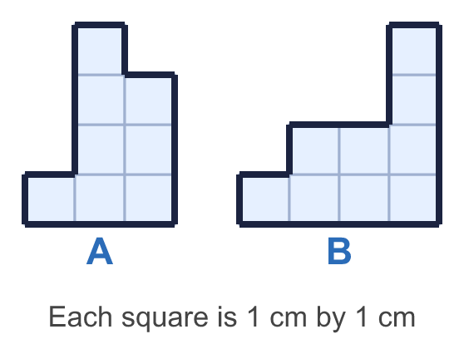
    a) Shape A: |  | cm.
    b) Shape B: |  | cm.
    Greater perimeter: shape
  12 | Work out the perimeter of each shape. Which shape has the greater perimeter?
    a) Shape A: |  | cm.
    b) Shape B: |  | cm.
    Greater perimeter: shape
  13 | 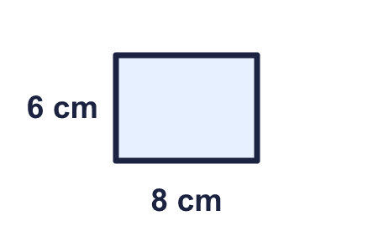  Is Amir correct? Circle yes or no.  Yes / No  Explain how you know.
    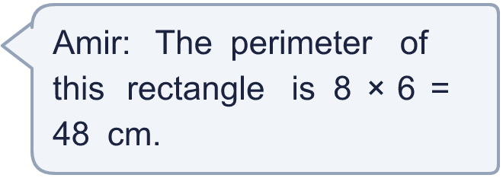
  13 | Is Amir correct? Circle yes or no.  Yes / No  Explain how you know.
  14 | Rectangles have sides that are whole numbers of centimetres. A 2 cm by 5 cm rectangle is the same as a 5 cm by 2 cm rectangle.  How many different rectangles have a perimeter of 12 cm?
    rectangles
  14 | Rectangles have sides that are whole numbers of centimetres. A 2 cm by 5 cm rectangle is the same as a 5 cm by 2 cm rectangle.  How many different rectangles have a perimeter of 12 cm?
    rectangles

Year 3 · Length and perimeter · Step 11
Measure perimeter
Answers (teacher copy)

  1 | Use the ruler to measure each line.  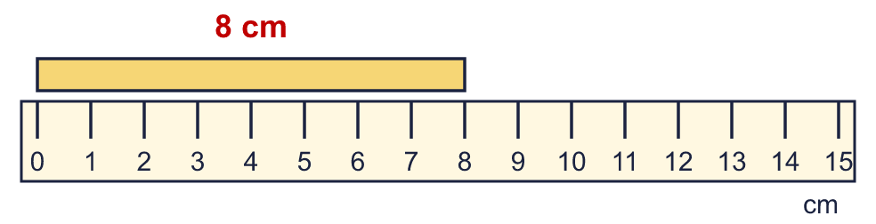  a) The line is 8 cm long.  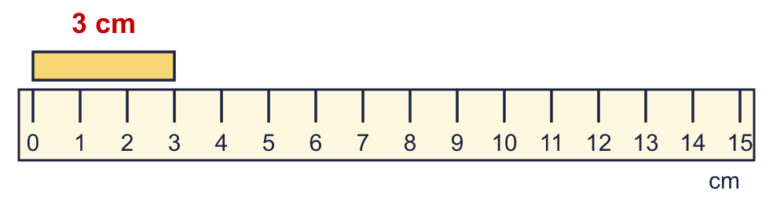  b) The line is 3 cm long.
  2 | Work out the perimeter of the rectangle.  Perimeter = 26 cm.
  3 | Use the ruler to measure each line.  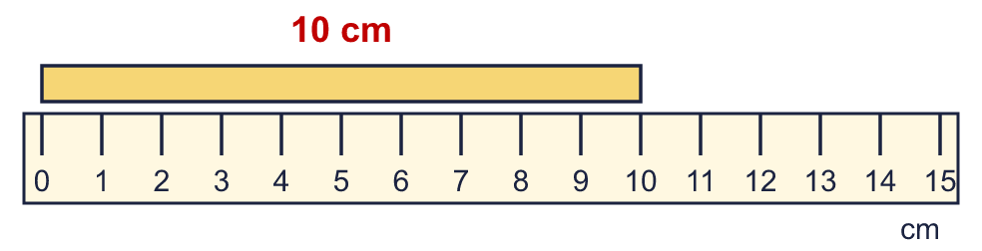  a) The line is 10 cm long.
  4 | A rectangle is 10 cm long and 6 cm wide.  Perimeter = 32 cm.
  5 | A square has a perimeter of 16 cm.  Length of one side = 4 cm.
  6 | A rectangle is 12 cm long and 5 cm wide.  Perimeter = 34 cm.
  7 | Work out the perimeter of the rectangle.  Perimeter = 26 cm.
  8 | A square has a perimeter of 32 cm.  Length of one side = 8 cm.
  9 | Is Mia correct? Circle yes or no.  Yes / No  Explain how you know.  No. 12 × 4 = 48 is the area, not the perimeter. The perimeter is 12 + 4 + 12 + 4 = 32 cm.
  10 | A rectangle is 9 cm long and 5 cm wide. Which calculations give its perimeter? Write the letters.  A: 9 + 5  B: 4 × 9  C: 2 × 9 + 5  D: 2 × 9 + 2 × 5  E: 9 + 5 + 9 + 5  D, E
  11 | Rectangles have sides that are whole numbers of centimetres. A 2 cm by 5 cm rectangle is the same as a 5 cm by 2 cm rectangle.  How many different rectangles have a perimeter of 14 cm?  3 rectangles
  12 | Work out the perimeter of each shape. Which shape has the greater perimeter?  a) Shape A: 14 cm.  b) Shape B: 16 cm.  Greater perimeter: shape B
  13 | Is Amir correct? Circle yes or no.  Yes / No  Explain how you know.  No. 8 × 6 = 48 is the area, not the perimeter. The perimeter is 8 + 6 + 8 + 6 = 28 cm.
  14 | Rectangles have sides that are whole numbers of centimetres. A 2 cm by 5 cm rectangle is the same as a 5 cm by 2 cm rectangle.  How many different rectangles have a perimeter of 12 cm?  3 rectangles

