  Year 3 · Length and perimeter · Step 2  Measure in millimetres | 
  Year 3 · Length and perimeter · Step 2
  Measure in millimetres
  1 | How long is each line in millimetres?  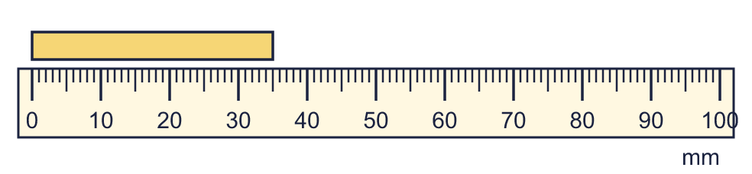  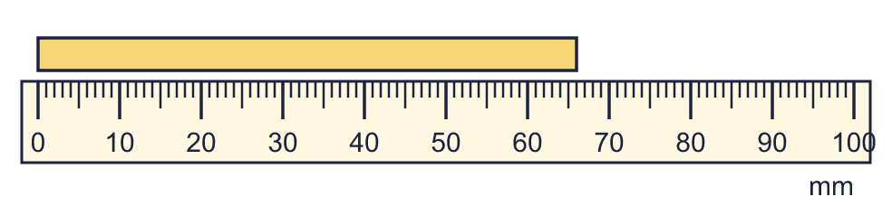
    a) | The line is |  | mm long.
    b) | The line is |  | mm long.
  1 | How long is each line in millimetres?
    a) | The line is |  | mm long.
    b) | The line is |  | mm long.
  2 | Which unit would you use to measure each? Write metres, centimetres or millimetres.
    a) | the height of a mug
    b) | the width of a stamp
    c) | the length of a football pitch
  2 | Which unit would you use to measure each? Write metres, centimetres or millimetres.
    a) | the height of a mug
    b) | the width of a stamp
    c) | the length of a football pitch
  3 | How long is each line in millimetres?  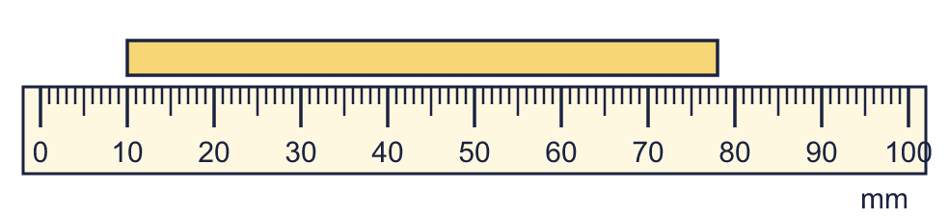
    a) | The line is |  | mm long.
  3 | How long is each line in millimetres?
    a) | The line is |  | mm long.
  4 | Write the short form (abbreviation) for each unit.
    a) | millimetres
    b) | metres
    c) | centimetres
  4 | Write the short form (abbreviation) for each unit.
    a) | millimetres
    b) | metres
    c) | centimetres
  5 | Complete the statements.
    a) | 2 cm = |  | mm
    b) | 8 cm = |  | mm
    c) | 5 cm = |  | mm
  5 | Complete the statements.
    a) | 2 cm = |  | mm
    b) | 8 cm = |  | mm
    c) | 5 cm = |  | mm
  6 | Complete the statements.
    a) | 60 mm = |  | cm
    b) | 30 mm = |  | cm
    c) | 50 mm = |  | cm
  6 | Complete the statements.
    a) | 60 mm = |  | cm
    b) | 30 mm = |  | cm
    c) | 50 mm = |  | cm
  7 | Write <, > or = in each box.
    a) | 100 mm |  | 1 cm
    b) | 12 cm |  | 120 mm
  7 | Write <, > or = in each box.
    a) | 100 mm |  | 1 cm
    b) | 12 cm |  | 120 mm
  8 | There are 10 millimetres in 1 centimetre. Use this to complete the statements.
    a) | 6 cm = |  | mm
    b) | 60 mm = |  | cm
  8 | There are 10 millimetres in 1 centimetre. Use this to complete the statements.
    a) | 6 cm = |  | mm
    b) | 60 mm = |  | cm

  9 | Is Boba correct? Circle yes or no.  Yes / No  Explain how you know.
     | 
  9 | Is Boba correct? Circle yes or no.  Yes / No  Explain how you know.
  10 | Write the lengths in order. Start with the shortest.  177 mm 131 mm 77 mm 94 mm
  10 | Write the lengths in order. Start with the shortest.  177 mm 131 mm 77 mm 94 mm
  11 | Work out the calculations. Write each answer in the form shown.
    a) | 63 mm + 73 mm = |  | mm
    b) | 38 mm + 16 mm =
  11 | Work out the calculations. Write each answer in the form shown.
    a) | 63 mm + 73 mm = |  | mm
    b) | 38 mm + 16 mm =
  12 | Write <, > or = in each box.
    a) | 2 cm |  | 25 mm
    b) | 7 cm 2 mm |  | 70 mm
    c) | 3 cm 5 mm |  | 40 mm
  12 | Write <, > or = in each box.
    a) | 2 cm |  | 25 mm
    b) | 7 cm 2 mm |  | 70 mm
    c) | 3 cm 5 mm |  | 40 mm
  13 | Is Boba correct? Circle yes or no.  Yes / No  Explain how you know.
    
  13 | Is Boba correct? Circle yes or no.  Yes / No  Explain how you know.
  14 | Work out the calculations. Write each answer in the form shown.
    a) | 119 mm − 75 mm = |  | mm
    b) | 81 mm − 19 mm = |  | mm
  14 | Work out the calculations. Write each answer in the form shown.
    a) | 119 mm − 75 mm = |  | mm
    b) | 81 mm − 19 mm = |  | mm

Year 3 · Length and perimeter · Step 2
Measure in millimetres
Answers (teacher copy)

  1 | How long is each line in millimetres?  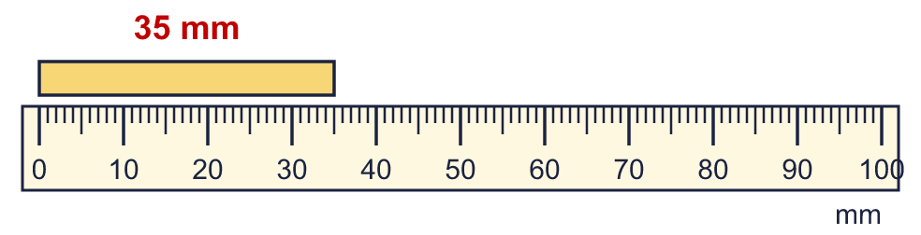  a) The line is 35 mm long.  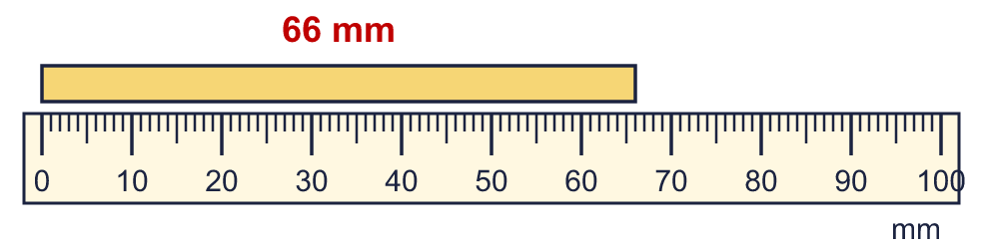  b) The line is 66 mm long.
  2 | Which unit would you use to measure each? Write metres, centimetres or millimetres.  a) the height of a mug centimetres  b) the width of a stamp millimetres  c) the length of a football pitch metres
  3 | How long is each line in millimetres?  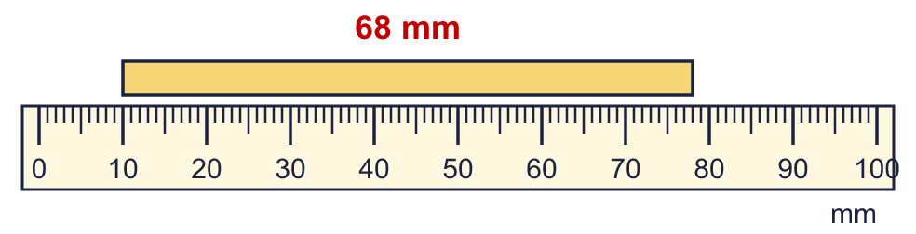  a) The line is 68 mm long.
  4 | Write the short form (abbreviation) for each unit.  a) millimetres mm  b) metres m  c) centimetres cm
  5 | Complete the statements.  a) 2 cm = 20 mm  b) 8 cm = 80 mm  c) 5 cm = 50 mm
  6 | Complete the statements.  a) 60 mm = 6 cm  b) 30 mm = 3 cm  c) 50 mm = 5 cm
  7 | Write <, > or = in each box.  a) 100 mm > 1 cm  b) 12 cm = 120 mm
  8 | There are 10 millimetres in 1 centimetre. Use this to complete the statements.  a) 6 cm = 60 mm  b) 60 mm = 6 cm
  9 | Is Boba correct? Circle yes or no.  Yes / No  Explain how you know.  There are 100 centimetres in 1 metre, so 6 m = 600 cm, not 60 cm.
  10 | Write the lengths in order. Start with the shortest.  177 mm 131 mm 77 mm 94 mm  77 mm, 94 mm, 131 mm, 177 mm
  11 | Work out the calculations. Write each answer in the form shown.  a) 63 mm + 73 mm = 136 mm  b) 38 mm + 16 mm = 5 cm 4 mm
  12 | Write <, > or = in each box.  a) 2 cm < 25 mm  b) 7 cm 2 mm > 70 mm  c) 3 cm 5 mm < 40 mm
  13 | Is Boba correct? Circle yes or no.  Yes / No  Explain how you know.  There are 100 centimetres in 1 metre, so 4 m = 400 cm, not 40 cm.
  14 | Work out the calculations. Write each answer in the form shown.  a) 119 mm − 75 mm = 44 mm  b) 81 mm − 19 mm = 62 mm

