  Year 3 · Length and perimeter · Step 1  Measure in metres and centimetres | 
  Year 3 · Length and perimeter · Step 1
  Measure in metres and centimetres
  1 | Use the ruler to measure each line.  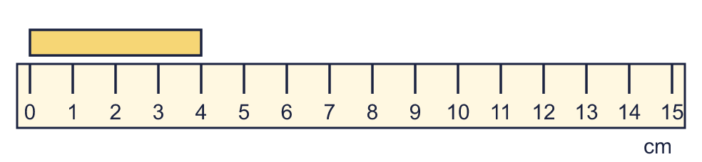  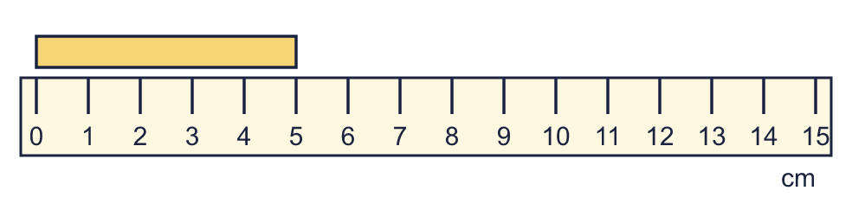
    a) | The line is |  | cm long.
    b) | The line is |  | cm long.
  1 | Use the ruler to measure each line.
    a) | The line is |  | cm long.
    b) | The line is |  | cm long.
  2 | Which unit would you use to measure each? Write metres, centimetres or millimetres.
    a) | the length of a pencil sharpener
    b) | the length of a football pitch
    c) | the length of a hand
  2 | Which unit would you use to measure each? Write metres, centimetres or millimetres.
    a) | the length of a pencil sharpener
    b) | the length of a football pitch
    c) | the length of a hand
  3 | Use the ruler to measure each line.  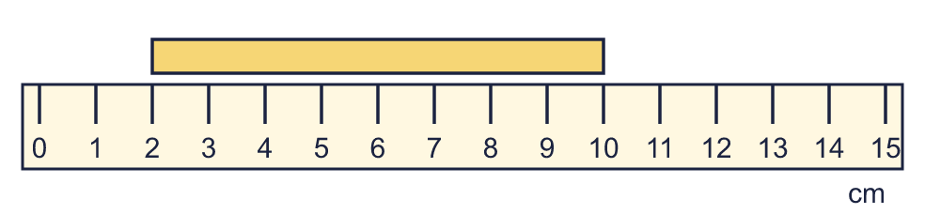
    a) | The line is |  | cm long.
  3 | Use the ruler to measure each line.
    a) | The line is |  | cm long.
  4 | Write the short form (abbreviation) for each unit.
    a) | millimetres
    b) | metres
    c) | centimetres
  4 | Write the short form (abbreviation) for each unit.
    a) | millimetres
    b) | metres
    c) | centimetres
  5 | Complete the statements.
    a) | 5 m = |  | cm
    b) | 8 m = |  | cm
    c) | 3 m = |  | cm
  5 | Complete the statements.
    a) | 5 m = |  | cm
    b) | 8 m = |  | cm
    c) | 3 m = |  | cm
  6 | Complete the statements.
    a) | 800 cm = |  | m
    b) | 200 cm = |  | m
    c) | 400 cm = |  | m
  6 | Complete the statements.
    a) | 800 cm = |  | m
    b) | 200 cm = |  | m
    c) | 400 cm = |  | m
  7 | Write <, > or = in each box.
    a) | 1 m 5 cm |  | 1 m 50 cm
    b) | 2 m |  | 150 cm
  7 | Write <, > or = in each box.
    a) | 1 m 5 cm |  | 1 m 50 cm
    b) | 2 m |  | 150 cm
  8 | There are 100 centimetres in 1 metre. Use this to complete the statements.
    a) | 5 m = |  | cm
    b) | 500 cm = |  | m
  8 | There are 100 centimetres in 1 metre. Use this to complete the statements.
    a) | 5 m = |  | cm
    b) | 500 cm = |  | m

  9 | Is Boba correct? Circle yes or no.  Yes / No  Explain how you know.
     | 
  9 | Is Boba correct? Circle yes or no.  Yes / No  Explain how you know.
  10 | Write the lengths in order. Start with the shortest.  355 cm 1 m 17 cm 2 m 31 cm 343 cm
  10 | Write the lengths in order. Start with the shortest.  355 cm 1 m 17 cm 2 m 31 cm 343 cm
  11 | Tia is 95 cm tall. Sam is 21 cm taller than Tia.  How tall is Sam? Write the answer in m and cm.
  11 | Tia is 95 cm tall. Sam is 21 cm taller than Tia.  How tall is Sam? Write the answer in m and cm.
  12 | Kim is 1 m 20 cm tall. Tia is 129 cm tall.  a) Who is taller?
    b) | How much taller? Write the difference in centimetres.
    cm
  12 | Kim is 1 m 20 cm tall. Tia is 129 cm tall.  a) Who is taller?
    b) | How much taller? Write the difference in centimetres.
    cm
  13 | Write <, > or = in each box.
    a) | 2 m 5 cm |  | 205 cm
    b) | 2 m |  | 150 cm
    c) | 1 m 50 cm |  | 115 cm
  13 | Write <, > or = in each box.
    a) | 2 m 5 cm |  | 205 cm
    b) | 2 m |  | 150 cm
    c) | 1 m 50 cm |  | 115 cm
  14 | Is Boba correct? Circle yes or no.  Yes / No  Explain how you know.
    
  14 | Is Boba correct? Circle yes or no.  Yes / No  Explain how you know.

Year 3 · Length and perimeter · Step 1
Measure in metres and centimetres
Answers (teacher copy)

  1 | Use the ruler to measure each line.  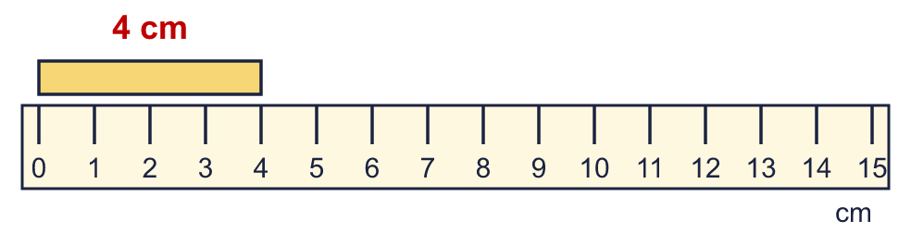  a) The line is 4 cm long.  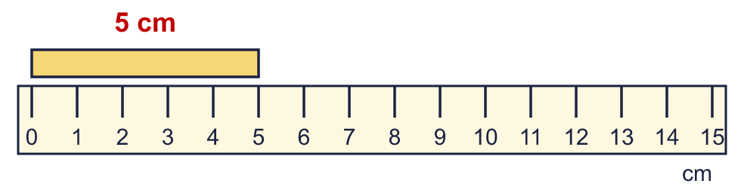  b) The line is 5 cm long.
  2 | Which unit would you use to measure each? Write metres, centimetres or millimetres.  a) the length of a pencil sharpener millimetres  b) the length of a football pitch metres  c) the length of a hand centimetres
  3 | Use the ruler to measure each line.  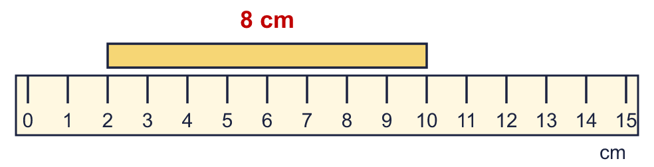  a) The line is 8 cm long.
  4 | Write the short form (abbreviation) for each unit.  a) millimetres mm  b) metres m  c) centimetres cm
  5 | Complete the statements.  a) 5 m = 500 cm  b) 8 m = 800 cm  c) 3 m = 300 cm
  6 | Complete the statements.  a) 800 cm = 8 m  b) 200 cm = 2 m  c) 400 cm = 4 m
  7 | Write <, > or = in each box.  a) 1 m 5 cm < 1 m 50 cm  b) 2 m > 150 cm
  8 | There are 100 centimetres in 1 metre. Use this to complete the statements.  a) 5 m = 500 cm  b) 500 cm = 5 m
  9 | Is Boba correct? Circle yes or no.  Yes / No  Explain how you know.  There are 100 centimetres in 1 metre, so 2 m = 200 cm, not 20 cm.
  10 | Write the lengths in order. Start with the shortest.  355 cm 1 m 17 cm 2 m 31 cm 343 cm  1 m 17 cm, 2 m 31 cm, 343 cm, 355 cm
  11 | Tia is 95 cm tall. Sam is 21 cm taller than Tia.  How tall is Sam? Write the answer in m and cm. 1 m 16 cm
  12 | Kim is 1 m 20 cm tall. Tia is 129 cm tall.  a) Who is taller? Tia  b) How much taller? Write the difference in centimetres. 9 cm
  13 | Write <, > or = in each box.  a) 2 m 5 cm = 205 cm  b) 2 m > 150 cm  c) 1 m 50 cm > 115 cm
  14 | Is Boba correct? Circle yes or no.  Yes / No  Explain how you know.  There are 100 centimetres in 1 metre, so 5 m = 500 cm, not 50 cm.

