  Year 3 · Length and perimeter · Step 3  Measure in centimetres and millimetres | 
  Year 3 · Length and perimeter · Step 3
  Measure in centimetres and millimetres
  1 | How long is each line? Write it in centimetres and millimetres.  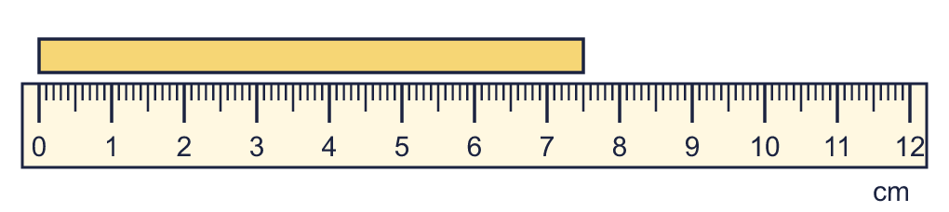  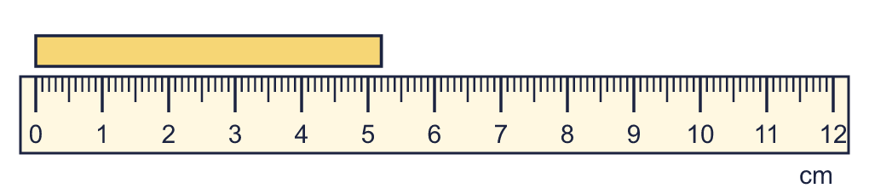
    a) |  | cm and |  | mm
    b) |  | cm and |  | mm
  1 | How long is each line? Write it in centimetres and millimetres.
    a) |  | cm and |  | mm
    b) |  | cm and |  | mm
  2 | Complete the statements.
    a) | 5 cm 6 mm = |  | mm
    b) | 2 cm 2 mm = |  | mm
    c) | 2 cm 5 mm = |  | mm
  2 | Complete the statements.
    a) | 5 cm 6 mm = |  | mm
    b) | 2 cm 2 mm = |  | mm
    c) | 2 cm 5 mm = |  | mm
  3 | How long is each line? Write it in centimetres and millimetres.  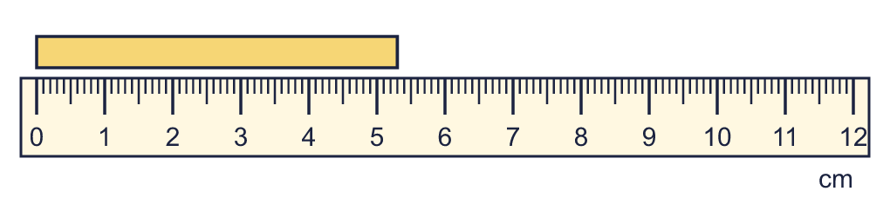
    a) |  | cm and |  | mm
  3 | How long is each line? Write it in centimetres and millimetres.
    a) |  | cm and |  | mm
  4 | There are 10 millimetres in 1 centimetre. Use this to complete the statements.
    a) | 6 cm = |  | mm
    b) | 60 mm = |  | cm
  4 | There are 10 millimetres in 1 centimetre. Use this to complete the statements.
    a) | 6 cm = |  | mm
    b) | 60 mm = |  | cm
  5 | Complete the statements.
    a) | 2 cm = |  | mm
    b) | 9 cm = |  | mm
  5 | Complete the statements.
    a) | 2 cm = |  | mm
    b) | 9 cm = |  | mm
  6 | Complete the statements.
    a) | 102 mm = |  | cm |  | mm
    b) | 4 cm 5 mm = |  | mm
    c) | 72 mm = |  | cm |  | mm
  6 | Complete the statements.
    a) | 102 mm = |  | cm |  | mm
    b) | 4 cm 5 mm = |  | mm
    c) | 72 mm = |  | cm |  | mm
  7 | Write <, > or = in each box.
    a) | 60 mm |  | 6 cm
    b) | 2 cm |  | 25 mm
  7 | Write <, > or = in each box.
    a) | 60 mm |  | 6 cm
    b) | 2 cm |  | 25 mm
  8 | How long is each line in millimetres?  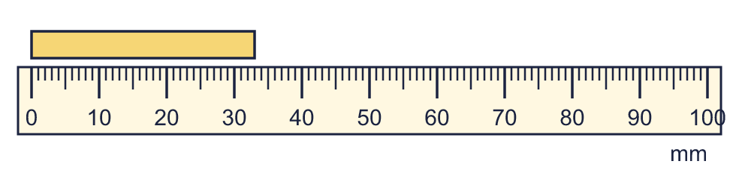
    a) | The line is |  | mm long.
  8 | How long is each line in millimetres?
    a) | The line is |  | mm long.

  9 | Is Boba correct? Circle yes or no.  Yes / No  Explain how you know.
     | 
  9 | Is Boba correct? Circle yes or no.  Yes / No  Explain how you know.
  10 | Write the lengths in order. Start with the shortest.  12 cm 7 mm 14 cm 3 mm 13 cm 9 mm 117 mm
  10 | Write the lengths in order. Start with the shortest.  12 cm 7 mm 14 cm 3 mm 13 cm 9 mm 117 mm
  11 | Work out the calculations. Write each answer in the form shown.
    a) | 194 mm + 31 mm =
    b) | 63 mm + 86 mm =
  11 | Work out the calculations. Write each answer in the form shown.
    a) | 194 mm + 31 mm =
    b) | 63 mm + 86 mm =
  12 | Write <, > or = in each box.
    a) | 7 cm 2 mm |  | 70 mm
    b) | 3 cm 5 mm |  | 40 mm
    c) | 8 cm |  | 75 mm
  12 | Write <, > or = in each box.
    a) | 7 cm 2 mm |  | 70 mm
    b) | 3 cm 5 mm |  | 40 mm
    c) | 8 cm |  | 75 mm
  13 | Is Boba correct? Circle yes or no.  Yes / No  Explain how you know.
    
  13 | Is Boba correct? Circle yes or no.  Yes / No  Explain how you know.
  14 | Work out the calculations. Write each answer in the form shown.
    a) | 153 mm − 58 mm = |  | mm
    b) | 176 mm − 67 mm =
  14 | Work out the calculations. Write each answer in the form shown.
    a) | 153 mm − 58 mm = |  | mm
    b) | 176 mm − 67 mm =

Year 3 · Length and perimeter · Step 3
Measure in centimetres and millimetres
Answers (teacher copy)

  1 | How long is each line? Write it in centimetres and millimetres.  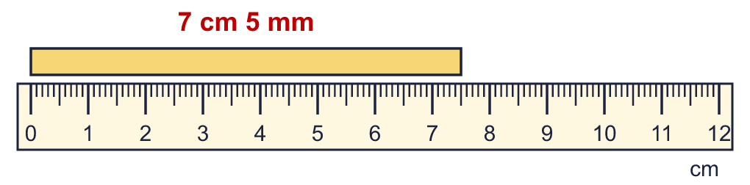  a) 7 cm and 5 mm  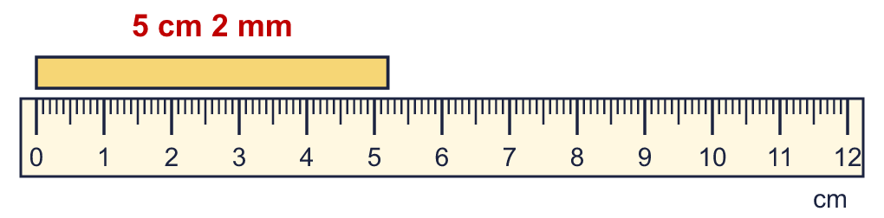  b) 5 cm and 2 mm
  2 | Complete the statements.  a) 5 cm 6 mm = 56 mm  b) 2 cm 2 mm = 22 mm  c) 2 cm 5 mm = 25 mm
  3 | How long is each line? Write it in centimetres and millimetres.  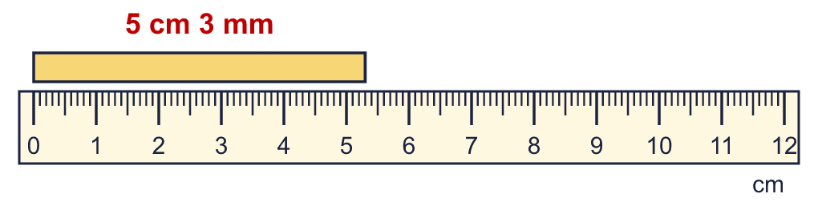  a) 5 cm and 3 mm
  4 | There are 10 millimetres in 1 centimetre. Use this to complete the statements.  a) 6 cm = 60 mm  b) 60 mm = 6 cm
  5 | Complete the statements.  a) 2 cm = 20 mm  b) 9 cm = 90 mm
  6 | Complete the statements.  a) 102 mm = 10 cm 2 mm  b) 4 cm 5 mm = 45 mm  c) 72 mm = 7 cm 2 mm
  7 | Write <, > or = in each box.  a) 60 mm = 6 cm  b) 2 cm < 25 mm
  8 | How long is each line in millimetres?  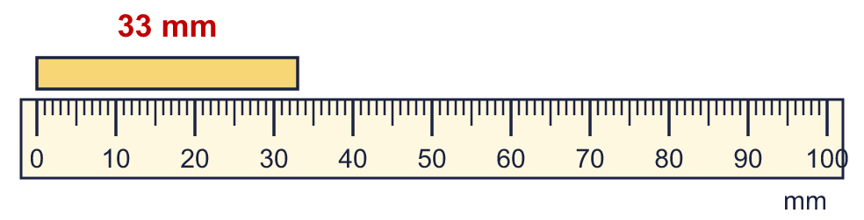  a) The line is 33 mm long.
  9 | Is Boba correct? Circle yes or no.  Yes / No  Explain how you know.  There are 100 centimetres in 1 metre, so 4 m = 400 cm, not 40 cm.
  10 | Write the lengths in order. Start with the shortest.  12 cm 7 mm 14 cm 3 mm 13 cm 9 mm 117 mm  117 mm, 12 cm 7 mm, 13 cm 9 mm, 14 cm 3 mm
  11 | Work out the calculations. Write each answer in the form shown.  a) 194 mm + 31 mm = 22 cm 5 mm  b) 63 mm + 86 mm = 14 cm 9 mm
  12 | Write <, > or = in each box.  a) 7 cm 2 mm > 70 mm  b) 3 cm 5 mm < 40 mm  c) 8 cm > 75 mm
  13 | Is Boba correct? Circle yes or no.  Yes / No  Explain how you know.  There are 100 centimetres in 1 metre, so 2 m = 200 cm, not 20 cm.
  14 | Work out the calculations. Write each answer in the form shown.  a) 153 mm − 58 mm = 95 mm  b) 176 mm − 67 mm = 10 cm 9 mm

