  Year 3 · Length and perimeter · Step 6  Equivalent lengths (centimetres and millimetres) | 
  Year 3 · Length and perimeter · Step 6
  Equivalent lengths (centimetres and millimetres)
  1 | There are 10 millimetres in 1 centimetre. Use this to complete the statements.
    a) | 3 cm = |  | mm
    b) | 30 mm = |  | cm
  1 | There are 10 millimetres in 1 centimetre. Use this to complete the statements.
    a) | 3 cm = |  | mm
    b) | 30 mm = |  | cm
  2 | Complete the statements.
    a) | 11 cm = |  | mm
    b) | 10 cm = |  | mm
    c) | 4 cm = |  | mm
  2 | Complete the statements.
    a) | 11 cm = |  | mm
    b) | 10 cm = |  | mm
    c) | 4 cm = |  | mm
  3 | Complete the statements.
    a) | 90 mm = |  | cm
    b) | 100 mm = |  | cm
    c) | 80 mm = |  | cm
  3 | Complete the statements.
    a) | 90 mm = |  | cm
    b) | 100 mm = |  | cm
    c) | 80 mm = |  | cm
  4 | Complete the statements.
    a) | 7 cm 5 mm = |  | mm
    b) | 81 mm = |  | cm |  | mm
    c) | 82 mm = |  | cm |  | mm
  4 | Complete the statements.
    a) | 7 cm 5 mm = |  | mm
    b) | 81 mm = |  | cm |  | mm
    c) | 82 mm = |  | cm |  | mm
  5 | How long is each line? Write it in centimetres and millimetres.  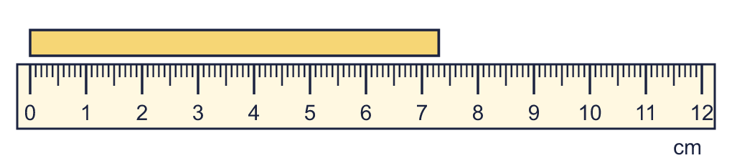  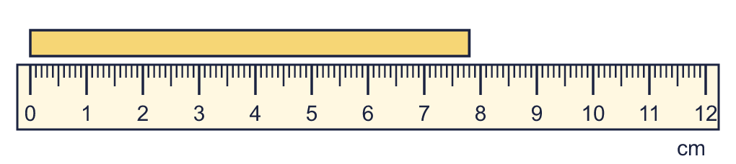
    a) |  | cm and |  | mm
    b) |  | cm and |  | mm
  5 | How long is each line? Write it in centimetres and millimetres.
    a) |  | cm and |  | mm
    b) |  | cm and |  | mm
  6 | Write <, > or = in each box.
    a) | 12 cm |  | 120 mm
    b) | 100 mm |  | 1 cm
  6 | Write <, > or = in each box.
    a) | 12 cm |  | 120 mm
    b) | 100 mm |  | 1 cm
  7 | Complete the statements.
    a) | 9 cm = |  | mm
    b) | 116 mm = |  | cm |  | mm
  7 | Complete the statements.
    a) | 9 cm = |  | mm
    b) | 116 mm = |  | cm |  | mm
  8 | Complete the statements.
    a) | 100 mm = |  | cm
    b) | 120 mm = |  | cm
  8 | Complete the statements.
    a) | 100 mm = |  | cm
    b) | 120 mm = |  | cm

  9 | Is Boba correct? Circle yes or no.  Yes / No  Explain how you know.
     | 
  9 | Is Boba correct? Circle yes or no.  Yes / No  Explain how you know.
  10 | Write the lengths in order. Start with the shortest.  58 mm 44 mm 184 mm 125 mm
  10 | Write the lengths in order. Start with the shortest.  58 mm 44 mm 184 mm 125 mm
  11 | Write <, > or = in each box.
    a) | 3 cm 5 mm |  | 40 mm
    b) | 8 cm |  | 75 mm
    c) | 100 mm |  | 1 cm
  11 | Write <, > or = in each box.
    a) | 3 cm 5 mm |  | 40 mm
    b) | 8 cm |  | 75 mm
    c) | 100 mm |  | 1 cm
  12 | Work out the calculations. Write each answer in the form shown.
    a) | 26 mm + 51 mm = |  | mm
    b) | 131 mm + 54 mm =
  12 | Work out the calculations. Write each answer in the form shown.
    a) | 26 mm + 51 mm = |  | mm
    b) | 131 mm + 54 mm =
  13 | Is Boba correct? Circle yes or no.  Yes / No  Explain how you know.
    
  13 | Is Boba correct? Circle yes or no.  Yes / No  Explain how you know.
  14 | Work out the calculations. Write each answer in the form shown.
    a) | 144 mm − 15 mm = |  | mm
    b) | 78 mm − 76 mm = |  | mm
  14 | Work out the calculations. Write each answer in the form shown.
    a) | 144 mm − 15 mm = |  | mm
    b) | 78 mm − 76 mm = |  | mm

Year 3 · Length and perimeter · Step 6
Equivalent lengths (centimetres and millimetres)
Answers (teacher copy)

  1 | There are 10 millimetres in 1 centimetre. Use this to complete the statements.  a) 3 cm = 30 mm  b) 30 mm = 3 cm
  2 | Complete the statements.  a) 11 cm = 110 mm  b) 10 cm = 100 mm  c) 4 cm = 40 mm
  3 | Complete the statements.  a) 90 mm = 9 cm  b) 100 mm = 10 cm  c) 80 mm = 8 cm
  4 | Complete the statements.  a) 7 cm 5 mm = 75 mm  b) 81 mm = 8 cm 1 mm  c) 82 mm = 8 cm 2 mm
  5 | How long is each line? Write it in centimetres and millimetres.  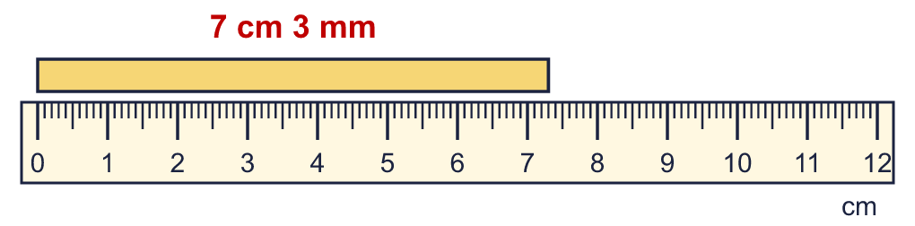  a) 7 cm and 3 mm  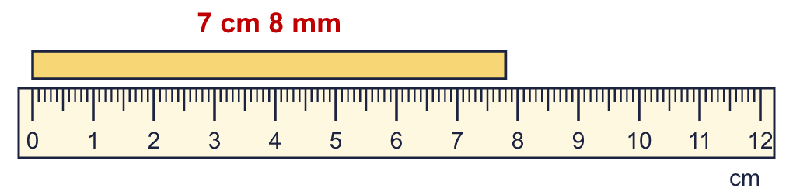  b) 7 cm and 8 mm
  6 | Write <, > or = in each box.  a) 12 cm = 120 mm  b) 100 mm > 1 cm
  7 | Complete the statements.  a) 9 cm = 90 mm  b) 116 mm = 11 cm 6 mm
  8 | Complete the statements.  a) 100 mm = 10 cm  b) 120 mm = 12 cm
  9 | Is Boba correct? Circle yes or no.  Yes / No  Explain how you know.  There are 100 centimetres in 1 metre, so 9 m = 900 cm, not 90 cm.
  10 | Write the lengths in order. Start with the shortest.  58 mm 44 mm 184 mm 125 mm  44 mm, 58 mm, 125 mm, 184 mm
  11 | Write <, > or = in each box.  a) 3 cm 5 mm < 40 mm  b) 8 cm > 75 mm  c) 100 mm > 1 cm
  12 | Work out the calculations. Write each answer in the form shown.  a) 26 mm + 51 mm = 77 mm  b) 131 mm + 54 mm = 18 cm 5 mm
  13 | Is Boba correct? Circle yes or no.  Yes / No  Explain how you know.  There are 10 millimetres in 1 centimetre, so 3 cm = 30 mm, not 300 mm.
  14 | Work out the calculations. Write each answer in the form shown.  a) 144 mm − 15 mm = 129 mm  b) 78 mm − 76 mm = 2 mm

