  Year 3 · Length and perimeter · Step 12  Calculate perimeter | 
  Year 3 · Length and perimeter · Step 12
  Calculate perimeter
  1 | Work out the perimeter of the rectangle.  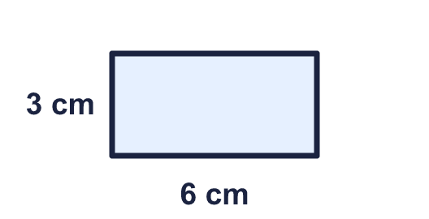
    Perimeter = |  | cm.
  1 | Work out the perimeter of the rectangle.
    Perimeter = |  | cm.
  2 | Work out the perimeter of the rectangle.  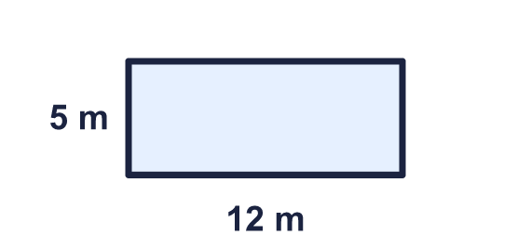
    Perimeter = |  | m.
  2 | Work out the perimeter of the rectangle.
    Perimeter = |  | m.
  3 | A rectangle is 12 cm long and 4 cm wide.
    Perimeter = |  | cm.
  3 | A rectangle is 12 cm long and 4 cm wide.
    Perimeter = |  | cm.
  4 | A square has a perimeter of 24 cm.
    Length of one side = |  | cm.
  4 | A square has a perimeter of 24 cm.
    Length of one side = |  | cm.
  5 | A rectangle is 12 cm long and 6 cm wide.
    Perimeter = |  | cm.
  5 | A rectangle is 12 cm long and 6 cm wide.
    Perimeter = |  | cm.
  6 | Work out the perimeter of the square.  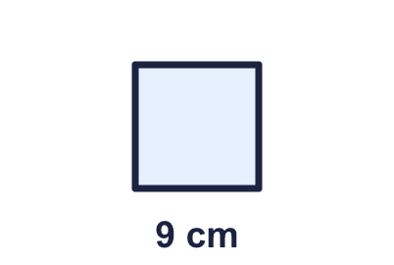
    Perimeter = |  | cm.
  6 | Work out the perimeter of the square.
    Perimeter = |  | cm.
  7 | This rectangle has a perimeter of 34 cm. Find the missing width.  
    Width = |  | cm.
  7 | This rectangle has a perimeter of 34 cm. Find the missing width.
    Width = |  | cm.
  8 | A square has a perimeter of 36 cm.
    Length of one side = |  | cm.
  8 | A square has a perimeter of 36 cm.
    Length of one side = |  | cm.

  9 | 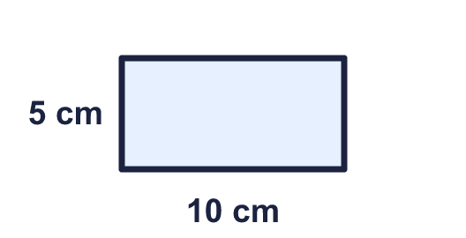  Is Eva correct? Circle yes or no.  Yes / No  Explain how you know.
     | 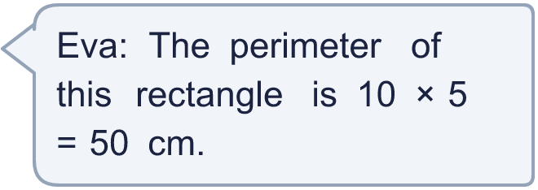
  9 | Is Eva correct? Circle yes or no.  Yes / No  Explain how you know.
  10 | A rectangle is 11 cm long and 4 cm wide. Which calculations give its perimeter? Write the letters.  A: 11 × 4 × 2  B: 2 × 11 + 2 × 4  C: 11 × 2 + 4 × 2  D: 11 × 4  E: 2 × 11 + 4
  10 | A rectangle is 11 cm long and 4 cm wide. Which calculations give its perimeter? Write the letters.  A: 11 × 4 × 2  B: 2 × 11 + 2 × 4  C: 11 × 2 + 4 × 2  D: 11 × 4  E: 2 × 11 + 4
  11 | Rectangles have sides that are whole numbers of centimetres. A 2 cm by 5 cm rectangle is the same as a 5 cm by 2 cm rectangle.  How many different rectangles have a perimeter of 20 cm?
    rectangles
  11 | Rectangles have sides that are whole numbers of centimetres. A 2 cm by 5 cm rectangle is the same as a 5 cm by 2 cm rectangle.  How many different rectangles have a perimeter of 20 cm?
    rectangles
  12 | This rectangle has a perimeter of 36 cm. Find the missing width.  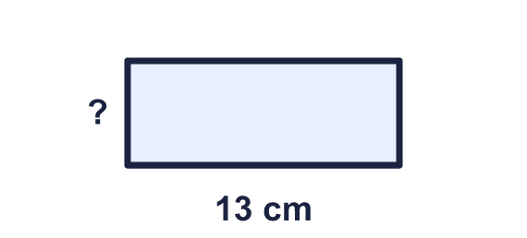
    Width = |  | cm.
  12 | This rectangle has a perimeter of 36 cm. Find the missing width.
    Width = |  | cm.
  13 | Work out the perimeter of the quadrilateral.  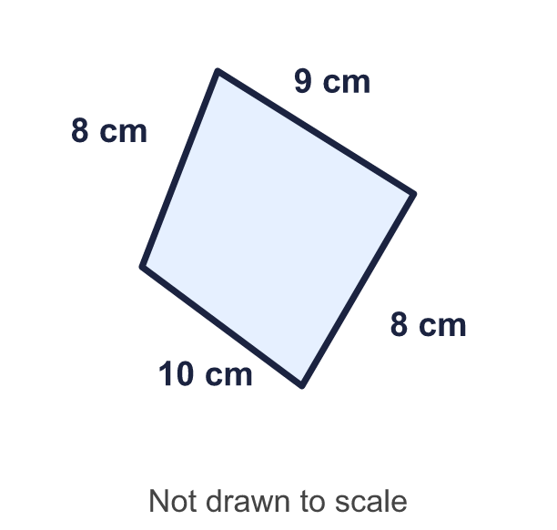
    Perimeter = |  | cm.
  13 | Work out the perimeter of the quadrilateral.
    Perimeter = |  | cm.
  14 | A square has a perimeter of 16 cm.
    Length of one side = |  | cm.
  14 | A square has a perimeter of 16 cm.
    Length of one side = |  | cm.

Year 3 · Length and perimeter · Step 12
Calculate perimeter
Answers (teacher copy)

  1 | Work out the perimeter of the rectangle.  Perimeter = 18 cm.
  2 | Work out the perimeter of the rectangle.  Perimeter = 34 m.
  3 | A rectangle is 12 cm long and 4 cm wide.  Perimeter = 32 cm.
  4 | A square has a perimeter of 24 cm.  Length of one side = 6 cm.
  5 | A rectangle is 12 cm long and 6 cm wide.  Perimeter = 36 cm.
  6 | Work out the perimeter of the square.  Perimeter = 36 cm.
  7 | This rectangle has a perimeter of 34 cm. Find the missing width.  Width = 3 cm.
  8 | A square has a perimeter of 36 cm.  Length of one side = 9 cm.
  9 | Is Eva correct? Circle yes or no.  Yes / No  Explain how you know.  No. 10 × 5 = 50 is the area, not the perimeter. The perimeter is 10 + 5 + 10 + 5 = 30 cm.
  10 | A rectangle is 11 cm long and 4 cm wide. Which calculations give its perimeter? Write the letters.  A: 11 × 4 × 2  B: 2 × 11 + 2 × 4  C: 11 × 2 + 4 × 2  D: 11 × 4  E: 2 × 11 + 4  B, C
  11 | Rectangles have sides that are whole numbers of centimetres. A 2 cm by 5 cm rectangle is the same as a 5 cm by 2 cm rectangle.  How many different rectangles have a perimeter of 20 cm?  5 rectangles
  12 | This rectangle has a perimeter of 36 cm. Find the missing width.  Width = 5 cm.
  13 | Work out the perimeter of the quadrilateral.  Perimeter = 35 cm.
  14 | A square has a perimeter of 16 cm.  Length of one side = 4 cm.

