  Year 3 · Fractions A · Step 3  Understand the numerators of non-unit fractions | 
  Year 3 · Fractions A · Step 3
  Understand the numerators of non-unit fractions
  1 | Look at the bar. It is one whole.  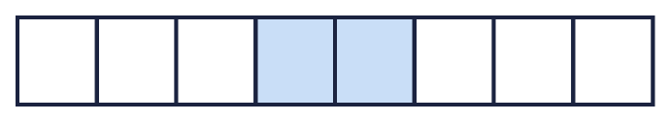
    The whole is split into
    equal parts.
    of the parts are shaded.
    The fraction shaded is
  1 | Look at the bar. It is one whole.
    The whole is split into
    equal parts.
    of the parts are shaded.
    The fraction shaded is
  2 | Shade the bar to show ²⁄₃.  
  2 | Shade the bar to show ²⁄₃.
  3 | Look at the bar. It is one whole.  
    The whole is split into
    equal parts.
    of the parts are shaded.
    The fraction shaded is
  3 | Look at the bar. It is one whole.
    The whole is split into
    equal parts.
    of the parts are shaded.
    The fraction shaded is
  4 | What fraction of the bar is shaded? What fraction is not shaded?  
  4 | What fraction of the bar is shaded? What fraction is not shaded?
  5 | Write each fraction in numbers.
    a) | seven tenths
    b) | one half
    c) | two thirds
  5 | Write each fraction in numbers.
    a) | seven tenths
    b) | one half
    c) | two thirds
  6 | Look at the bar. It is one whole.  
    The whole is split into
    equal parts.
    of the parts are shaded.
    The fraction shaded is
  6 | Look at the bar. It is one whole.
    The whole is split into
    equal parts.
    of the parts are shaded.
    The fraction shaded is
  7 | Shade the bar to show ²⁄₃.
  7 | Shade the bar to show ²⁄₃.
  8 | A pie is cut into 4 equal pieces. Cal eats 3 of the pieces.  What fraction of the pie does Cal eat?
  8 | A pie is cut into 4 equal pieces. Cal eats 3 of the pieces.  What fraction of the pie does Cal eat?

  9 | Is Boba correct? Circle yes or no.  Yes / No  Explain your answer.
     | 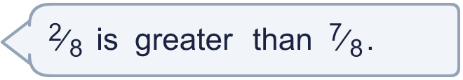
  9 | Is Boba correct? Circle yes or no.  Yes / No  Explain your answer.
  10 | A chocolate bar is cut into 8 equal pieces. Ben eats 5 of the pieces.  What fraction of the chocolate bar does Ben eat?
  10 | A chocolate bar is cut into 8 equal pieces. Ben eats 5 of the pieces.  What fraction of the chocolate bar does Ben eat?
  11 | Write each fraction in numbers.
    a) | one fifth
    b) | three eighths
    c) | one half
  11 | Write each fraction in numbers.
    a) | one fifth
    b) | three eighths
    c) | one half
  12 | A cake is cut into 4 equal pieces. Fay eats 3 of the pieces.  What fraction of the cake is left?
  12 | A cake is cut into 4 equal pieces. Fay eats 3 of the pieces.  What fraction of the cake is left?
  13 | What fraction of the bar is shaded? What fraction is not shaded?  
  13 | What fraction of the bar is shaded? What fraction is not shaded?
  14 | Is Boba correct? Circle yes or no.  Yes / No  Explain your answer.
    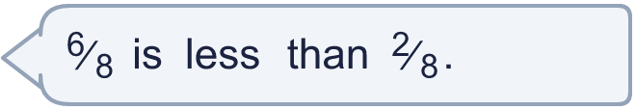
  14 | Is Boba correct? Circle yes or no.  Yes / No  Explain your answer.

Year 3 · Fractions A · Step 3
Understand the numerators of non-unit fractions
Answers (teacher copy)

  1 | Look at the bar. It is one whole.  The whole is split into 8 equal parts.  2 of the parts are shaded.  The fraction shaded is ²⁄₈
  2 | Shade the bar to show ²⁄₃.  
  3 | Look at the bar. It is one whole.  The whole is split into 4 equal parts.  3 of the parts are shaded.  The fraction shaded is ³⁄₄
  4 | What fraction of the bar is shaded? What fraction is not shaded?  Shaded: ⁵⁄₆  Not shaded: ¹⁄₆
  5 | Write each fraction in numbers.  a) seven tenths ⁷⁄₁₀  b) one half ¹⁄₂  c) two thirds ²⁄₃
  6 | Look at the bar. It is one whole.  The whole is split into 4 equal parts.  3 of the parts are shaded.  The fraction shaded is ³⁄₄
  7 | Shade the bar to show ²⁄₃.
  8 | A pie is cut into 4 equal pieces. Cal eats 3 of the pieces.  What fraction of the pie does Cal eat? ³⁄₄
  9 | Is Boba correct? Circle yes or no.  Yes / No  Explain your answer.  ²⁄₈ and ⁷⁄₈ have the same denominator, so compare the numerators: ²⁄₈ is less than ⁷⁄₈.
  10 | A chocolate bar is cut into 8 equal pieces. Ben eats 5 of the pieces.  What fraction of the chocolate bar does Ben eat? ⁵⁄₈
  11 | Write each fraction in numbers.  a) one fifth ¹⁄₅  b) three eighths ³⁄₈  c) one half ¹⁄₂
  12 | A cake is cut into 4 equal pieces. Fay eats 3 of the pieces.  What fraction of the cake is left? ¹⁄₄
  13 | What fraction of the bar is shaded? What fraction is not shaded?  Shaded: ¹⁄₆  Not shaded: ⁵⁄₆
  14 | Is Boba correct? Circle yes or no.  Yes / No  Explain your answer.  ⁶⁄₈ and ²⁄₈ have the same denominator, so compare the numerators: ⁶⁄₈ is greater than ²⁄₈.

