  Year 3 · Fractions A · Step 1  Understand the denominators of unit fractions | 
  Year 3 · Fractions A · Step 1
  Understand the denominators of unit fractions
  1 | Look at the bar. It is one whole.  
    The whole is split into
    equal parts.
    The denominator is
    The fraction shaded is
  1 | Look at the bar. It is one whole.
    The whole is split into
    equal parts.
    The denominator is
    The fraction shaded is
  2 | Write each fraction in numbers.
    a) | one half
    b) | one quarter
    c) | one fifth
  2 | Write each fraction in numbers.
    a) | one half
    b) | one quarter
    c) | one fifth
  3 | Look at the bar. It is one whole.  
    The whole is split into
    equal parts.
    The denominator is
    The fraction shaded is
  3 | Look at the bar. It is one whole.
    The whole is split into
    equal parts.
    The denominator is
    The fraction shaded is
  4 | Shade the bar to show ¹⁄₆.  
  4 | Shade the bar to show ¹⁄₆.
  5 | Write each fraction in numbers.
    a) | one quarter
    b) | one tenth
    c) | one third
  5 | Write each fraction in numbers.
    a) | one quarter
    b) | one tenth
    c) | one third
  6 | Look at the bar. It is one whole.  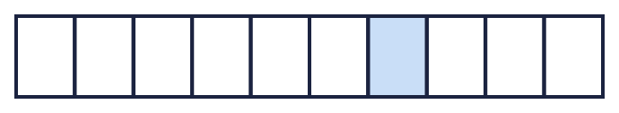
    The whole is split into
    equal parts.
    The denominator is
    The fraction shaded is
  6 | Look at the bar. It is one whole.
    The whole is split into
    equal parts.
    The denominator is
    The fraction shaded is
  7 | Shade the bar to show ¹⁄₃.  
  7 | Shade the bar to show ¹⁄₃.
  8 | A chocolate bar is cut into 10 equal pieces. Eli eats 1 of the pieces.  What fraction of the chocolate bar does Eli eat?
  8 | A chocolate bar is cut into 10 equal pieces. Eli eats 1 of the pieces.  What fraction of the chocolate bar does Eli eat?

  9 | Is Tiny correct? Circle yes or no.  Yes / No  Explain your answer.
     | 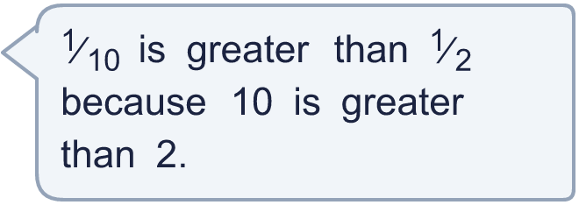
  9 | Is Tiny correct? Circle yes or no.  Yes / No  Explain your answer.
  10 | A cake is cut into 10 equal pieces. Dee eats 1 of the pieces.  What fraction of the cake does Dee eat?
  10 | A cake is cut into 10 equal pieces. Dee eats 1 of the pieces.  What fraction of the cake does Dee eat?
  11 | Write each fraction in numbers.
    a) | one third
    b) | one eighth
    c) | one quarter
  11 | Write each fraction in numbers.
    a) | one third
    b) | one eighth
    c) | one quarter
  12 | Is Boba correct? Circle yes or no.  Yes / No  Explain your answer.
    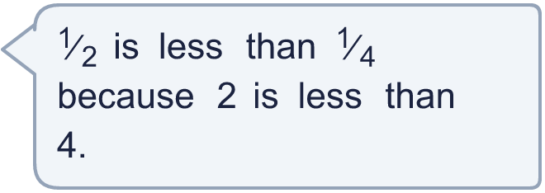
  12 | Is Boba correct? Circle yes or no.  Yes / No  Explain your answer.
  13 | Shade the bar to show ¹⁄₆.
  13 | Shade the bar to show ¹⁄₆.
  14 | Look at the bar. It is one whole.  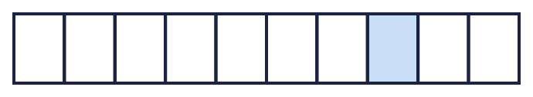
    The whole is split into
    equal parts.
    The denominator is
    The fraction shaded is
  14 | Look at the bar. It is one whole.
    The whole is split into
    equal parts.
    The denominator is
    The fraction shaded is

Year 3 · Fractions A · Step 1
Understand the denominators of unit fractions
Answers (teacher copy)

  1 | Look at the bar. It is one whole.  The whole is split into 3 equal parts.  The denominator is 3  The fraction shaded is ¹⁄₃
  2 | Write each fraction in numbers.  a) one half ¹⁄₂  b) one quarter ¹⁄₄  c) one fifth ¹⁄₅
  3 | Look at the bar. It is one whole.  The whole is split into 4 equal parts.  The denominator is 4  The fraction shaded is ¹⁄₄
  4 | Shade the bar to show ¹⁄₆.  
  5 | Write each fraction in numbers.  a) one quarter ¹⁄₄  b) one tenth ¹⁄₁₀  c) one third ¹⁄₃
  6 | Look at the bar. It is one whole.  The whole is split into 10 equal parts.  The denominator is 10  The fraction shaded is ¹⁄₁₀
  7 | Shade the bar to show ¹⁄₃.  
  8 | A chocolate bar is cut into 10 equal pieces. Eli eats 1 of the pieces.  What fraction of the chocolate bar does Eli eat? ¹⁄₁₀
  9 | Is Tiny correct? Circle yes or no.  Yes / No  Explain your answer.  ¹⁄₁₀ and ¹⁄₂: the greater the denominator, the smaller each part. ¹⁄₁₀ is less than ¹⁄₂.
  10 | A cake is cut into 10 equal pieces. Dee eats 1 of the pieces.  What fraction of the cake does Dee eat? ¹⁄₁₀
  11 | Write each fraction in numbers.  a) one third ¹⁄₃  b) one eighth ¹⁄₈  c) one quarter ¹⁄₄
  12 | Is Boba correct? Circle yes or no.  Yes / No  Explain your answer.  ¹⁄₂ and ¹⁄₄: the greater the denominator, the smaller each part. ¹⁄₂ is greater than ¹⁄₄.
  13 | Shade the bar to show ¹⁄₆.
  14 | Look at the bar. It is one whole.  The whole is split into 10 equal parts.  The denominator is 10  The fraction shaded is ¹⁄₁₀

