  Year 3 · Fractions A · Step 7  Fractions on a number line | 
  Year 3 · Fractions A · Step 7
  Fractions on a number line
  1 | Look at the number line from 0 to 1.  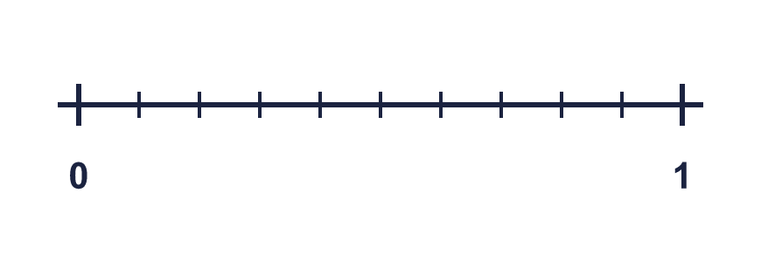
    The line is split into
    equal parts.
    Each part is worth one
  1 | Look at the number line from 0 to 1.
    The line is split into
    equal parts.
    Each part is worth one
  2 | Write the fraction shown by each lettered box on the number line.  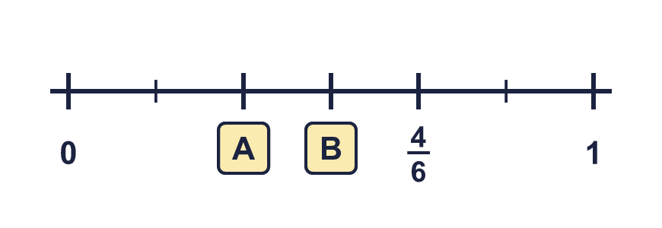
  2 | Write the fraction shown by each lettered box on the number line.
  3 | The number line goes from 0 to 1. What fraction is each arrow pointing to?  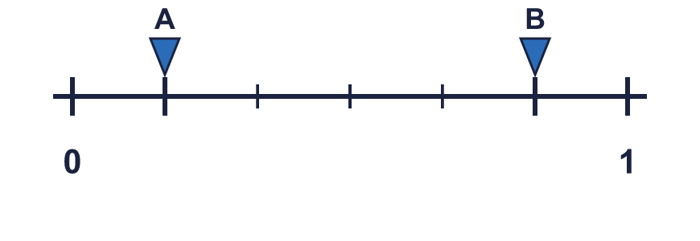
  3 | The number line goes from 0 to 1. What fraction is each arrow pointing to?
  4 | Look at the number line from 0 to 1.
    The line is split into
    equal parts.
    Each part is worth one
  4 | Look at the number line from 0 to 1.
    The line is split into
    equal parts.
    Each part is worth one
  5 | Write the fraction shown by each lettered box on the number line.
  5 | Write the fraction shown by each lettered box on the number line.
  6 | The number line goes from 0 to 1. What fraction is each arrow pointing to?  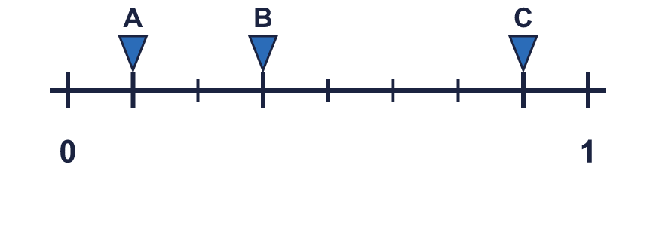
  6 | The number line goes from 0 to 1. What fraction is each arrow pointing to?
  7 | Write each fraction in numbers.
    a) | three quarters
    b) | seven tenths
    c) | one fifth
  7 | Write each fraction in numbers.
    a) | three quarters
    b) | seven tenths
    c) | one fifth
  8 | Write the fraction shown by each lettered box on the number line.  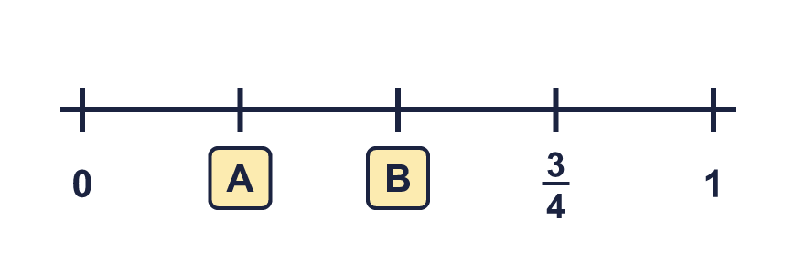
  8 | Write the fraction shown by each lettered box on the number line.

  9 | The number line goes from 0 to 1. What fraction is each arrow pointing to?
  9 | The number line goes from 0 to 1. What fraction is each arrow pointing to?
  10 | Is Tiara correct? Circle yes or no.  Yes / No  Explain your answer.
     | 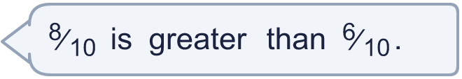
  10 | Is Tiara correct? Circle yes or no.  Yes / No  Explain your answer.
  11 | Write the fraction shown by each lettered box on the number line.  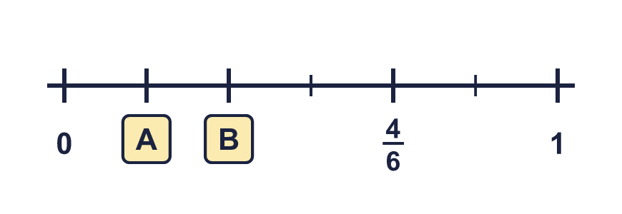
  11 | Write the fraction shown by each lettered box on the number line.
  12 | The number line goes from 0 to 1. What fraction is each arrow pointing to?  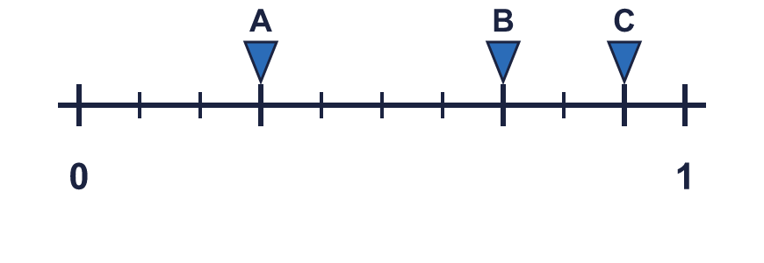
  12 | The number line goes from 0 to 1. What fraction is each arrow pointing to?
  13 | A pizza is cut into 8 equal pieces. Eli eats 7 of the pieces.  What fraction of the pizza does Eli eat?
  13 | A pizza is cut into 8 equal pieces. Eli eats 7 of the pieces.  What fraction of the pizza does Eli eat?
  14 | Look at the number line from 0 to 1.  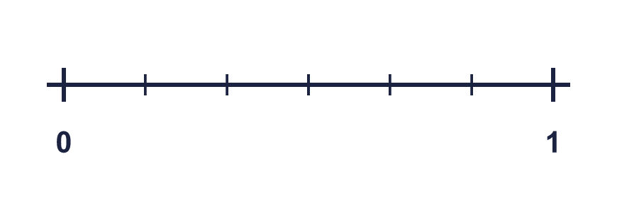
    The line is split into
    equal parts.
    Each part is worth one
  14 | Look at the number line from 0 to 1.
    The line is split into
    equal parts.
    Each part is worth one

Year 3 · Fractions A · Step 7
Fractions on a number line
Answers (teacher copy)

  1 | Look at the number line from 0 to 1.  The line is split into 10 equal parts.  Each part is worth one tenth
  2 | Write the fraction shown by each lettered box on the number line.  A = ²⁄₆ B = ³⁄₆
  3 | The number line goes from 0 to 1. What fraction is each arrow pointing to?  A = ¹⁄₆ B = ⁵⁄₆
  4 | Look at the number line from 0 to 1.  The line is split into 10 equal parts.  Each part is worth one tenth
  5 | Write the fraction shown by each lettered box on the number line.  A = ²⁄₆ B = ³⁄₆
  6 | The number line goes from 0 to 1. What fraction is each arrow pointing to?  A = ¹⁄₈ B = ³⁄₈ C = ⁷⁄₈
  7 | Write each fraction in numbers.  a) three quarters ³⁄₄  b) seven tenths ⁷⁄₁₀  c) one fifth ¹⁄₅
  8 | Write the fraction shown by each lettered box on the number line.  A = ¹⁄₄ B = ²⁄₄
  9 | The number line goes from 0 to 1. What fraction is each arrow pointing to?  A = ¹⁄₆ B = ⁵⁄₆
  10 | Is Tiara correct? Circle yes or no.  Yes / No  Explain your answer.  ⁸⁄₁₀ and ⁶⁄₁₀ have the same denominator, so compare the numerators: ⁸⁄₁₀ is greater than ⁶⁄₁₀.
  11 | Write the fraction shown by each lettered box on the number line.  A = ¹⁄₆ B = ²⁄₆
  12 | The number line goes from 0 to 1. What fraction is each arrow pointing to?  A = ³⁄₁₀ B = ⁷⁄₁₀ C = ⁹⁄₁₀
  13 | A pizza is cut into 8 equal pieces. Eli eats 7 of the pieces.  What fraction of the pizza does Eli eat? ⁷⁄₈
  14 | Look at the number line from 0 to 1.  The line is split into 6 equal parts.  Each part is worth one sixth

