  Year 3 · Fractions A · Step 6  Fractions and scales | 
  Year 3 · Fractions A · Step 6
  Fractions and scales
  1 | The number line goes from 0 to 1. What fraction is each arrow pointing to?  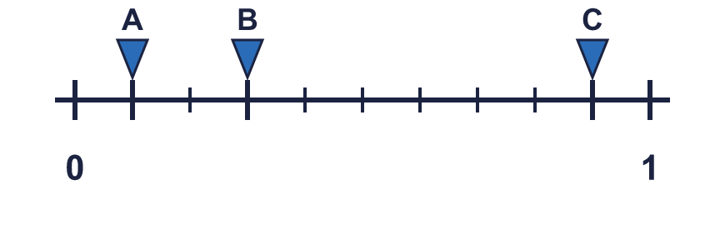
  1 | The number line goes from 0 to 1. What fraction is each arrow pointing to?
  2 | Write the fraction shown by each lettered box on the number line.  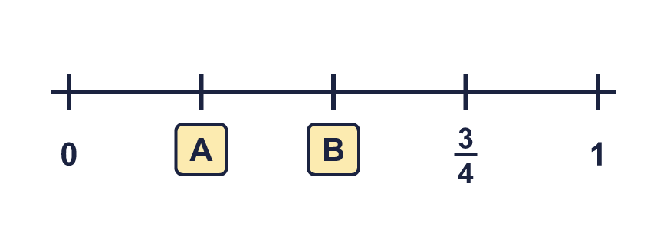
  2 | Write the fraction shown by each lettered box on the number line.
  3 | Look at the number line from 0 to 1.  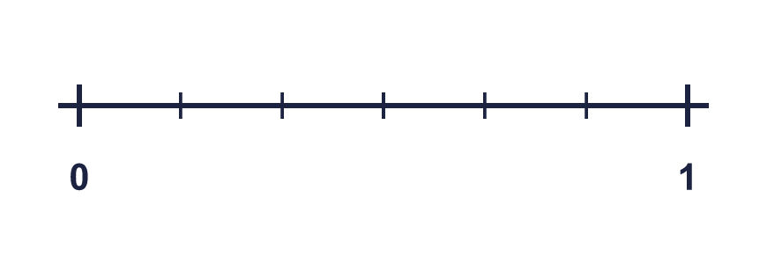
    The line is split into
    equal parts.
    Each part is worth one
  3 | Look at the number line from 0 to 1.
    The line is split into
    equal parts.
    Each part is worth one
  4 | The number line goes from 0 to 1. What fraction is each arrow pointing to?  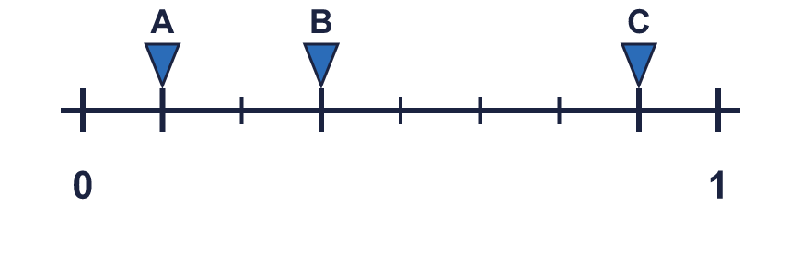
  4 | The number line goes from 0 to 1. What fraction is each arrow pointing to?
  5 | Dee is taking part in a 30 km race. Dee has run ⁴⁄₅ of the race.
    How far has Dee run? |  | km
  5 | Dee is taking part in a 30 km race. Dee has run ⁴⁄₅ of the race.
    How far has Dee run? |  | km
  6 | Write the fraction shown by each lettered box on the number line.  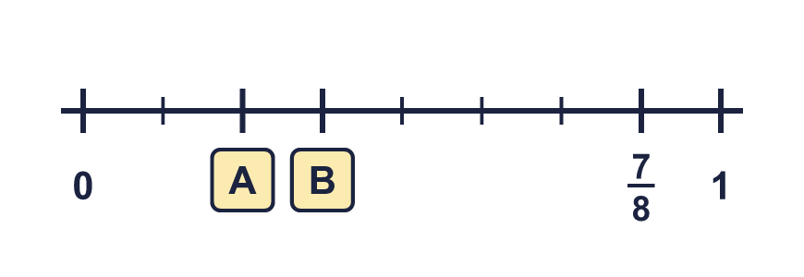
  6 | Write the fraction shown by each lettered box on the number line.
  7 | The number line goes from 0 to 1. What fraction is each arrow pointing to?  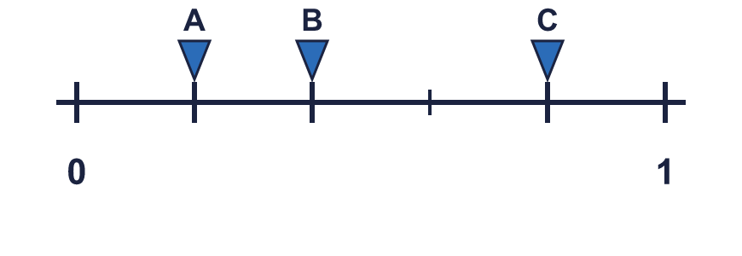
  7 | The number line goes from 0 to 1. What fraction is each arrow pointing to?
  8 | Look at the number line from 0 to 1.  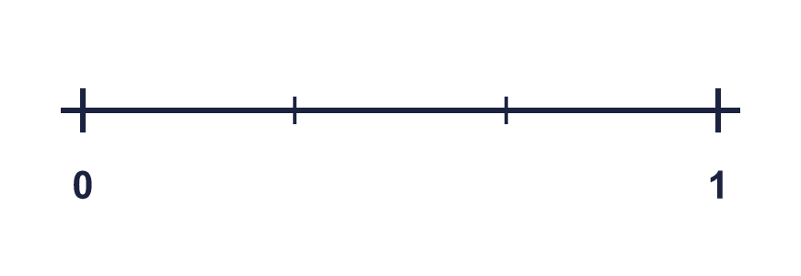
    The line is split into
    equal parts.
    Each part is worth one
  8 | Look at the number line from 0 to 1.
    The line is split into
    equal parts.
    Each part is worth one

  9 | The number line goes from 0 to 1. What fraction is each arrow pointing to?  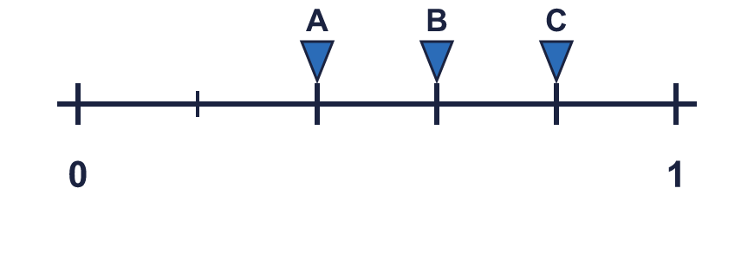
  9 | The number line goes from 0 to 1. What fraction is each arrow pointing to?
  10 | Is Tiara correct? Circle yes or no.  Yes / No  Explain your answer.
     | 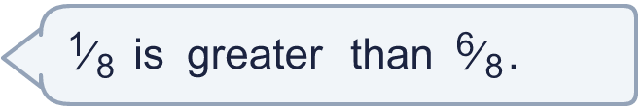
  10 | Is Tiara correct? Circle yes or no.  Yes / No  Explain your answer.
  11 | Write the fraction shown by each lettered box on the number line.  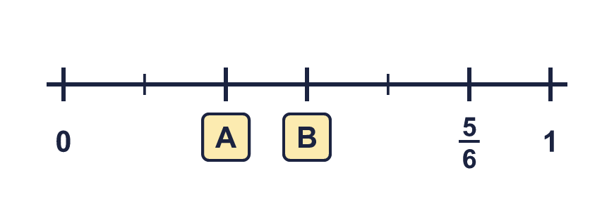
  11 | Write the fraction shown by each lettered box on the number line.
  12 | Dee is taking part in a 20 km race. Dee has run ⁶⁄₁₀ of the race.
    How far has Dee run? |  | km
  12 | Dee is taking part in a 20 km race. Dee has run ⁶⁄₁₀ of the race.
    How far has Dee run? |  | km
  13 | The number line goes from 0 to 1. What fraction is each arrow pointing to?  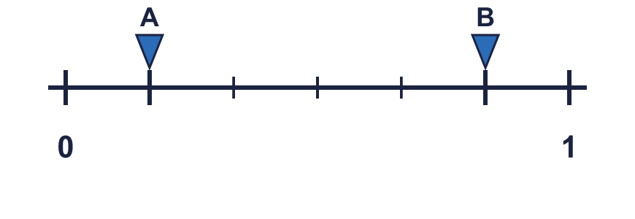
  13 | The number line goes from 0 to 1. What fraction is each arrow pointing to?
  14 | Write each fraction in numbers.
    a) | one quarter
    b) | three quarters
    c) | one fifth
  14 | Write each fraction in numbers.
    a) | one quarter
    b) | three quarters
    c) | one fifth

Year 3 · Fractions A · Step 6
Fractions and scales
Answers (teacher copy)

  1 | The number line goes from 0 to 1. What fraction is each arrow pointing to?  A = ¹⁄₁₀ B = ³⁄₁₀ C = ⁹⁄₁₀
  2 | Write the fraction shown by each lettered box on the number line.  A = ¹⁄₄ B = ²⁄₄
  3 | Look at the number line from 0 to 1.  The line is split into 6 equal parts.  Each part is worth one sixth
  4 | The number line goes from 0 to 1. What fraction is each arrow pointing to?  A = ¹⁄₈ B = ³⁄₈ C = ⁷⁄₈
  5 | Dee is taking part in a 30 km race. Dee has run ⁴⁄₅ of the race.  How far has Dee run? 24 km
  6 | Write the fraction shown by each lettered box on the number line.  A = ²⁄₈ B = ³⁄₈
  7 | The number line goes from 0 to 1. What fraction is each arrow pointing to?  A = ¹⁄₅ B = ²⁄₅ C = ⁴⁄₅
  8 | Look at the number line from 0 to 1.  The line is split into 3 equal parts.  Each part is worth one third
  9 | The number line goes from 0 to 1. What fraction is each arrow pointing to?  A = ²⁄₅ B = ³⁄₅ C = ⁴⁄₅
  10 | Is Tiara correct? Circle yes or no.  Yes / No  Explain your answer.  ¹⁄₈ and ⁶⁄₈ have the same denominator, so compare the numerators: ¹⁄₈ is less than ⁶⁄₈.
  11 | Write the fraction shown by each lettered box on the number line.  A = ²⁄₆ B = ³⁄₆
  12 | Dee is taking part in a 20 km race. Dee has run ⁶⁄₁₀ of the race.  How far has Dee run? 12 km
  13 | The number line goes from 0 to 1. What fraction is each arrow pointing to?  A = ¹⁄₆ B = ⁵⁄₆
  14 | Write each fraction in numbers.  a) one quarter ¹⁄₄  b) three quarters ³⁄₄  c) one fifth ¹⁄₅

