  Year 3 · Fractions A · Step 9  Equivalent fractions on a number line | 
  Year 3 · Fractions A · Step 9
  Equivalent fractions on a number line
  1 | Arrow A is in the same place on both number lines. Write the missing numerator.  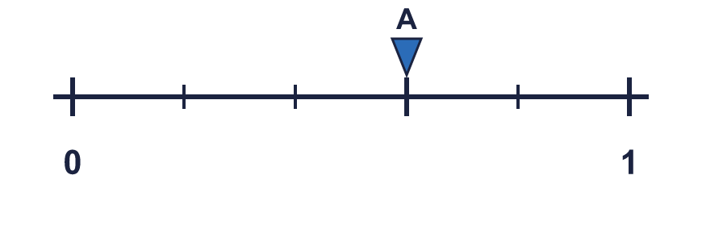  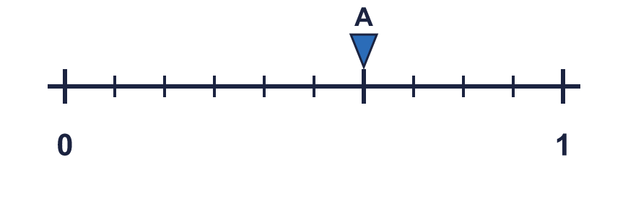  ³⁄₅ = ?⁄₁₀
  1 | Arrow A is in the same place on both number lines. Write the missing numerator.  ³⁄₅ = ?⁄₁₀
  2 | Write the missing numerator in each pair of equal fractions.  a) ²⁄₄ = ?⁄₈  b) ²⁄₅ = ?⁄₁₀  c) ³⁄₄ = ?⁄₈
  2 | Write the missing numerator in each pair of equal fractions.  a) ²⁄₄ = ?⁄₈  b) ²⁄₅ = ?⁄₁₀  c) ³⁄₄ = ?⁄₈
  3 | Arrow A is in the same place on both number lines. Write the missing numerator.  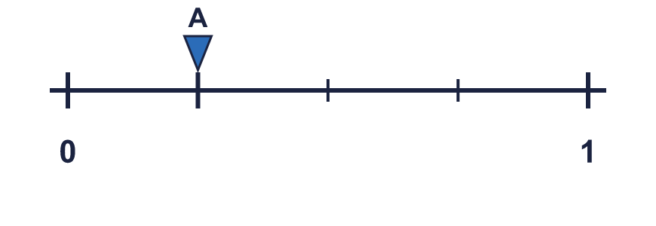  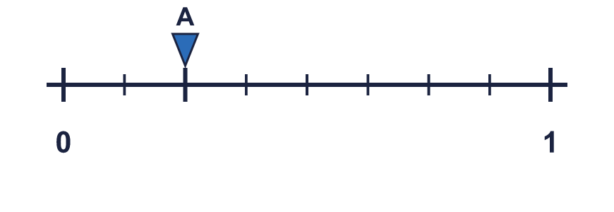  ¹⁄₄ = ?⁄₈
  3 | Arrow A is in the same place on both number lines. Write the missing numerator.  ¹⁄₄ = ?⁄₈
  4 | Each bar is the same length. Use the bars to find the missing numerator.  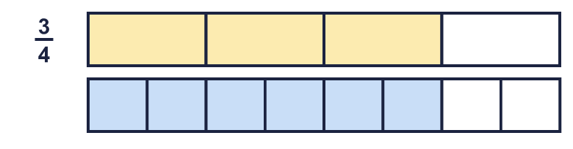  ³⁄₄ = ?⁄₈
  4 | Each bar is the same length. Use the bars to find the missing numerator.  ³⁄₄ = ?⁄₈
  5 | Write the missing numerator in each pair of equal fractions.  a) ¹⁄₂ = ?⁄₆  b) ²⁄₄ = ?⁄₈
  5 | Write the missing numerator in each pair of equal fractions.  a) ¹⁄₂ = ?⁄₆  b) ²⁄₄ = ?⁄₈
  6 | Arrow A is in the same place on both number lines. Write the missing numerator.  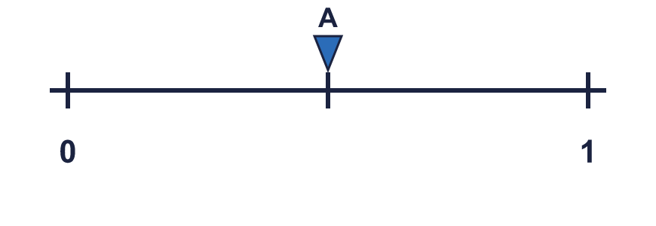  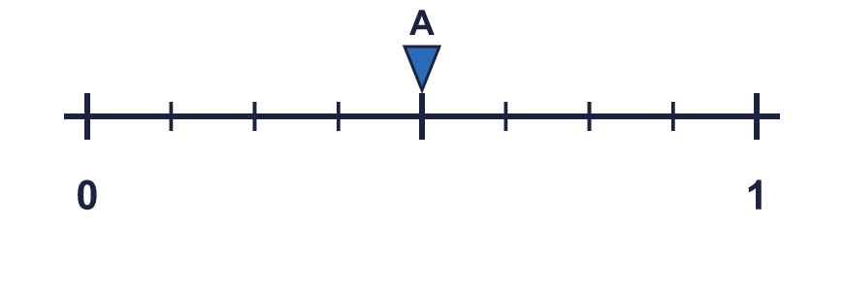  ¹⁄₂ = ?⁄₈
  6 | Arrow A is in the same place on both number lines. Write the missing numerator.  ¹⁄₂ = ?⁄₈
  7 | Each bar is the same length. Use the bars to find the missing numerator.  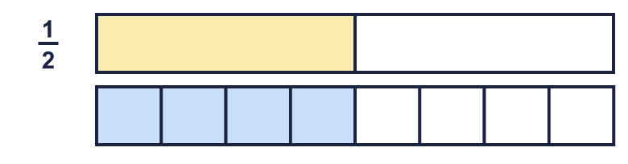  ¹⁄₂ = ?⁄₈
  7 | Each bar is the same length. Use the bars to find the missing numerator.  ¹⁄₂ = ?⁄₈
  8 | Write the missing numerator in each pair of equal fractions.  a) ¹⁄₂ = ?⁄₄  b) ¹⁄₃ = ?⁄₆  c) ¹⁄₄ = ?⁄₈
  8 | Write the missing numerator in each pair of equal fractions.  a) ¹⁄₂ = ?⁄₄  b) ¹⁄₃ = ?⁄₆  c) ¹⁄₄ = ?⁄₈

  9 | Is Tiny correct? Circle yes or no.  Yes / No  Explain how you know.
     | 
  9 | Is Tiny correct? Circle yes or no.  Yes / No  Explain how you know.
  10 | Arrow A is in the same place on both number lines. Write the missing numerator.  ¹⁄₂ = ?⁄₈
  10 | Arrow A is in the same place on both number lines. Write the missing numerator.  ¹⁄₂ = ?⁄₈
  11 | Is Boba correct? Circle yes or no.  Yes / No  Explain how you know.
    
  11 | Is Boba correct? Circle yes or no.  Yes / No  Explain how you know.
  12 | Write the missing numerator in each pair of equal fractions.  a) ¹⁄₃ = ?⁄₆  b) ³⁄₅ = ?⁄₁₀
  12 | Write the missing numerator in each pair of equal fractions.  a) ¹⁄₃ = ?⁄₆  b) ³⁄₅ = ?⁄₁₀
  13 | Is Tiny correct? Circle yes or no.  Yes / No  Explain how you know.
    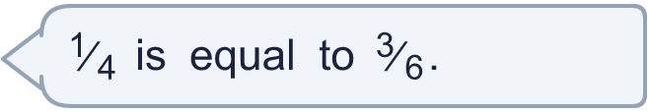
  13 | Is Tiny correct? Circle yes or no.  Yes / No  Explain how you know.
  14 | Each bar is the same length. Use the bars to find the missing numerator.  ³⁄₄ = ?⁄₈
  14 | Each bar is the same length. Use the bars to find the missing numerator.  ³⁄₄ = ?⁄₈

Year 3 · Fractions A · Step 9
Equivalent fractions on a number line
Answers (teacher copy)

  1 | Arrow A is in the same place on both number lines. Write the missing numerator.  ³⁄₅ = ?⁄₁₀ 6
  2 | Write the missing numerator in each pair of equal fractions.  a) ²⁄₄ = ?⁄₈ 4  b) ²⁄₅ = ?⁄₁₀ 4  c) ³⁄₄ = ?⁄₈ 6
  3 | Arrow A is in the same place on both number lines. Write the missing numerator.  ¹⁄₄ = ?⁄₈ 2
  4 | Each bar is the same length. Use the bars to find the missing numerator.  ³⁄₄ = ?⁄₈ 6
  5 | Write the missing numerator in each pair of equal fractions.  a) ¹⁄₂ = ?⁄₆ 3  b) ²⁄₄ = ?⁄₈ 4
  6 | Arrow A is in the same place on both number lines. Write the missing numerator.  ¹⁄₂ = ?⁄₈ 4
  7 | Each bar is the same length. Use the bars to find the missing numerator.  ¹⁄₂ = ?⁄₈ 4
  8 | Write the missing numerator in each pair of equal fractions.  a) ¹⁄₂ = ?⁄₄ 2  b) ¹⁄₃ = ?⁄₆ 2  c) ¹⁄₄ = ?⁄₈ 2
  9 | Is Tiny correct? Circle yes or no.  Yes / No  Explain how you know.  ¹⁄₃ and ³⁄₅ are not equal. ³⁄₅ is not the same place as ¹⁄₃ on a number line.
  10 | Arrow A is in the same place on both number lines. Write the missing numerator.  ¹⁄₂ = ?⁄₈ 4
  11 | Is Boba correct? Circle yes or no.  Yes / No  Explain how you know.  ¹⁄₂ and ³⁄₄ are not equal. ³⁄₄ is not the same place as ¹⁄₂ on a number line.
  12 | Write the missing numerator in each pair of equal fractions.  a) ¹⁄₃ = ?⁄₆ 2  b) ³⁄₅ = ?⁄₁₀ 6
  13 | Is Tiny correct? Circle yes or no.  Yes / No  Explain how you know.  ¹⁄₄ and ³⁄₆ are not equal. ³⁄₆ is not the same place as ¹⁄₄ on a number line.
  14 | Each bar is the same length. Use the bars to find the missing numerator.  ³⁄₄ = ?⁄₈ 6

