  Year 3 · Fractions A · Step 10  Equivalent fractions as bar models | 
  Year 3 · Fractions A · Step 10
  Equivalent fractions as bar models
  1 | Each bar is the same length. Use the bars to find the missing numerator.  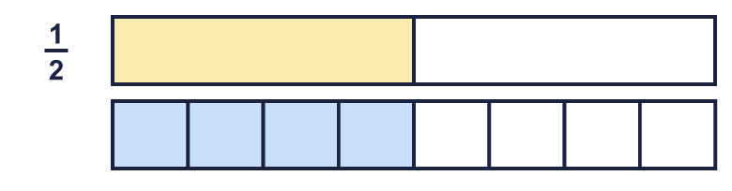  ¹⁄₂ = ?⁄₈
  1 | Each bar is the same length. Use the bars to find the missing numerator.  ¹⁄₂ = ?⁄₈
  2 | Write the missing numerator in each pair of equal fractions.  a) ³⁄₄ = ?⁄₈  b) ³⁄₅ = ?⁄₁₀  c) ¹⁄₂ = ?⁄₄
  2 | Write the missing numerator in each pair of equal fractions.  a) ³⁄₄ = ?⁄₈  b) ³⁄₅ = ?⁄₁₀  c) ¹⁄₂ = ?⁄₄
  3 | Shade the bar to show ³⁄₅.  
  3 | Shade the bar to show ³⁄₅.
  4 | Each bar is the same length. Use the bars to find the missing numerator.  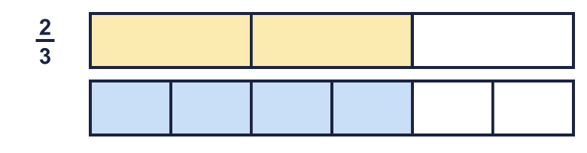  ²⁄₃ = ?⁄₆
  4 | Each bar is the same length. Use the bars to find the missing numerator.  ²⁄₃ = ?⁄₆
  5 | Write the missing numerator in each pair of equal fractions.  a) ¹⁄₃ = ?⁄₆  b) ¹⁄₂ = ?⁄₆
  5 | Write the missing numerator in each pair of equal fractions.  a) ¹⁄₃ = ?⁄₆  b) ¹⁄₂ = ?⁄₆
  6 | Each bar is the same length. Use the bars to find the missing numerator.  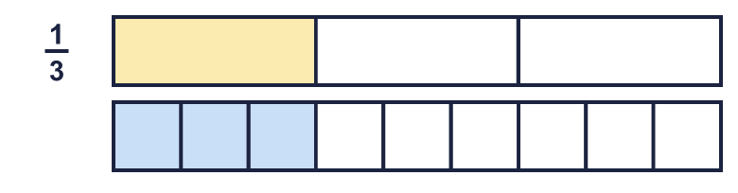  ¹⁄₃ = ?⁄₉
  6 | Each bar is the same length. Use the bars to find the missing numerator.  ¹⁄₃ = ?⁄₉
  7 | Shade the bar to show ⁷⁄₁₀.  
  7 | Shade the bar to show ⁷⁄₁₀.
  8 | Write the missing numerator in each pair of equal fractions.  a) ²⁄₃ = ?⁄₉  b) ⁴⁄₅ = ?⁄₁₀  c) ¹⁄₃ = ?⁄₆
  8 | Write the missing numerator in each pair of equal fractions.  a) ²⁄₃ = ?⁄₉  b) ⁴⁄₅ = ?⁄₁₀  c) ¹⁄₃ = ?⁄₆

  9 | Is Tiny correct? Circle yes or no.  Yes / No  Explain how you know.
     | 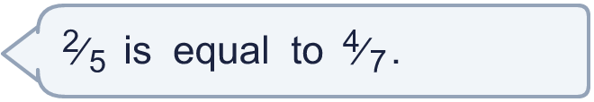
  9 | Is Tiny correct? Circle yes or no.  Yes / No  Explain how you know.
  10 | Each bar is the same length. Use the bars to find the missing numerator.  ¹⁄₂ = ?⁄₈
  10 | Each bar is the same length. Use the bars to find the missing numerator.  ¹⁄₂ = ?⁄₈
  11 | Is Tiny correct? Circle yes or no.  Yes / No  Explain how you know.
    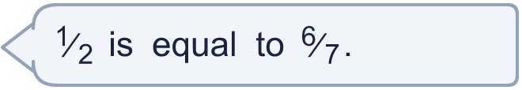
  11 | Is Tiny correct? Circle yes or no.  Yes / No  Explain how you know.
  12 | Write the missing numerator in each pair of equal fractions.  a) ²⁄₃ = ?⁄₆  b) ¹⁄₄ = ?⁄₈
  12 | Write the missing numerator in each pair of equal fractions.  a) ²⁄₃ = ?⁄₆  b) ¹⁄₄ = ?⁄₈
  13 | Is Tiny correct? Circle yes or no.  Yes / No  Explain how you know.
    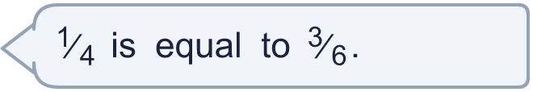
  13 | Is Tiny correct? Circle yes or no.  Yes / No  Explain how you know.
  14 | Each bar is the same length. Use the bars to find the missing numerator.  ²⁄₃ = ?⁄₆
  14 | Each bar is the same length. Use the bars to find the missing numerator.  ²⁄₃ = ?⁄₆

Year 3 · Fractions A · Step 10
Equivalent fractions as bar models
Answers (teacher copy)

  1 | Each bar is the same length. Use the bars to find the missing numerator.  ¹⁄₂ = ?⁄₈ 4
  2 | Write the missing numerator in each pair of equal fractions.  a) ³⁄₄ = ?⁄₈ 6  b) ³⁄₅ = ?⁄₁₀ 6  c) ¹⁄₂ = ?⁄₄ 2
  3 | Shade the bar to show ³⁄₅.  
  4 | Each bar is the same length. Use the bars to find the missing numerator.  ²⁄₃ = ?⁄₆ 4
  5 | Write the missing numerator in each pair of equal fractions.  a) ¹⁄₃ = ?⁄₆ 2  b) ¹⁄₂ = ?⁄₆ 3
  6 | Each bar is the same length. Use the bars to find the missing numerator.  ¹⁄₃ = ?⁄₉ 3
  7 | Shade the bar to show ⁷⁄₁₀.  
  8 | Write the missing numerator in each pair of equal fractions.  a) ²⁄₃ = ?⁄₉ 6  b) ⁴⁄₅ = ?⁄₁₀ 8  c) ¹⁄₃ = ?⁄₆ 2
  9 | Is Tiny correct? Circle yes or no.  Yes / No  Explain how you know.  ²⁄₅ and ⁴⁄₇ are not equal. ⁴⁄₇ is not the same place as ²⁄₅ on a number line.
  10 | Each bar is the same length. Use the bars to find the missing numerator.  ¹⁄₂ = ?⁄₈ 4
  11 | Is Tiny correct? Circle yes or no.  Yes / No  Explain how you know.  ¹⁄₂ and ⁶⁄₇ are not equal. ⁶⁄₇ is not the same place as ¹⁄₂ on a number line.
  12 | Write the missing numerator in each pair of equal fractions.  a) ²⁄₃ = ?⁄₆ 4  b) ¹⁄₄ = ?⁄₈ 2
  13 | Is Tiny correct? Circle yes or no.  Yes / No  Explain how you know.  ¹⁄₄ and ³⁄₆ are not equal. ³⁄₆ is not the same place as ¹⁄₄ on a number line.
  14 | Each bar is the same length. Use the bars to find the missing numerator.  ²⁄₃ = ?⁄₆ 4

