  Year 3 · Fractions A · Step 8  Count in fractions on a number line | 
  Year 3 · Fractions A · Step 8
  Count in fractions on a number line
  1 | Write the fraction shown by each lettered box on the number line.  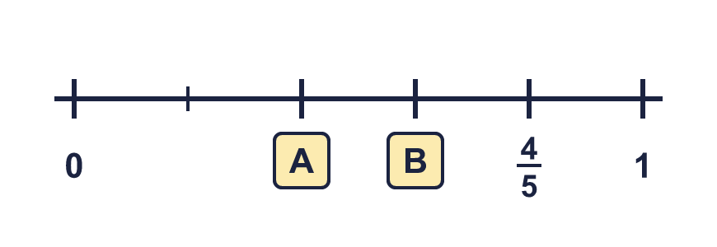
  1 | Write the fraction shown by each lettered box on the number line.
  2 | This sequence counts on in fifths. Write the next two numbers.  ¹⁄₅, ²⁄₅, ³⁄₅, ..., ...
  2 | This sequence counts on in fifths. Write the next two numbers.  ¹⁄₅, ²⁄₅, ³⁄₅, ..., ...
  3 | Write the fraction shown by each lettered box on the number line.
  3 | Write the fraction shown by each lettered box on the number line.
  4 | This sequence counts back in fifths. Write the next two numbers.  ⁵⁄₅, ⁴⁄₅, ³⁄₅, ..., ...
  4 | This sequence counts back in fifths. Write the next two numbers.  ⁵⁄₅, ⁴⁄₅, ³⁄₅, ..., ...
  5 | The number line goes from 0 to 1. What fraction is each arrow pointing to?  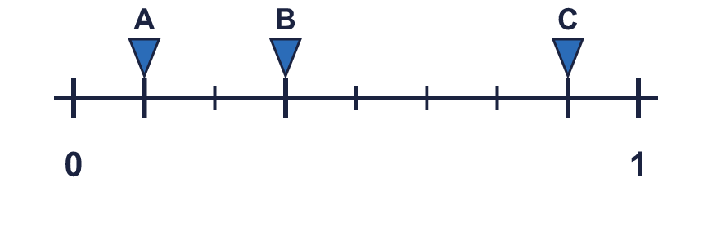
  5 | The number line goes from 0 to 1. What fraction is each arrow pointing to?
  6 | This sequence counts on in fifths. Write the next two numbers.  ¹⁄₅, ²⁄₅, ³⁄₅, ..., ...
  6 | This sequence counts on in fifths. Write the next two numbers.  ¹⁄₅, ²⁄₅, ³⁄₅, ..., ...
  7 | Write the fraction shown by each lettered box on the number line.
  7 | Write the fraction shown by each lettered box on the number line.
  8 | This sequence counts back in fifths. Write the next two numbers.  ⁵⁄₅, ⁴⁄₅, ³⁄₅, ..., ...
  8 | This sequence counts back in fifths. Write the next two numbers.  ⁵⁄₅, ⁴⁄₅, ³⁄₅, ..., ...

  9 | The number line goes from 0 to 1. What fraction is each arrow pointing to?  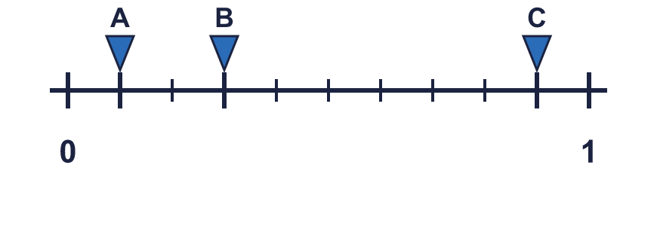
  9 | The number line goes from 0 to 1. What fraction is each arrow pointing to?
  10 | This sequence counts on in fifths. Write the next two numbers.  ¹⁄₅, ²⁄₅, ³⁄₅, ..., ...
  10 | This sequence counts on in fifths. Write the next two numbers.  ¹⁄₅, ²⁄₅, ³⁄₅, ..., ...
  11 | Is Boba correct? Circle yes or no.  Yes / No  Explain your answer.
     | 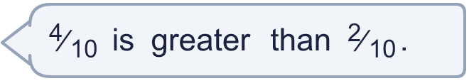
  11 | Is Boba correct? Circle yes or no.  Yes / No  Explain your answer.
  12 | Write the fraction shown by each lettered box on the number line.  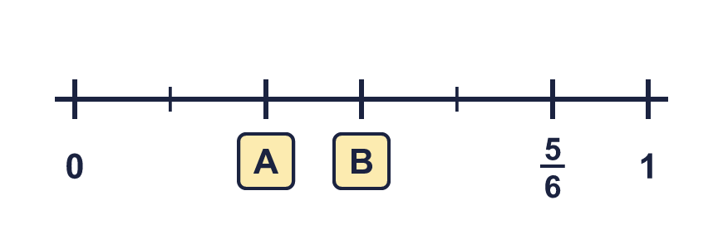
  12 | Write the fraction shown by each lettered box on the number line.
  13 | This sequence counts back in fifths. Write the next two numbers.  ⁵⁄₅, ⁴⁄₅, ³⁄₅, ..., ...
  13 | This sequence counts back in fifths. Write the next two numbers.  ⁵⁄₅, ⁴⁄₅, ³⁄₅, ..., ...
  14 | The number line goes from 0 to 1. What fraction is each arrow pointing to?  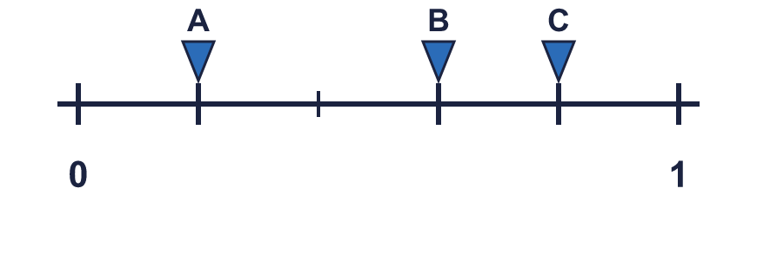
  14 | The number line goes from 0 to 1. What fraction is each arrow pointing to?

Year 3 · Fractions A · Step 8
Count in fractions on a number line
Answers (teacher copy)

  1 | Write the fraction shown by each lettered box on the number line.  A = ²⁄₅ B = ³⁄₅
  2 | This sequence counts on in fifths. Write the next two numbers.  ¹⁄₅, ²⁄₅, ³⁄₅, ..., ...  ⁴⁄₅ 1
  3 | Write the fraction shown by each lettered box on the number line.  A = ²⁄₅ B = ³⁄₅
  4 | This sequence counts back in fifths. Write the next two numbers.  ⁵⁄₅, ⁴⁄₅, ³⁄₅, ..., ...  ²⁄₅ ¹⁄₅
  5 | The number line goes from 0 to 1. What fraction is each arrow pointing to?  A = ¹⁄₈ B = ³⁄₈ C = ⁷⁄₈
  6 | This sequence counts on in fifths. Write the next two numbers.  ¹⁄₅, ²⁄₅, ³⁄₅, ..., ...  ⁴⁄₅ 1
  7 | Write the fraction shown by each lettered box on the number line.  A = ²⁄₅ B = ³⁄₅
  8 | This sequence counts back in fifths. Write the next two numbers.  ⁵⁄₅, ⁴⁄₅, ³⁄₅, ..., ...  ²⁄₅ ¹⁄₅
  9 | The number line goes from 0 to 1. What fraction is each arrow pointing to?  A = ¹⁄₁₀ B = ³⁄₁₀ C = ⁹⁄₁₀
  10 | This sequence counts on in fifths. Write the next two numbers.  ¹⁄₅, ²⁄₅, ³⁄₅, ..., ...  ⁴⁄₅ 1
  11 | Is Boba correct? Circle yes or no.  Yes / No  Explain your answer.  ⁴⁄₁₀ and ²⁄₁₀ have the same denominator, so compare the numerators: ⁴⁄₁₀ is greater than ²⁄₁₀.
  12 | Write the fraction shown by each lettered box on the number line.  A = ²⁄₆ B = ³⁄₆
  13 | This sequence counts back in fifths. Write the next two numbers.  ⁵⁄₅, ⁴⁄₅, ³⁄₅, ..., ...  ²⁄₅ ¹⁄₅
  14 | The number line goes from 0 to 1. What fraction is each arrow pointing to?  A = ¹⁄₅ B = ³⁄₅ C = ⁴⁄₅

