  Year 3 · Fractions A · Step 2  Compare and order unit fractions | 
  Year 3 · Fractions A · Step 2
  Compare and order unit fractions
  1 | Write <, > or = in each box.
    a) | ¹⁄₈ |  | ¹⁄₁₂
    b) | ¹⁄₃ |  | ¹⁄₁₀
    c) | ¹⁄₉ |  | ¹⁄₁₂
  1 | Write <, > or = in each box.
    a) | ¹⁄₈ |  | ¹⁄₁₂
    b) | ¹⁄₃ |  | ¹⁄₁₀
    c) | ¹⁄₉ |  | ¹⁄₁₂
  2 | Write the fractions in order.  a) ¹⁄₂ ¹⁄₈ ¹⁄₁₀ ¹⁄₅  b) ¹⁄₅ ¹⁄₃ ¹⁄₁₀ ¹⁄₄
  2 | Write the fractions in order.  a) ¹⁄₂ ¹⁄₈ ¹⁄₁₀ ¹⁄₅  b) ¹⁄₅ ¹⁄₃ ¹⁄₁₀ ¹⁄₄
  3 | Look at the number line from 0 to 1.  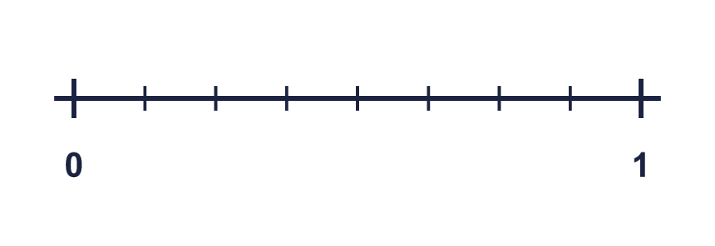
    The line is split into
    equal parts.
    Each part is worth one
  3 | Look at the number line from 0 to 1.
    The line is split into
    equal parts.
    Each part is worth one
  4 | Write <, > or = in each box.
    a) | ¹⁄₈ |  | ¹⁄₇
    b) | ¹⁄₄ |  | ¹⁄₆
  4 | Write <, > or = in each box.
    a) | ¹⁄₈ |  | ¹⁄₇
    b) | ¹⁄₄ |  | ¹⁄₆
  5 | Shade the bar to show ¹⁄₅.  
  5 | Shade the bar to show ¹⁄₅.
  6 | Write each fraction in numbers.
    a) | one eighth
    b) | one quarter
    c) | one sixth
  6 | Write each fraction in numbers.
    a) | one eighth
    b) | one quarter
    c) | one sixth
  7 | Write <, > or = in each box.
    a) | ¹⁄₈ |  | ¹⁄₉
    b) | ¹⁄₄ |  | ¹⁄₈
    c) | ¹⁄₂ |  | ¹⁄₃
  7 | Write <, > or = in each box.
    a) | ¹⁄₈ |  | ¹⁄₉
    b) | ¹⁄₄ |  | ¹⁄₈
    c) | ¹⁄₂ |  | ¹⁄₃
  8 | Write the fractions in order.  a) ¹⁄₈ ¹⁄₄ ¹⁄₆ ¹⁄₅  b) ¹⁄₃ ¹⁄₆ ¹⁄₈ ¹⁄₅
  8 | Write the fractions in order.  a) ¹⁄₈ ¹⁄₄ ¹⁄₆ ¹⁄₅  b) ¹⁄₃ ¹⁄₆ ¹⁄₈ ¹⁄₅

  9 | Is Tiara correct? Circle yes or no.  Yes / No  Explain your answer.
     | 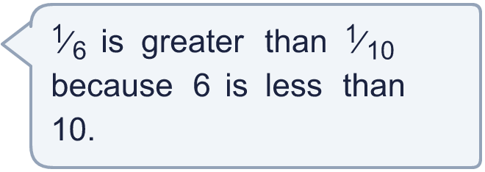
  9 | Is Tiara correct? Circle yes or no.  Yes / No  Explain your answer.
  10 | Is Tiara correct? Circle yes or no.  Yes / No  Explain your answer.
    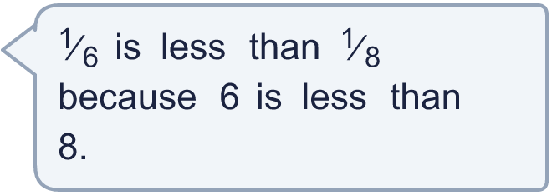
  10 | Is Tiara correct? Circle yes or no.  Yes / No  Explain your answer.
  11 | A pie is cut into 4 equal pieces. Ana eats 1 of the pieces.  What fraction of the pie does Ana eat?
  11 | A pie is cut into 4 equal pieces. Ana eats 1 of the pieces.  What fraction of the pie does Ana eat?
  12 | Write each fraction in numbers.
    a) | one tenth
    b) | one half
    c) | one third
  12 | Write each fraction in numbers.
    a) | one tenth
    b) | one half
    c) | one third
  13 | Is Tiara correct? Circle yes or no.  Yes / No  Explain your answer.
    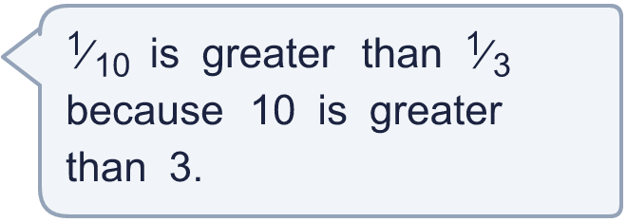
  13 | Is Tiara correct? Circle yes or no.  Yes / No  Explain your answer.
  14 | Look at the bar. It is one whole.  
    The whole is split into
    equal parts.
    The denominator is
    The fraction shaded is
  14 | Look at the bar. It is one whole.
    The whole is split into
    equal parts.
    The denominator is
    The fraction shaded is

Year 3 · Fractions A · Step 2
Compare and order unit fractions
Answers (teacher copy)

  1 | Write <, > or = in each box.  a) ¹⁄₈ > ¹⁄₁₂  b) ¹⁄₃ > ¹⁄₁₀  c) ¹⁄₉ > ¹⁄₁₂
  2 | Write the fractions in order.  a) ¹⁄₂ ¹⁄₈ ¹⁄₁₀ ¹⁄₅  smallest first: ¹⁄₁₀, ¹⁄₈, ¹⁄₅, ¹⁄₂  b) ¹⁄₅ ¹⁄₃ ¹⁄₁₀ ¹⁄₄  greatest first: ¹⁄₃, ¹⁄₄, ¹⁄₅, ¹⁄₁₀
  3 | Look at the number line from 0 to 1.  The line is split into 8 equal parts.  Each part is worth one eighth
  4 | Write <, > or = in each box.  a) ¹⁄₈ < ¹⁄₇  b) ¹⁄₄ > ¹⁄₆
  5 | Shade the bar to show ¹⁄₅.  
  6 | Write each fraction in numbers.  a) one eighth ¹⁄₈  b) one quarter ¹⁄₄  c) one sixth ¹⁄₆
  7 | Write <, > or = in each box.  a) ¹⁄₈ > ¹⁄₉  b) ¹⁄₄ > ¹⁄₈  c) ¹⁄₂ > ¹⁄₃
  8 | Write the fractions in order.  a) ¹⁄₈ ¹⁄₄ ¹⁄₆ ¹⁄₅  smallest first: ¹⁄₈, ¹⁄₆, ¹⁄₅, ¹⁄₄  b) ¹⁄₃ ¹⁄₆ ¹⁄₈ ¹⁄₅  greatest first: ¹⁄₃, ¹⁄₅, ¹⁄₆, ¹⁄₈
  9 | Is Tiara correct? Circle yes or no.  Yes / No  Explain your answer.  ¹⁄₆ and ¹⁄₁₀: the greater the denominator, the smaller each part. ¹⁄₆ is greater than ¹⁄₁₀.
  10 | Is Tiara correct? Circle yes or no.  Yes / No  Explain your answer.  ¹⁄₆ and ¹⁄₈: the greater the denominator, the smaller each part. ¹⁄₆ is greater than ¹⁄₈.
  11 | A pie is cut into 4 equal pieces. Ana eats 1 of the pieces.  What fraction of the pie does Ana eat? ¹⁄₄
  12 | Write each fraction in numbers.  a) one tenth ¹⁄₁₀  b) one half ¹⁄₂  c) one third ¹⁄₃
  13 | Is Tiara correct? Circle yes or no.  Yes / No  Explain your answer.  ¹⁄₁₀ and ¹⁄₃: the greater the denominator, the smaller each part. ¹⁄₁₀ is less than ¹⁄₃.
  14 | Look at the bar. It is one whole.  The whole is split into 6 equal parts.  The denominator is 6  The fraction shaded is ¹⁄₆

