  Year 3 · Fractions A · Step 5  Compare and order non-unit fractions | 
  Year 3 · Fractions A · Step 5
  Compare and order non-unit fractions
  1 | Write <, > or = in each box.
    a) | ⁵⁄₆ |  | ²⁄₆
    b) | ¹⁄₅ |  | ²⁄₅
    c) | ⁵⁄₆ |  | ⁴⁄₆
  1 | Write <, > or = in each box.
    a) | ⁵⁄₆ |  | ²⁄₆
    b) | ¹⁄₅ |  | ²⁄₅
    c) | ⁵⁄₆ |  | ⁴⁄₆
  2 | Write the fractions in order.  a) ⁴⁄₅ ¹⁄₅ ³⁄₅ ²⁄₅  b) ²⁄₆ ⁴⁄₆ ¹⁄₆ ³⁄₆
  2 | Write the fractions in order.  a) ⁴⁄₅ ¹⁄₅ ³⁄₅ ²⁄₅  b) ²⁄₆ ⁴⁄₆ ¹⁄₆ ³⁄₆
  3 | Write <, > or = in each box.
    a) | ⁴⁄₅ |  | ⁴⁄₁₀
    b) | ³⁄₅ |  | ³⁄₈
    c) | ²⁄₁₀ |  | ²⁄₅
  3 | Write <, > or = in each box.
    a) | ⁴⁄₅ |  | ⁴⁄₁₀
    b) | ³⁄₅ |  | ³⁄₈
    c) | ²⁄₁₀ |  | ²⁄₅
  4 | Eli eats ⁷⁄₈ of a pizza. Cal eats ¹⁄₈ of the same pizza.
  4 | Eli eats ⁷⁄₈ of a pizza. Cal eats ¹⁄₈ of the same pizza.
  5 | Write <, > or = in each box.
    a) | ⁴⁄₆ |  | ²⁄₆
    b) | ³⁄₆ |  | ⁴⁄₆
  5 | Write <, > or = in each box.
    a) | ⁴⁄₆ |  | ²⁄₆
    b) | ³⁄₆ |  | ⁴⁄₆
  6 | Write the fractions in order.  a) ¹⁄₁₀ ⁴⁄₁₀ ⁷⁄₁₀ ³⁄₁₀  b) ⁶⁄₁₀ ⁴⁄₁₀ ⁸⁄₁₀ ³⁄₁₀
  6 | Write the fractions in order.  a) ¹⁄₁₀ ⁴⁄₁₀ ⁷⁄₁₀ ³⁄₁₀  b) ⁶⁄₁₀ ⁴⁄₁₀ ⁸⁄₁₀ ³⁄₁₀
  7 | Shade the bar to show ²⁄₃.  
  7 | Shade the bar to show ²⁄₃.
  8 | Write <, > or = in each box.
    a) | ¹⁄₆ |  | ¹⁄₁₀
    b) | ²⁄₁₀ |  | ²⁄₄
    c) | ⁴⁄₅ |  | ⁴⁄₉
  8 | Write <, > or = in each box.
    a) | ¹⁄₆ |  | ¹⁄₁₀
    b) | ²⁄₁₀ |  | ²⁄₄
    c) | ⁴⁄₅ |  | ⁴⁄₉

  9 | Is Tiny correct? Circle yes or no.  Yes / No  Explain your answer.
     | 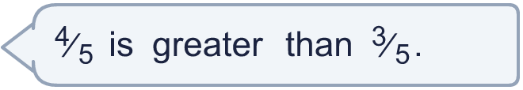
  9 | Is Tiny correct? Circle yes or no.  Yes / No  Explain your answer.
  10 | Ben eats ⁷⁄₈ of a pizza. Fay eats ⁴⁄₈ of the same pizza.
  10 | Ben eats ⁷⁄₈ of a pizza. Fay eats ⁴⁄₈ of the same pizza.
  11 | Is Tiny correct? Circle yes or no.  Yes / No  Explain your answer.
    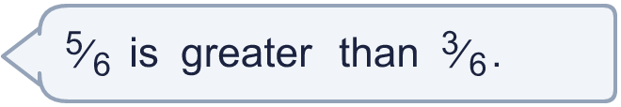
  11 | Is Tiny correct? Circle yes or no.  Yes / No  Explain your answer.
  12 | A pie is cut into 4 equal pieces. Eli eats 3 of the pieces.  What fraction of the pie does Eli eat?
  12 | A pie is cut into 4 equal pieces. Eli eats 3 of the pieces.  What fraction of the pie does Eli eat?
  13 | Cal eats ⁶⁄₁₀ of a pizza. Dee eats ⁸⁄₁₀ of the same pizza.
  13 | Cal eats ⁶⁄₁₀ of a pizza. Dee eats ⁸⁄₁₀ of the same pizza.
  14 | Is Boba correct? Circle yes or no.  Yes / No  Explain your answer.
    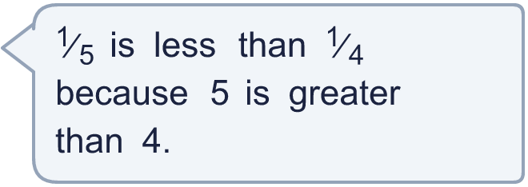
  14 | Is Boba correct? Circle yes or no.  Yes / No  Explain your answer.

Year 3 · Fractions A · Step 5
Compare and order non-unit fractions
Answers (teacher copy)

  1 | Write <, > or = in each box.  a) ⁵⁄₆ > ²⁄₆  b) ¹⁄₅ < ²⁄₅  c) ⁵⁄₆ > ⁴⁄₆
  2 | Write the fractions in order.  a) ⁴⁄₅ ¹⁄₅ ³⁄₅ ²⁄₅  smallest first: ¹⁄₅, ²⁄₅, ³⁄₅, ⁴⁄₅  b) ²⁄₆ ⁴⁄₆ ¹⁄₆ ³⁄₆  greatest first: ⁴⁄₆, ³⁄₆, ²⁄₆, ¹⁄₆
  3 | Write <, > or = in each box.  a) ⁴⁄₅ > ⁴⁄₁₀  b) ³⁄₅ > ³⁄₈  c) ²⁄₁₀ < ²⁄₅
  4 | Eli eats ⁷⁄₈ of a pizza. Cal eats ¹⁄₈ of the same pizza.  Who eats the most pizza? Eli
  5 | Write <, > or = in each box.  a) ⁴⁄₆ > ²⁄₆  b) ³⁄₆ < ⁴⁄₆
  6 | Write the fractions in order.  a) ¹⁄₁₀ ⁴⁄₁₀ ⁷⁄₁₀ ³⁄₁₀  smallest first: ¹⁄₁₀, ³⁄₁₀, ⁴⁄₁₀, ⁷⁄₁₀  b) ⁶⁄₁₀ ⁴⁄₁₀ ⁸⁄₁₀ ³⁄₁₀  greatest first: ⁸⁄₁₀, ⁶⁄₁₀, ⁴⁄₁₀, ³⁄₁₀
  7 | Shade the bar to show ²⁄₃.  
  8 | Write <, > or = in each box.  a) ¹⁄₆ > ¹⁄₁₀  b) ²⁄₁₀ < ²⁄₄  c) ⁴⁄₅ > ⁴⁄₉
  9 | Is Tiny correct? Circle yes or no.  Yes / No  Explain your answer.  ⁴⁄₅ and ³⁄₅ have the same denominator, so compare the numerators: ⁴⁄₅ is greater than ³⁄₅.
  10 | Ben eats ⁷⁄₈ of a pizza. Fay eats ⁴⁄₈ of the same pizza.  Who eats the most pizza? Ben
  11 | Is Tiny correct? Circle yes or no.  Yes / No  Explain your answer.  ⁵⁄₆ and ³⁄₆ have the same denominator, so compare the numerators: ⁵⁄₆ is greater than ³⁄₆.
  12 | A pie is cut into 4 equal pieces. Eli eats 3 of the pieces.  What fraction of the pie does Eli eat? ³⁄₄
  13 | Cal eats ⁶⁄₁₀ of a pizza. Dee eats ⁸⁄₁₀ of the same pizza.  Who eats the most pizza? Dee
  14 | Is Boba correct? Circle yes or no.  Yes / No  Explain your answer.  ¹⁄₅ and ¹⁄₄: the greater the denominator, the smaller each part. ¹⁄₅ is less than ¹⁄₄.

