  Year 3 · Place value · Step 5  Represent numbers to 1000 | 
  Year 3 · Place value · Step 5
  Represent numbers to 1000
  1 | Look at the base ten blocks. A flat is 1 hundred, a rod is 1 ten and a cube is 1 one.  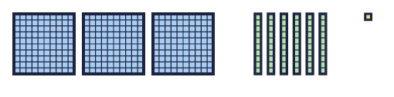  a) How many hundreds?  b) How many tens?  c) How many ones?
  1 | Look at the base ten blocks. A flat is 1 hundred, a rod is 1 ten and a cube is 1 one.  a) How many hundreds?  b) How many tens?  c) How many ones?
  2 | What number do the base ten blocks show?  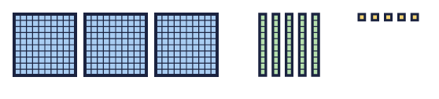
    The number is
  2 | What number do the base ten blocks show?
    The number is
  3 | What number is shown in the place value chart?  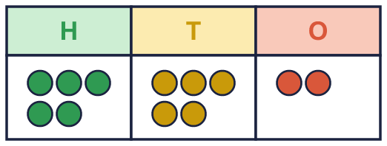
    The number is
  3 | What number is shown in the place value chart?
    The number is
  4 | Draw base ten blocks to show 532 in your book.    a) How many flats did you draw?  b) How many rods did you draw?  c) How many cubes did you draw?
  4 | Draw base ten blocks to show 532 in your book.  a) How many flats did you draw?  b) How many rods did you draw?  c) How many cubes did you draw?
  5 | Write each number.  a) 7 hundreds, 5 tens and 8 ones =  b) 9 hundreds, 5 tens and 7 ones =
  5 | Write each number.  a) 7 hundreds, 5 tens and 8 ones =  b) 9 hundreds, 5 tens and 7 ones =
  6 | What is the value of the digit in each number?  a) the digit 1 in 631:  b) the digit 4 in 841:
  6 | What is the value of the digit in each number?  a) the digit 1 in 631:  b) the digit 4 in 841:
  7 | Which picture shows 645? Write the letter.  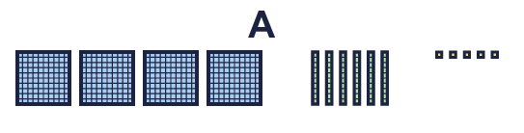  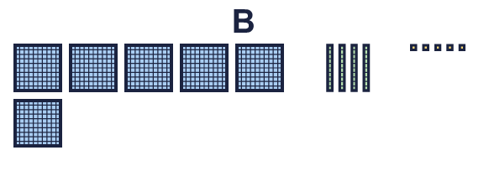
    The answer is picture
  7 | Which picture shows 645? Write the letter.
    The answer is picture
  8 | Look at the number 711.  a) How many hundreds does it have?  b) How many tens does it have?  c) How many ones does it have?
  8 | Look at the number 711.  a) How many hundreds does it have?  b) How many tens does it have?  c) How many ones does it have?

  9 | Tiny uses base ten blocks to make 293 in different ways. Which picture does not show 293? Write the letter.  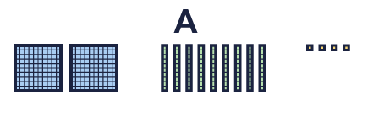    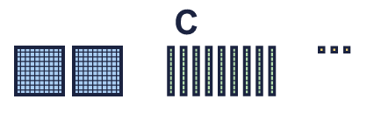
    The picture that does not show 293 is picture
  9 | Tiny uses base ten blocks to make 293 in different ways. Which picture does not show 293? Write the letter.
    The picture that does not show 293 is picture
  10 | 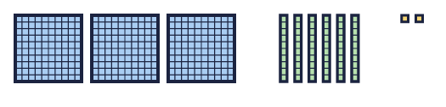  Is Mia correct? Circle yes or no.  Yes / No  Explain how you know.
     | 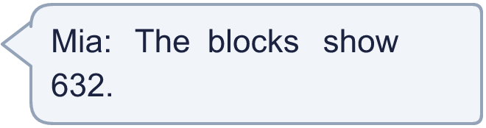
  10 | Is Mia correct? Circle yes or no.  Yes / No  Explain how you know.
  11 | Dora is thinking of a 3-digit number. There are 4 more hundreds than ones. There is an odd number of ones.
    How many different numbers could it be?
  11 | Dora is thinking of a 3-digit number. There are 4 more hundreds than ones. There is an odd number of ones.
    How many different numbers could it be?
  12 | Write the number. There are more than 9 tens, so exchange 10 tens for 1 hundred.  a) 5 hundreds, 15 tens and 5 ones =
  12 | Write the number. There are more than 9 tens, so exchange 10 tens for 1 hundred.  a) 5 hundreds, 15 tens and 5 ones =
  13 | 426 can be made with 40 tens and some ones.  a) 426 is 40 tens and how many ones?
  13 | 426 can be made with 40 tens and some ones.  a) 426 is 40 tens and how many ones?
  14 | Challenge  Leo is thinking of a 3-digit number. The digits add up to 12. The number is even.  Write a number Leo could be thinking of:
  14 | Challenge  Leo is thinking of a 3-digit number. The digits add up to 12. The number is even.  Write a number Leo could be thinking of:

Year 3 · Place value · Step 5
Represent numbers to 1000
Answers (teacher copy)

  1 | Look at the base ten blocks. A flat is 1 hundred, a rod is 1 ten and a cube is 1 one.  a) How many hundreds? 3  b) How many tens? 6  c) How many ones? 1
  2 | What number do the base ten blocks show?  The number is 355
  3 | What number is shown in the place value chart?  The number is 552
  4 | Draw base ten blocks to show 532 in your book.  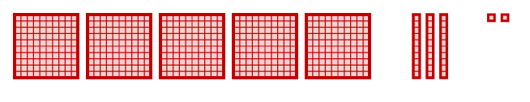  a) How many flats did you draw? 5  b) How many rods did you draw? 3  c) How many cubes did you draw? 2
  5 | Write each number.  a) 7 hundreds, 5 tens and 8 ones = 758  b) 9 hundreds, 5 tens and 7 ones = 957
  6 | What is the value of the digit in each number?  a) the digit 1 in 631: 1  b) the digit 4 in 841: 40
  7 | Which picture shows 645? Write the letter.  The answer is picture B
  8 | Look at the number 711.  a) How many hundreds does it have? 7  b) How many tens does it have? 1  c) How many ones does it have? 1
  9 | Tiny uses base ten blocks to make 293 in different ways. Which picture does not show 293? Write the letter.  The picture that does not show 293 is picture A
  10 | Is Mia correct? Circle yes or no.  Yes / No  Explain how you know.  No. There are 3 hundreds, 6 tens and 2 ones, so the blocks show 362.
  11 | Dora is thinking of a 3-digit number. There are 4 more hundreds than ones. There is an odd number of ones.  How many different numbers could it be? 30
  12 | Write the number. There are more than 9 tens, so exchange 10 tens for 1 hundred.  a) 5 hundreds, 15 tens and 5 ones = 655
  13 | 426 can be made with 40 tens and some ones.  a) 426 is 40 tens and how many ones? 26
  14 | Challenge  Leo is thinking of a 3-digit number. The digits add up to 12. The number is even.  Write a number Leo could be thinking of: 156

