  Year 3 · Place value · Step 1  Represent numbers to 100 | 
  Year 3 · Place value · Step 1
  Represent numbers to 100
  1 | Look at the base ten blocks. A long rod is 1 ten and a small cube is 1 one.  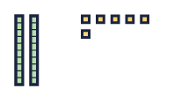  a) How many tens?  b) How many ones?
  1 | Look at the base ten blocks. A long rod is 1 ten and a small cube is 1 one.  a) How many tens?  b) How many ones?
  2 | What number do the base ten blocks show?  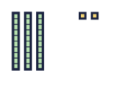
    The number is
  2 | What number do the base ten blocks show?
    The number is
  3 | What number is shown in the place value chart?  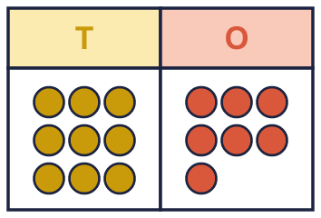
    The number is
  3 | What number is shown in the place value chart?
    The number is
  4 | Draw base ten blocks to show 23 in your book. Use rods for tens and cubes for ones.    a) How many tens did you draw?  b) How many ones did you draw?
  4 | Draw base ten blocks to show 23 in your book. Use rods for tens and cubes for ones.  a) How many tens did you draw?  b) How many ones did you draw?
  5 | Write each number.  a) 1 ten and 2 ones =  b) 8 tens and 6 ones =
  5 | Write each number.  a) 1 ten and 2 ones =  b) 8 tens and 6 ones =
  6 | What is the value of the digit in each number?  a) the digit 3 in 35:  b) the digit 5 in 58:
  6 | What is the value of the digit in each number?  a) the digit 3 in 35:  b) the digit 5 in 58:
  7 | Which picture shows 34? Write the letter.  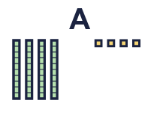  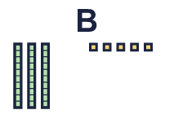  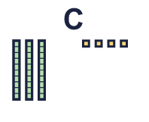
    The answer is picture
  7 | Which picture shows 34? Write the letter.
    The answer is picture
  8 | Look at the number 15.  a) How many tens are in this number?  b) How many ones are in this number?
  8 | Look at the number 15.  a) How many tens are in this number?  b) How many ones are in this number?

  9 | Tiny uses base ten blocks to make 83 in different ways. Which picture does not show 83? Write the letter.  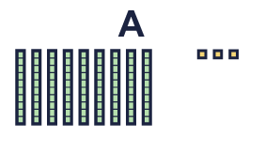  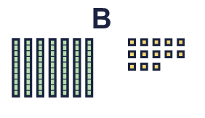  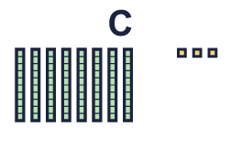
    The picture that does not show 83 is picture
  9 | Tiny uses base ten blocks to make 83 in different ways. Which picture does not show 83? Write the letter.
    The picture that does not show 83 is picture
  10 |   Is Ron correct? Circle yes or no.  Yes / No  Explain how you know.
     | 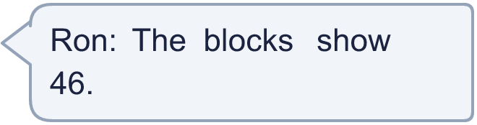
  10 | Is Ron correct? Circle yes or no.  Yes / No  Explain how you know.
  11 | Tia is thinking of a 2-digit number. There are 3 more tens than ones. There is an odd number of ones.
    How many different numbers could it be?
  11 | Tia is thinking of a 2-digit number. There are 3 more tens than ones. There is an odd number of ones.
    How many different numbers could it be?
  12 | Write the number. There are more than 9 ones, so exchange 10 ones for 1 ten.  a) 5 tens and 11 ones =
  12 | Write the number. There are more than 9 ones, so exchange 10 ones for 1 ten.  a) 5 tens and 11 ones =
  13 | 48 can be made with 3 tens and some ones.  a) 48 is 3 tens and how many ones?
  13 | 48 can be made with 3 tens and some ones.  a) 48 is 3 tens and how many ones?
  14 | Challenge  Mo is thinking of a 2-digit number. There are 3 more tens than ones. There is an odd number of ones.  Write a number Mo could be thinking of:
  14 | Challenge  Mo is thinking of a 2-digit number. There are 3 more tens than ones. There is an odd number of ones.  Write a number Mo could be thinking of:

Year 3 · Place value · Step 1
Represent numbers to 100
Answers (teacher copy)

  1 | Look at the base ten blocks. A long rod is 1 ten and a small cube is 1 one.  a) How many tens? 2  b) How many ones? 6
  2 | What number do the base ten blocks show?  The number is 32
  3 | What number is shown in the place value chart?  The number is 97
  4 | Draw base ten blocks to show 23 in your book. Use rods for tens and cubes for ones.  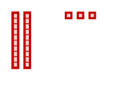  a) How many tens did you draw? 2  b) How many ones did you draw? 3
  5 | Write each number.  a) 1 ten and 2 ones = 12  b) 8 tens and 6 ones = 86
  6 | What is the value of the digit in each number?  a) the digit 3 in 35: 30  b) the digit 5 in 58: 50
  7 | Which picture shows 34? Write the letter.  The answer is picture C
  8 | Look at the number 15.  a) How many tens are in this number? 1  b) How many ones are in this number? 5
  9 | Tiny uses base ten blocks to make 83 in different ways. Which picture does not show 83? Write the letter.  The picture that does not show 83 is picture A
  10 | Is Ron correct? Circle yes or no.  Yes / No  Explain how you know.  No. There are 6 tens and 4 ones, so the blocks show 64.
  11 | Tia is thinking of a 2-digit number. There are 3 more tens than ones. There is an odd number of ones.  How many different numbers could it be? 3
  12 | Write the number. There are more than 9 ones, so exchange 10 ones for 1 ten.  a) 5 tens and 11 ones = 61
  13 | 48 can be made with 3 tens and some ones.  a) 48 is 3 tens and how many ones? 18
  14 | Challenge  Mo is thinking of a 2-digit number. There are 3 more tens than ones. There is an odd number of ones.  Write a number Mo could be thinking of: 63

