  Year 3 · Place value · Step 13  Order numbers to 1000 | 
  Year 3 · Place value · Step 13
  Order numbers to 1000
  1 | Put the numbers in order, smallest first.  473 185 194  Order:
  1 | Put the numbers in order, smallest first.  473 185 194  Order:
  2 | Put the numbers in order, greatest first.  791 872 973 831  Order:
  2 | Put the numbers in order, greatest first.  791 872 973 831  Order:
  3 | Ron has 723 points. Nina has 273 points. Sam has 453 points.
    Who has the fewest points?
  3 | Ron has 723 points. Nina has 273 points. Sam has 453 points.
    Who has the fewest points?
  4 | The numbers have the same hundreds digit. Put them in order, smallest first.  845 847 896 829  Order:
  4 | The numbers have the same hundreds digit. Put them in order, smallest first.  845 847 896 829  Order:
  5 | Write the numbers that are less than 540.  549 390 520 450 650  Numbers:
  5 | Write the numbers that are less than 540.  549 390 520 450 650  Numbers:
  6 | Sam has three digit cards: 5 7 6. Sam uses all three cards to make a 3-digit number.
    What is the largest number Sam can make?
  6 | Sam has three digit cards: 5 7 6. Sam uses all three cards to make a 3-digit number.
    What is the largest number Sam can make?
  7 | Write a number that is between 880 and 910.  A number between them:
  7 | Write a number that is between 880 and 910.  A number between them:
  8 | Put the numbers in order, greatest first.  925 409 152  Order:
  8 | Put the numbers in order, greatest first.  925 409 152  Order:

  9 | Put the numbers in order, smallest first.  673 637 763 376 367  Order:
     | 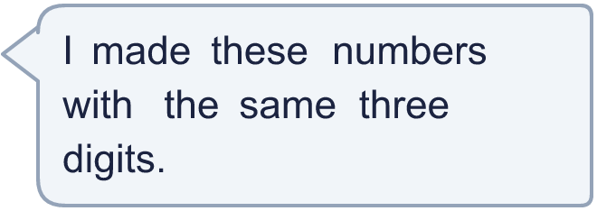
  9 | Put the numbers in order, smallest first.  673 637 763 376 367  Order:
  10 | Dora has 644 cards. Mo has 678 cards. Alex has 699 cards. Zach has 604 cards.
    Who has the most cards?
  10 | Dora has 644 cards. Mo has 678 cards. Alex has 699 cards. Zach has 604 cards.
    Who has the most cards?
  11 | Challenge  Here are four digit cards: 3 7 1 5. Make a 3-digit number using three of the cards.
    Write the largest number you can make.
  11 | Challenge  Here are four digit cards: 3 7 1 5. Make a 3-digit number using three of the cards.
    Write the largest number you can make.
  12 | Alex writes every number that is greater than 509 and less than 600 and has 1 in the tens place.
    How many numbers does Alex write?
  12 | Alex writes every number that is greater than 509 and less than 600 and has 1 in the tens place.
    How many numbers does Alex write?
  13 | Write a number that is between 795 and 801. It must be a multiple of 100.  A number between them:
  13 | Write a number that is between 795 and 801. It must be a multiple of 100.  A number between them:
  14 | Put the numbers in order, greatest first. Look at the tens, then the ones.  350 310 360 390 325  Order:
  14 | Put the numbers in order, greatest first. Look at the tens, then the ones.  350 310 360 390 325  Order:

Year 3 · Place value · Step 13
Order numbers to 1000
Answers (teacher copy)

  1 | Put the numbers in order, smallest first.  473 185 194  Order: 185, 194, 473
  2 | Put the numbers in order, greatest first.  791 872 973 831  Order: 973, 872, 831, 791
  3 | Ron has 723 points. Nina has 273 points. Sam has 453 points.  Who has the fewest points? Nina
  4 | The numbers have the same hundreds digit. Put them in order, smallest first.  845 847 896 829  Order: 829, 845, 847, 896
  5 | Write the numbers that are less than 540.  549 390 520 450 650  Numbers: 390, 520, 450
  6 | Sam has three digit cards: 5 7 6. Sam uses all three cards to make a 3-digit number.  What is the largest number Sam can make? 765
  7 | Write a number that is between 880 and 910.  A number between them: 895
  8 | Put the numbers in order, greatest first.  925 409 152  Order: 925, 409, 152
  9 | Put the numbers in order, smallest first.  673 637 763 376 367  Order: 367, 376, 637, 673, 763
  10 | Dora has 644 cards. Mo has 678 cards. Alex has 699 cards. Zach has 604 cards.  Who has the most cards? Alex
  11 | Challenge  Here are four digit cards: 3 7 1 5. Make a 3-digit number using three of the cards.  Write the largest number you can make. 753
  12 | Alex writes every number that is greater than 509 and less than 600 and has 1 in the tens place.  How many numbers does Alex write? 10
  13 | Write a number that is between 795 and 801. It must be a multiple of 100.  A number between them: 800
  14 | Put the numbers in order, greatest first. Look at the tens, then the ones.  350 310 360 390 325  Order: 390, 360, 350, 325, 310

