  Year 3 · Place value · Step 10  Number line to 1000 | 
  Year 3 · Place value · Step 10
  Number line to 1000
  1 | What number is the arrow pointing to?
    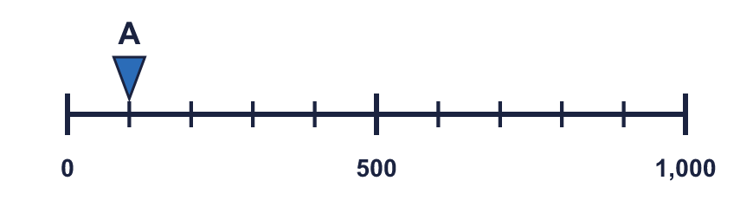
  1 | What number is the arrow pointing to?
  2 | What numbers are the arrows pointing to?  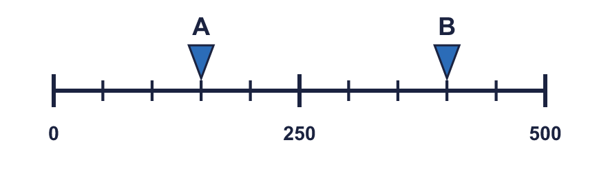
  2 | What numbers are the arrows pointing to?
  3 | Which arrow points to 800? Write its letter.  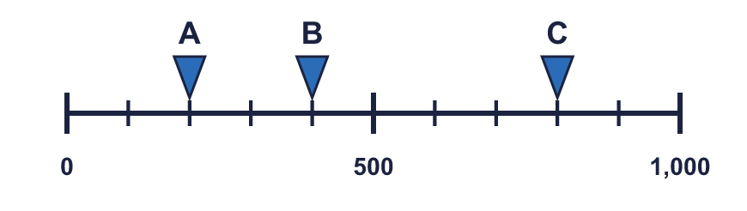  Answer:
  3 | Which arrow points to 800? Write its letter.  Answer:
  4 | Look at the number line.  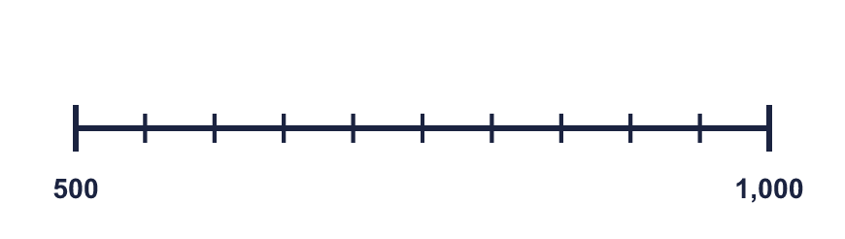  The difference between the start and the end is  The line counts up in
    There are |  | equal intervals.
  4 | Look at the number line.  The difference between the start and the end is  The line counts up in
    There are |  | equal intervals.
  5 | Write the missing numbers on the line.  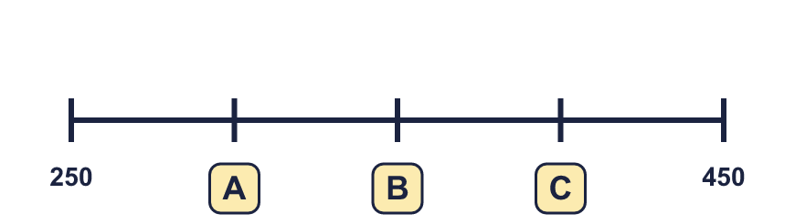
  5 | Write the missing numbers on the line.
  6 | What number is the arrow pointing to?
    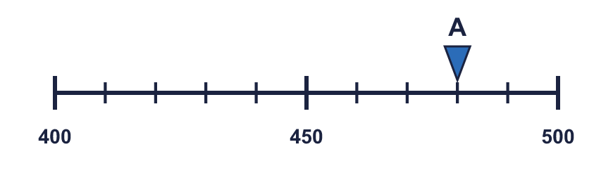
  6 | What number is the arrow pointing to?
  7 | What number is the arrow pointing to? It is exactly halfway between two marks.
    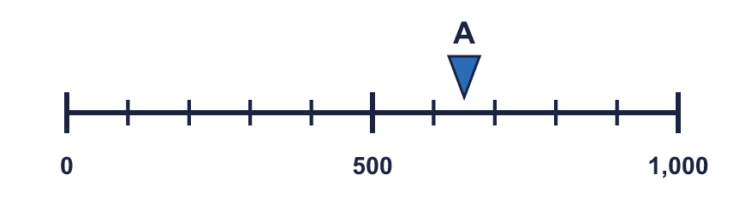
  7 | What number is the arrow pointing to? It is exactly halfway between two marks.
  8 | The arrow is between two marks. Which number is it closest to? Write the letter.  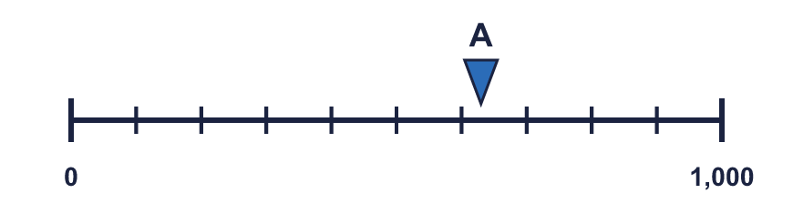  a) 800 b) 300 c) 600  Answer:
  8 | The arrow is between two marks. Which number is it closest to? Write the letter.  a) 800 b) 300 c) 600  Answer:

  9 | 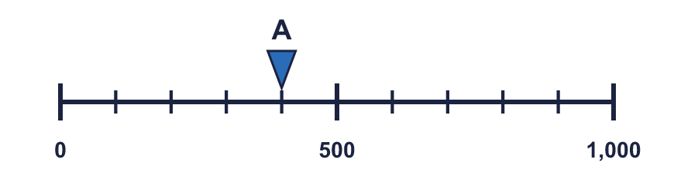  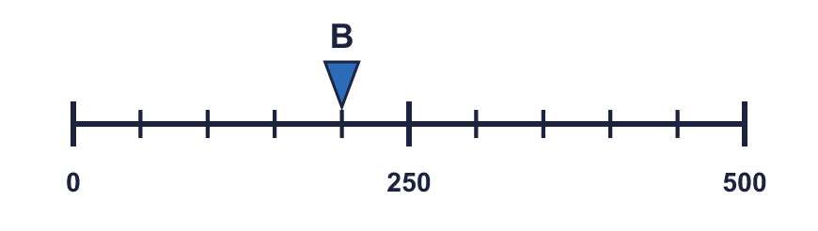  Is Boba correct? Circle yes or no.  Yes / No  Explain how you know.
    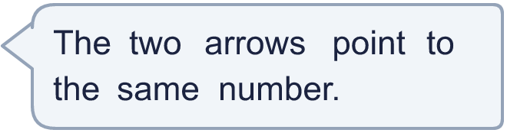
  9 | Is Boba correct? Circle yes or no.  Yes / No  Explain how you know.
  10 | 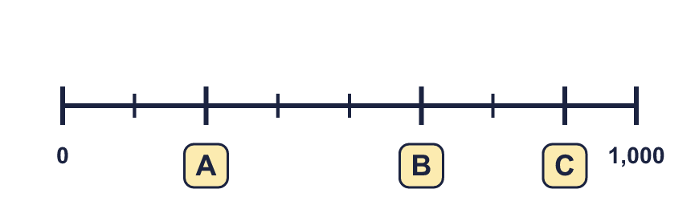
     | 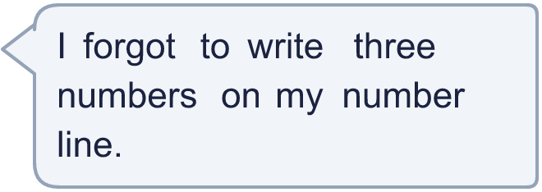
  10
  11 | 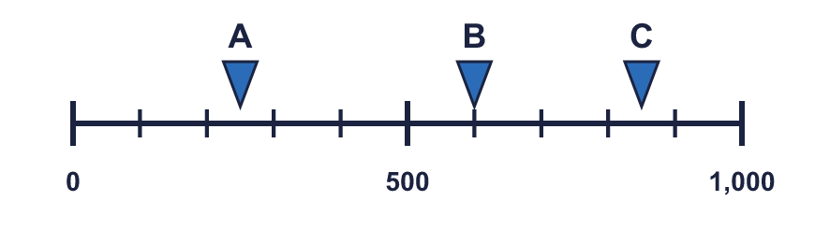  a) What number is arrow A pointing to?  b) What is the difference between B and C?
     | 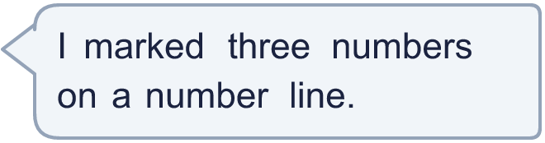
  11 | a) What number is arrow A pointing to?  b) What is the difference between B and C?
  12 | What numbers are the arrows pointing to?  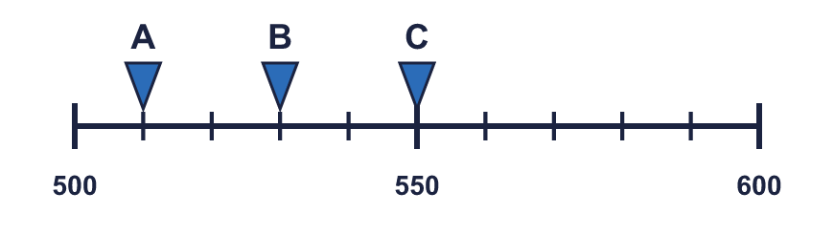
  12 | What numbers are the arrows pointing to?
  13 | 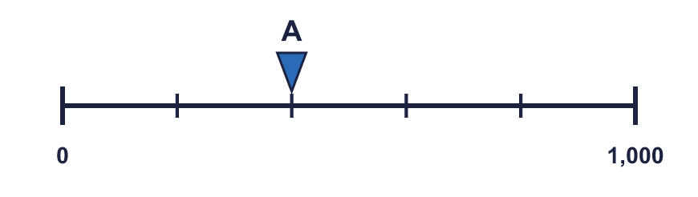  a) What is each step worth?  b) What number is arrow A pointing to?
     | 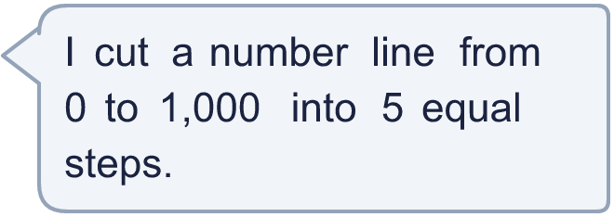
  13 | a) What is each step worth?  b) What number is arrow A pointing to?
  14 | 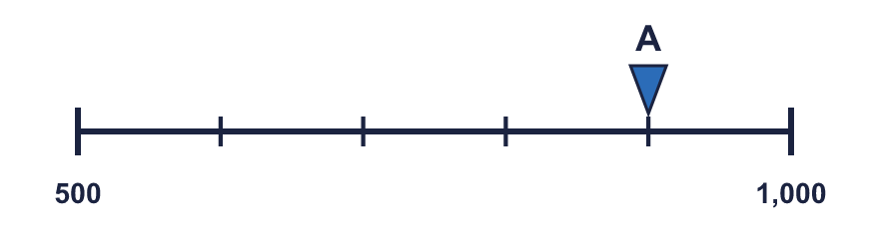  a) What mistake has Boba made?  b) What number is arrow A pointing to?
    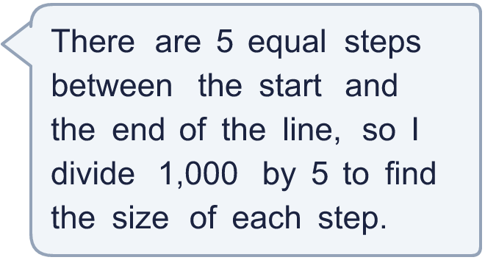
  14 | a) What mistake has Boba made?  b) What number is arrow A pointing to?

Year 3 · Place value · Step 10
Number line to 1000
Answers (teacher copy)

  1 | What number is the arrow pointing to?
    100
  2 | What numbers are the arrows pointing to?  A = 150 B = 400
  3 | Which arrow points to 800? Write its letter.  Answer: C
  4 | Look at the number line.  The difference between the start and the end is 500  There are 10 equal intervals.  The line counts up in 50
  5 | Write the missing numbers on the line.  A = 300 B = 350 C = 400
  6 | What number is the arrow pointing to?
    480
  7 | What number is the arrow pointing to? It is exactly halfway between two marks.
    650
  8 | The arrow is between two marks. Which number is it closest to? Write the letter.  a) 800 b) 300 c) 600  Answer: c
  9 | Is Boba correct? Circle yes or no.  Yes / No  Explain how you know.  Arrow A points to 400 and arrow B points to 200. The lines have different scales: line A ends at 1,000 and line B ends at 500.
  10 | A = 250 B = 625 C = 875
  11 | a) What number is arrow A pointing to? 250  b) What is the difference between B and C? 250
  12 | What numbers are the arrows pointing to?  A = 510 B = 530 C = 550
  13 | a) What is each step worth? 200  b) What number is arrow A pointing to? 400
  14 | a) What mistake has Boba made?  Boba divided the end number. The line does not start at 0, so each step is (1,000 − 500) ÷ 5 = 100.  b) What number is arrow A pointing to? 900

