  Year 3 · Place value · Step 3  Number line to 100 | 
  Year 3 · Place value · Step 3
  Number line to 100
  1 | What number is the arrow pointing to?
    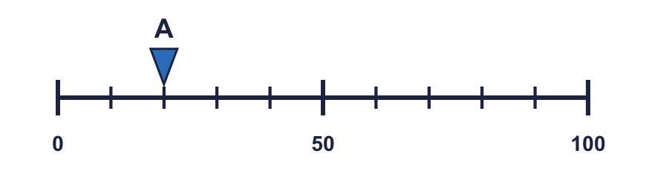
  1 | What number is the arrow pointing to?
  2 | What numbers are the arrows pointing to?  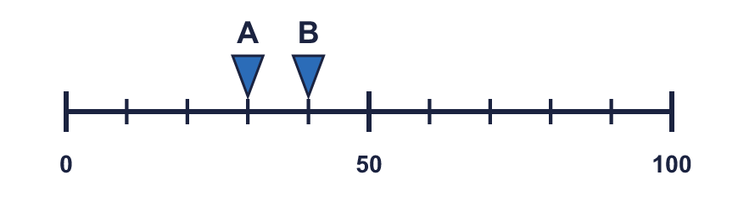
  2 | What numbers are the arrows pointing to?
  3 | Which arrow points to 30? Write its letter.  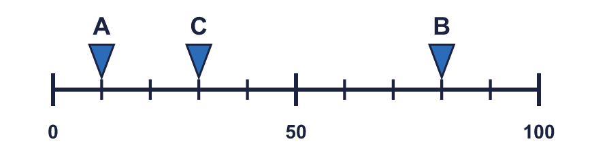  Answer:
  3 | Which arrow points to 30? Write its letter.  Answer:
  4 | Write the missing numbers on the line.  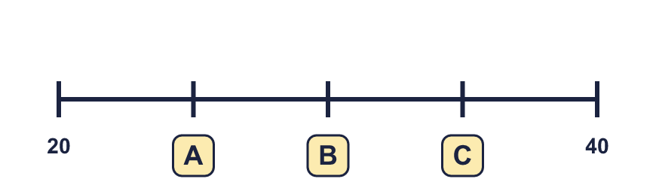
  4 | Write the missing numbers on the line.
  5 | Look at the number line.  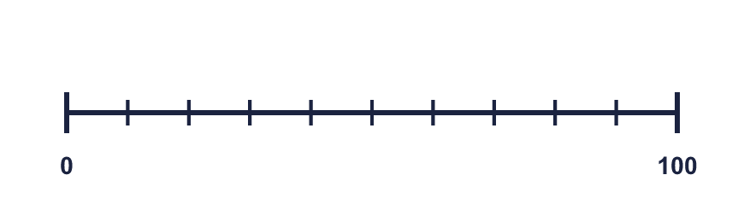  The difference between the start and the end is  The line counts up in
    There are |  | equal intervals.
  5 | Look at the number line.  The difference between the start and the end is  The line counts up in
    There are |  | equal intervals.
  6 | What number is the arrow pointing to? The line goes up in 2s.
    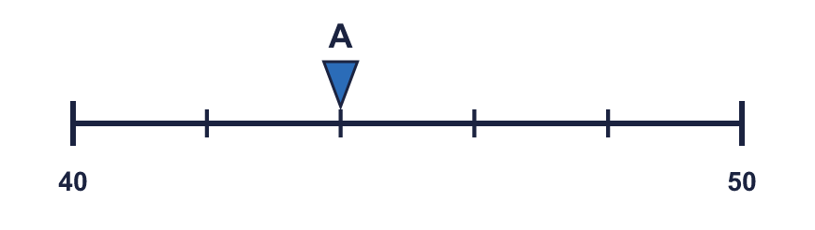
  6 | What number is the arrow pointing to? The line goes up in 2s.
  7 | What number is the arrow pointing to? The line goes up in 5s.
    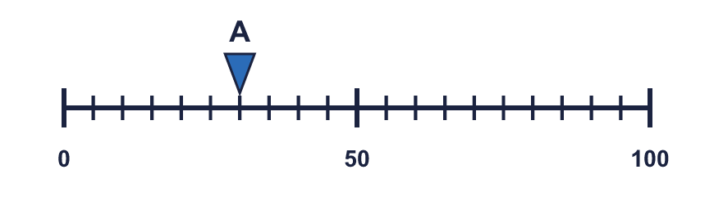
  7 | What number is the arrow pointing to? The line goes up in 5s.
  8 | The arrow is between two marks. Which number is it closest to? Write the letter.  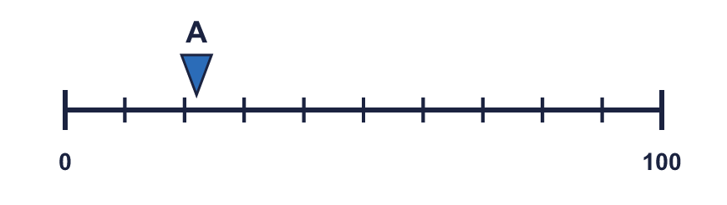  a) 60 b) 50 c) 20  Answer:
  8 | The arrow is between two marks. Which number is it closest to? Write the letter.  a) 60 b) 50 c) 20  Answer:

  9 | 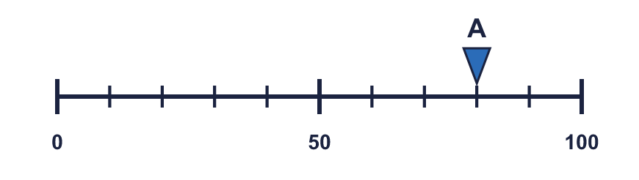  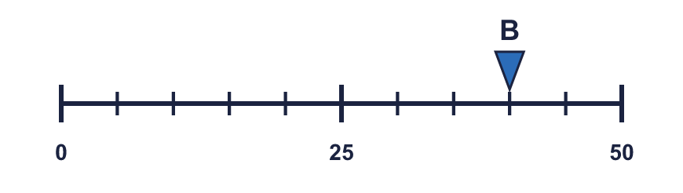  Is Boba correct? Circle yes or no.  Yes / No  Explain how you know.
    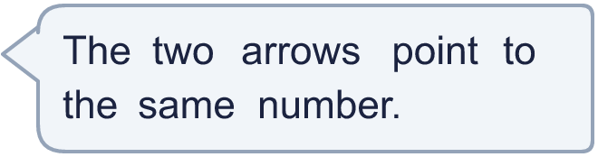
  9 | Is Boba correct? Circle yes or no.  Yes / No  Explain how you know.
  10 | 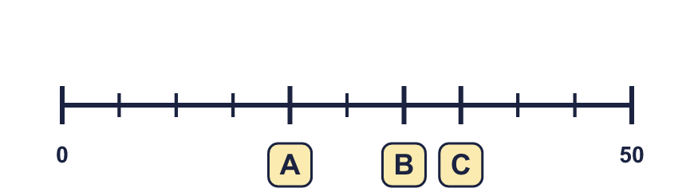
     | 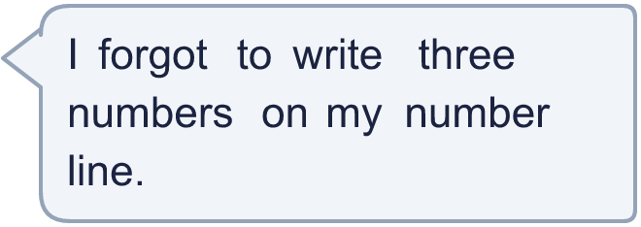
  10
  11 | 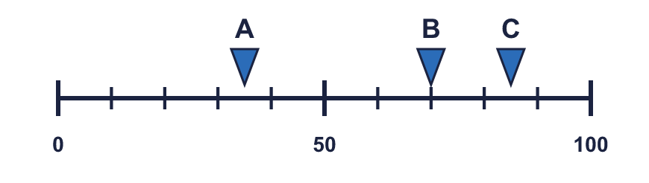  a) What number is arrow A pointing to?  b) What is the difference between B and C?
     | 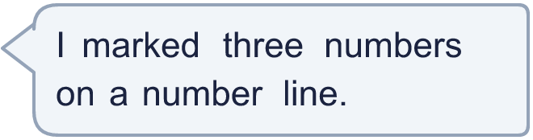
  11 | a) What number is arrow A pointing to?  b) What is the difference between B and C?
  12 | What numbers are the arrows pointing to?  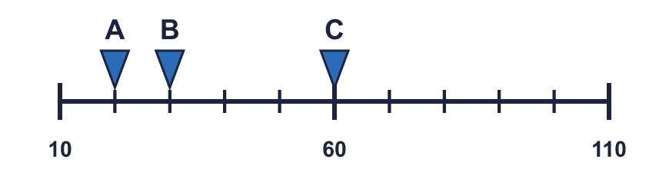
  12 | What numbers are the arrows pointing to?
  13 | 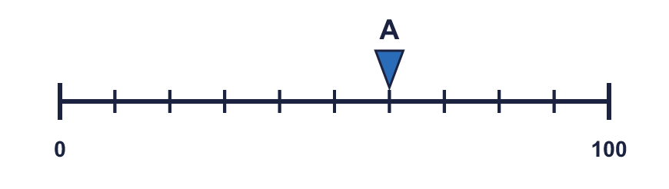  a) What is each step worth?  b) What number is arrow A pointing to?
     | 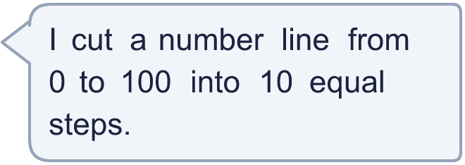
  13 | a) What is each step worth?  b) What number is arrow A pointing to?
  14 | 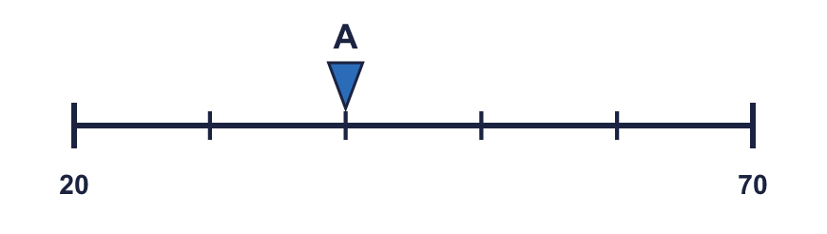  a) What mistake has Boba made?  b) What number is arrow A pointing to?
    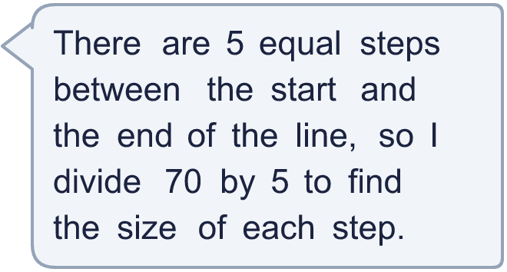
  14 | a) What mistake has Boba made?  b) What number is arrow A pointing to?

Year 3 · Place value · Step 3
Number line to 100
Answers (teacher copy)

  1 | What number is the arrow pointing to?
    20
  2 | What numbers are the arrows pointing to?  A = 30 B = 40
  3 | Which arrow points to 30? Write its letter.  Answer: C
  4 | Write the missing numbers on the line.  A = 25 B = 30 C = 35
  5 | Look at the number line.  The difference between the start and the end is 100  There are 10 equal intervals.  The line counts up in 10
  6 | What number is the arrow pointing to? The line goes up in 2s.
    44
  7 | What number is the arrow pointing to? The line goes up in 5s.
    30
  8 | The arrow is between two marks. Which number is it closest to? Write the letter.  a) 60 b) 50 c) 20  Answer: c
  9 | Is Boba correct? Circle yes or no.  Yes / No  Explain how you know.  Arrow A points to 80 and arrow B points to 40. The lines have different scales: line A ends at 100 and line B ends at 50.
  10 | A = 20 B = 30 C = 35
  11 | a) What number is arrow A pointing to? 35  b) What is the difference between B and C? 15
  12 | What numbers are the arrows pointing to?  A = 20 B = 30 C = 60
  13 | a) What is each step worth? 10  b) What number is arrow A pointing to? 60
  14 | a) What mistake has Boba made?  Boba divided the end number. The line does not start at 0, so each step is (70 − 20) ÷ 5 = 10.  b) What number is arrow A pointing to? 40

