  Year 3 · Place value · Step 4  Hundreds | 
  Year 3 · Place value · Step 4
  Hundreds
  1 | Look at the base ten blocks. A flat is 1 hundred.  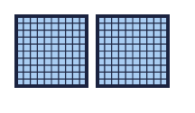  a) How many hundreds?  b) What is the number?
  1 | Look at the base ten blocks. A flat is 1 hundred.  a) How many hundreds?  b) What is the number?
  2 | What number is shown in the place value chart?  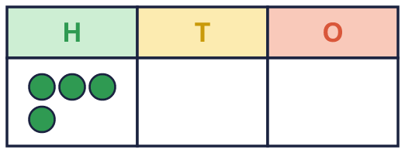
    The number is
  2 | What number is shown in the place value chart?
    The number is
  3 | Write each number.  a) 8 hundreds =  b) 9 hundreds =  c) 4 hundreds =
  3 | Write each number.  a) 8 hundreds =  b) 9 hundreds =  c) 4 hundreds =
  4 | Draw base ten blocks to show 300 in your book. Use flats for hundreds.    a) How many flats did you draw?
  4 | Draw base ten blocks to show 300 in your book. Use flats for hundreds.  a) How many flats did you draw?
  5 | Count in 100s. Write the missing numbers.
    0, | 100, |  | , | 300, | 400,
  5 | Count in 100s. Write the missing numbers.
    0, | 100, |  | , | 300, | 400,
  6 | Work out each answer.  a) 300 + 300 =  b) 700 - 300 =  c) 100 + 100 =
  6 | Work out each answer.  a) 300 + 300 =  b) 700 - 300 =  c) 100 + 100 =
  7 | Circle the numbers you say when you count in 100s from 0. Write them.  650 400 250 200 750  Numbers:
  7 | Circle the numbers you say when you count in 100s from 0. Write them.  650 400 250 200 750  Numbers:
  8 | 10 tens make 1 hundred. How many tens are in each number?  a) 800:  b) 400:
  8 | 10 tens make 1 hundred. How many tens are in each number?  a) 800:  b) 400:

  9 | Is Tia correct? Circle yes or no.  Yes / No  Explain how you know.
     | 
  9 | Is Tia correct? Circle yes or no.  Yes / No  Explain how you know.
  10 | Tiny uses base ten blocks to make 200 in different ways. Which picture does not show 200? Write the letter.  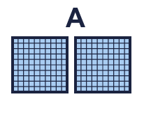  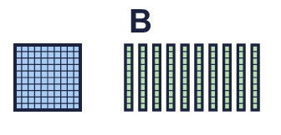  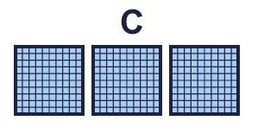
    The picture that does not show 200 is picture
  10 | Tiny uses base ten blocks to make 200 in different ways. Which picture does not show 200? Write the letter.
    The picture that does not show 200 is picture
  11 | Dora is thinking of a 3-digit number. It is a multiple of 100. It is greater than 150 and less than 650.
    How many different numbers could it be?
  11 | Dora is thinking of a 3-digit number. It is a multiple of 100. It is greater than 150 and less than 650.
    How many different numbers could it be?
  12 | 900 can be made with 6 hundreds and some tens.  a) 900 is 6 hundreds and how many tens?
  12 | 900 can be made with 6 hundreds and some tens.  a) 900 is 6 hundreds and how many tens?
  13 | Count back in 100s. Write the missing numbers.
    600, | 500, |  | , | 300,
  13 | Count back in 100s. Write the missing numbers.
    600, | 500, |  | , | 300,
  14 | Challenge  Mia is thinking of a 3-digit number. It is a multiple of 100. It is greater than 350 and less than 550.  Write a number Mia could be thinking of:
  14 | Challenge  Mia is thinking of a 3-digit number. It is a multiple of 100. It is greater than 350 and less than 550.  Write a number Mia could be thinking of:

Year 3 · Place value · Step 4
Hundreds
Answers (teacher copy)

  1 | Look at the base ten blocks. A flat is 1 hundred.  a) How many hundreds? 2  b) What is the number? 200
  2 | What number is shown in the place value chart?  The number is 400
  3 | Write each number.  a) 8 hundreds = 800  b) 9 hundreds = 900  c) 4 hundreds = 400
  4 | Draw base ten blocks to show 300 in your book. Use flats for hundreds.  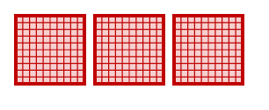  a) How many flats did you draw? 3
  5 | Count in 100s. Write the missing numbers.  0, 100, 200 , 300, 400, 500
  6 | Work out each answer.  a) 300 + 300 = 600  b) 700 - 300 = 400  c) 100 + 100 = 200
  7 | Circle the numbers you say when you count in 100s from 0. Write them.  650 400 250 200 750  Numbers: 400, 200
  8 | 10 tens make 1 hundred. How many tens are in each number?  a) 800: 80  b) 400: 40
  9 | Is Tia correct? Circle yes or no.  Yes / No  Explain how you know.  No. 4 hundreds + 4 hundreds = 8 hundreds, so 400 + 400 = 800.
  10 | Tiny uses base ten blocks to make 200 in different ways. Which picture does not show 200? Write the letter.  The picture that does not show 200 is picture C
  11 | Dora is thinking of a 3-digit number. It is a multiple of 100. It is greater than 150 and less than 650.  How many different numbers could it be? 5
  12 | 900 can be made with 6 hundreds and some tens.  a) 900 is 6 hundreds and how many tens? 30
  13 | Count back in 100s. Write the missing numbers.  600, 500, 400 , 300, 200
  14 | Challenge  Mia is thinking of a 3-digit number. It is a multiple of 100. It is greater than 350 and less than 550.  Write a number Mia could be thinking of: 400

