  Year 3 · Place value · Step 8  Hundreds, tens and ones | 
  Year 3 · Place value · Step 8
  Hundreds, tens and ones
  1 | What number is shown in the place value chart?  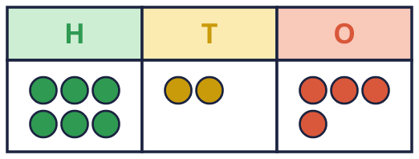
    The number is
  1 | What number is shown in the place value chart?
    The number is
  2 | Look at the place value chart.  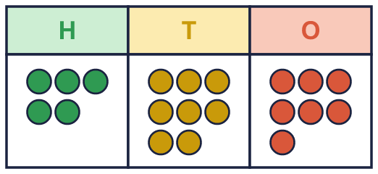  a) How many hundreds?  b) How many tens?  c) How many ones?
  2 | Look at the place value chart.  a) How many hundreds?  b) How many tens?  c) How many ones?
  3 | What number do the base ten blocks show? Look carefully: some pieces may be missing.  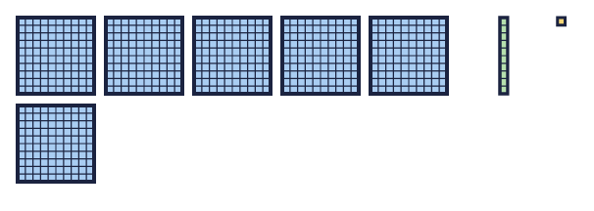
    The number is
  3 | What number do the base ten blocks show? Look carefully: some pieces may be missing.
    The number is
  4 | What is the value of the digit in each number?  a) the digit 3 in 153:  b) the digit 7 in 763:  c) the digit 8 in 683:
  4 | What is the value of the digit in each number?  a) the digit 3 in 153:  b) the digit 7 in 763:  c) the digit 8 in 683:
  5 | Write each number.  a) 1 hundreds, 2 tens and 9 ones =  b) 3 hundreds, 7 tens and 1 one =  c) 1 hundreds, 0 tens and 3 ones =
  5 | Write each number.  a) 1 hundreds, 2 tens and 9 ones =  b) 3 hundreds, 7 tens and 1 one =  c) 1 hundreds, 0 tens and 3 ones =
  6 | Look at the number 864.  a) How many hundreds?  b) How many tens?  c) How many ones?
  6 | Look at the number 864.  a) How many hundreds?  b) How many tens?  c) How many ones?
  7 | Work out each number.  a) 800 + 6 =  b) 300 + 7 =  c) 100 + 0 =
  7 | Work out each number.  a) 800 + 6 =  b) 300 + 7 =  c) 100 + 0 =
  8 | 10 tens make 1 hundred. How many tens are in 761 altogether?  a) There are [ ] tens in 761:
  8 | 10 tens make 1 hundred. How many tens are in 761 altogether?  a) There are [ ] tens in 761:

  9 | 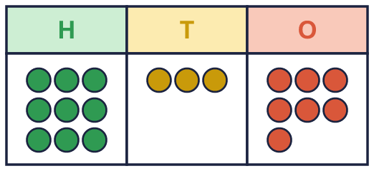  Is Rosie correct? Circle yes or no.  Yes / No  Explain how you know.
     | 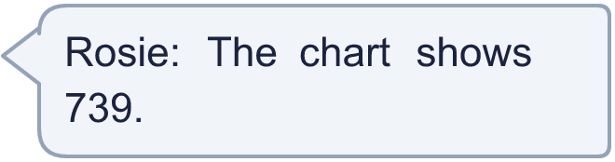
  9 | Is Rosie correct? Circle yes or no.  Yes / No  Explain how you know.
  10 | Alex is thinking of a 3-digit number with 3 hundreds. There are 2 more tens than ones.
    How many different numbers could it be?
  10 | Alex is thinking of a 3-digit number with 3 hundreds. There are 2 more tens than ones.
    How many different numbers could it be?
  11 | Ron is thinking of a 3-digit number. There are 5 more hundreds than ones. The tens digit is 6.  Write a number Ron could be thinking of:
  11 | Ron is thinking of a 3-digit number. There are 5 more hundreds than ones. The tens digit is 6.  Write a number Ron could be thinking of:
  12 | Dora has three digit cards: 6 8 5. Dora uses all three cards to make a 3-digit number.
    What is the largest number Dora can make?
  12 | Dora has three digit cards: 6 8 5. Dora uses all three cards to make a 3-digit number.
    What is the largest number Dora can make?
  13 | Write the number. Remember to exchange 10 tens for 1 hundred.  a) 5 hundreds, 14 tens and 9 ones =
  13 | Write the number. Remember to exchange 10 tens for 1 hundred.  a) 5 hundreds, 14 tens and 9 ones =
  14 | The hundreds are made of tens too.  a) How many tens are in 715 altogether?
     | 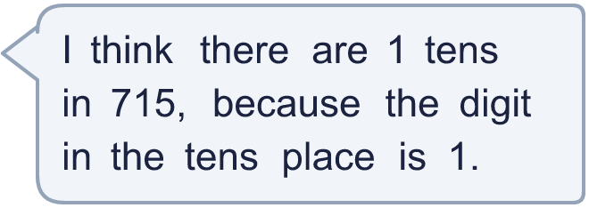
  14 | The hundreds are made of tens too.  a) How many tens are in 715 altogether?

Year 3 · Place value · Step 8
Hundreds, tens and ones
Answers (teacher copy)

  1 | What number is shown in the place value chart?  The number is 624
  2 | Look at the place value chart.  a) How many hundreds? 5  b) How many tens? 8  c) How many ones? 7
  3 | What number do the base ten blocks show? Look carefully: some pieces may be missing.  The number is 611
  4 | What is the value of the digit in each number?  a) the digit 3 in 153: 3  b) the digit 7 in 763: 700  c) the digit 8 in 683: 80
  5 | Write each number.  a) 1 hundreds, 2 tens and 9 ones = 129  b) 3 hundreds, 7 tens and 1 one = 371  c) 1 hundreds, 0 tens and 3 ones = 103
  6 | Look at the number 864.  a) How many hundreds? 8  b) How many tens? 6  c) How many ones? 4
  7 | Work out each number.  a) 800 + 6 = 806  b) 300 + 7 = 307  c) 100 + 0 = 100
  8 | 10 tens make 1 hundred. How many tens are in 761 altogether?  a) There are [ ] tens in 761: 76
  9 | Is Rosie correct? Circle yes or no.  Yes / No  Explain how you know.  No. The chart has 9 hundreds, 3 tens and 7 ones, so it shows 937.
  10 | Alex is thinking of a 3-digit number with 3 hundreds. There are 2 more tens than ones.  How many different numbers could it be? 8
  11 | Ron is thinking of a 3-digit number. There are 5 more hundreds than ones. The tens digit is 6.  Write a number Ron could be thinking of: 560
  12 | Dora has three digit cards: 6 8 5. Dora uses all three cards to make a 3-digit number.  What is the largest number Dora can make? 865
  13 | Write the number. Remember to exchange 10 tens for 1 hundred.  a) 5 hundreds, 14 tens and 9 ones = 649
  14 | The hundreds are made of tens too.  a) How many tens are in 715 altogether? 71

