  Year 3 · Place value · Step 7  Flexible partitioning of numbers to 1000 | 
  Year 3 · Place value · Step 7
  Flexible partitioning of numbers to 1000
  1 | Write the missing number. There is more than one way to split a number.  a) 561 = 500 + 60 + [ ]:  b) 561 = 400 + [ ] + 1:
  1 | Write the missing number. There is more than one way to split a number.  a) 561 = 500 + 60 + [ ]:  b) 561 = 400 + [ ] + 1:
  2 | 560 can be made with 3 hundreds and some tens.  a) 560 is 3 hundreds and how many tens?
  2 | 560 can be made with 3 hundreds and some tens.  a) 560 is 3 hundreds and how many tens?
  3 | Write the number. Remember that 10 tens make 1 hundred.  a) 6 hundreds, 18 tens and 9 ones =
  3 | Write the number. Remember that 10 tens make 1 hundred.  a) 6 hundreds, 18 tens and 9 ones =
  4 | Some hundreds have been exchanged for tens. What number do the blocks show?  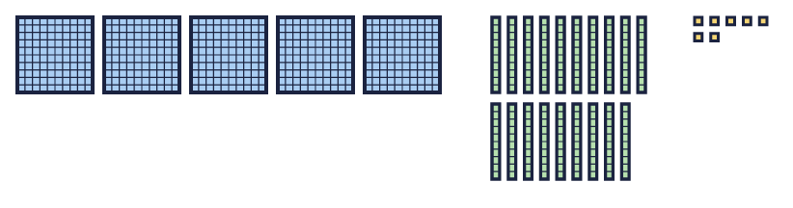
    The number is
  4 | Some hundreds have been exchanged for tens. What number do the blocks show?
    The number is
  5 | 533 can be made with 50 tens and some ones.  a) 533 is 50 tens and how many ones?
  5 | 533 can be made with 50 tens and some ones.  a) 533 is 50 tens and how many ones?
  6 | Work out each number.  a) 700 + 150 + 3 =  b) 600 + 150 + 3 =  c) 33 + 600 + 50 =
  6 | Work out each number.  a) 700 + 150 + 3 =  b) 600 + 150 + 3 =  c) 33 + 600 + 50 =
  7 | Write the missing number.  a) 494 = 300 + [ ] + 4:  b) 504 = 400 + [ ] + 4:
  7 | Write the missing number.  a) 494 = 300 + [ ] + 4:  b) 504 = 400 + [ ] + 4:
  8 | How many tens are in 782?  a) There are [ ] tens in 782:
  8 | How many tens are in 782?  a) There are [ ] tens in 782:

  9 | 824 is made in different ways with base ten blocks. Which picture does not show 824? Write the letter.  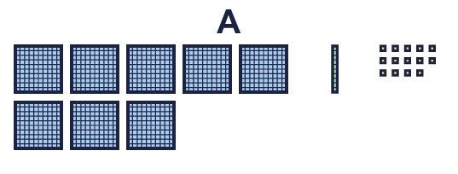  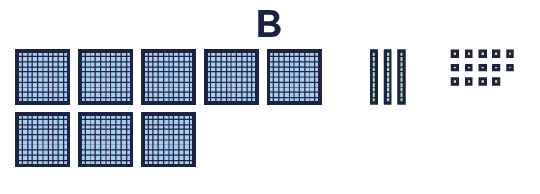  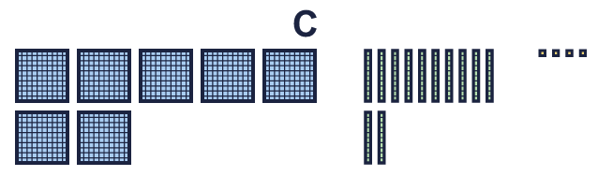
    The picture that does not show 824 is picture
  9 | 824 is made in different ways with base ten blocks. Which picture does not show 824? Write the letter.
    The picture that does not show 824 is picture
  10 | Is Rosie correct? Circle yes or no.  Yes / No  Explain how you know.
     | 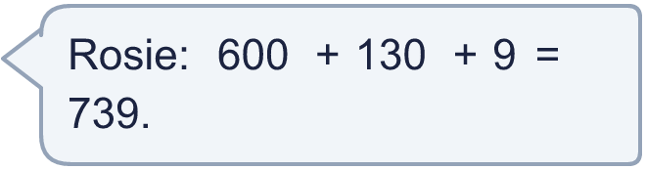
  10 | Is Rosie correct? Circle yes or no.  Yes / No  Explain how you know.
  11 | Write the missing number.  a) 557 = 300 + [ ] + 7:  b) 557 = 400 + 90 + [ ]:
  11 | Write the missing number.  a) 557 = 300 + [ ] + 7:  b) 557 = 400 + 90 + [ ]:
  12 | Look at the number 819.  a) How many tens are in this number?  b) How many ones are left over?
  12 | Look at the number 819.  a) How many tens are in this number?  b) How many ones are left over?
  13 | Dora makes a number with 3 hundreds, 25 tens and 6 ones.  a) What number does Dora make?
  13 | Dora makes a number with 3 hundreds, 25 tens and 6 ones.  a) What number does Dora make?
  14 | Challenge  Rosie is thinking of a 3-digit number. The digits add up to 7. There is 1 more ten than ones.  Write a number Rosie could be thinking of:
  14 | Challenge  Rosie is thinking of a 3-digit number. The digits add up to 7. There is 1 more ten than ones.  Write a number Rosie could be thinking of:

Year 3 · Place value · Step 7
Flexible partitioning of numbers to 1000
Answers (teacher copy)

  1 | Write the missing number. There is more than one way to split a number.  a) 561 = 500 + 60 + [ ]: 1  b) 561 = 400 + [ ] + 1: 160
  2 | 560 can be made with 3 hundreds and some tens.  a) 560 is 3 hundreds and how many tens? 26
  3 | Write the number. Remember that 10 tens make 1 hundred.  a) 6 hundreds, 18 tens and 9 ones = 789
  4 | Some hundreds have been exchanged for tens. What number do the blocks show?  The number is 697
  5 | 533 can be made with 50 tens and some ones.  a) 533 is 50 tens and how many ones? 33
  6 | Work out each number.  a) 700 + 150 + 3 = 853  b) 600 + 150 + 3 = 753  c) 33 + 600 + 50 = 683
  7 | Write the missing number.  a) 494 = 300 + [ ] + 4: 190  b) 504 = 400 + [ ] + 4: 100
  8 | How many tens are in 782?  a) There are [ ] tens in 782: 78
  9 | 824 is made in different ways with base ten blocks. Which picture does not show 824? Write the letter.  The picture that does not show 824 is picture B
  10 | Is Rosie correct? Circle yes or no.  Yes / No  Explain how you know.  Yes. 600 + 130 + 9 = 739.
  11 | Write the missing number.  a) 557 = 300 + [ ] + 7: 250  b) 557 = 400 + 90 + [ ]: 67
  12 | Look at the number 819.  a) How many tens are in this number? 81  b) How many ones are left over? 9
  13 | Dora makes a number with 3 hundreds, 25 tens and 6 ones.  a) What number does Dora make? 556
  14 | Challenge  Rosie is thinking of a 3-digit number. The digits add up to 7. There is 1 more ten than ones.  Write a number Rosie could be thinking of: 421

