  Year 3 · Place value · Step 9  Find 1, 10 or 100 more or less | 
  Year 3 · Place value · Step 9
  Find 1, 10 or 100 more or less
  1 | Work out each answer.  a) 100 more than 476 =  b) 1 more than 787 =  c) 10 more than 418 =
  1 | Work out each answer.  a) 100 more than 476 =  b) 1 more than 787 =  c) 10 more than 418 =
  2 | Work out each answer.  a) 10 less than 695 =  b) 1 less than 573 =  c) 100 less than 200 =
  2 | Work out each answer.  a) 10 less than 695 =  b) 1 less than 573 =  c) 100 less than 200 =
  3 | What is 10 more than the number shown by the base ten blocks?  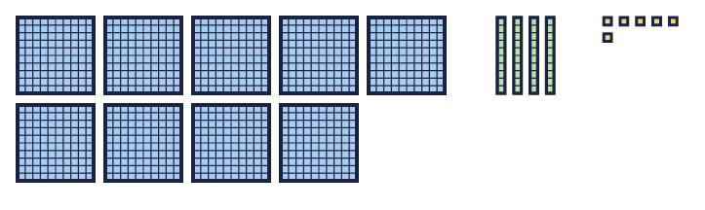
    10 more than the number is
  3 | What is 10 more than the number shown by the base ten blocks?
    10 more than the number is
  4 | What is 100 less than the number shown in the place value chart?  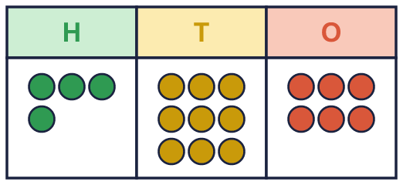
    100 less than the number is
  4 | What is 100 less than the number shown in the place value chart?
    100 less than the number is
  5 | Write the missing number.  a) 415 + [ ] = 425:  b) 597 + [ ] = 697:  c) 328 + [ ] = 329:
  5 | Write the missing number.  a) 415 + [ ] = 425:  b) 597 + [ ] = 697:  c) 328 + [ ] = 329:
  6 | Count back in 10s. Write the missing numbers.
    640, | 630, | 620, |  | , | 600,
  6 | Count back in 10s. Write the missing numbers.
    640, | 630, | 620, |  | , | 600,
  7 | Is Mia correct? Circle yes or no.  Yes / No  Explain how you know.
     | 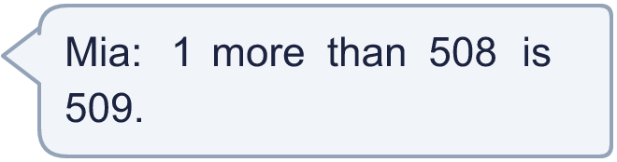
  7 | Is Mia correct? Circle yes or no.  Yes / No  Explain how you know.
  8 | Write the missing number.  a) [ ] - 1 = 237:  b) [ ] - 100 = 497:  c) [ ] - 10 = 666:
  8 | Write the missing number.  a) [ ] - 1 = 237:  b) [ ] - 100 = 497:  c) [ ] - 10 = 666:

  9 | Is Ron correct? Circle yes or no.  Yes / No  Explain how you know.
    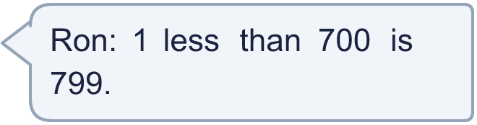
  9 | Is Ron correct? Circle yes or no.  Yes / No  Explain how you know.
  10 | Write the missing number.  a) [ ] - 100 = 317:  b) 225 + [ ] = 335:
  10 | Write the missing number.  a) [ ] - 100 = 317:  b) 225 + [ ] = 335:
  11 | Work out each answer.  a) 505 + 100 - 1 =  b) 505 - 100 + 1 =
  11 | Work out each answer.  a) 505 + 100 - 1 =  b) 505 - 100 + 1 =
  12 | Count back in 1s. Write the missing numbers.
    702, |  | , | 700, |  | , | 698
  12 | Count back in 1s. Write the missing numbers.
    702, |  | , | 700, |  | , | 698
  13 | 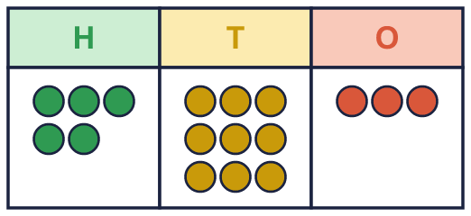  What is 10 more than the number in the chart?
    10 more than the number is
  13 | What is 10 more than the number in the chart?
    10 more than the number is
  14 | Challenge  Eva is thinking of a 3-digit number. It is a multiple of 10. The tens digit is 2. It is greater than 500 and less than 700.  Write a number Eva could be thinking of:
  14 | Challenge  Eva is thinking of a 3-digit number. It is a multiple of 10. The tens digit is 2. It is greater than 500 and less than 700.  Write a number Eva could be thinking of:

Year 3 · Place value · Step 9
Find 1, 10 or 100 more or less
Answers (teacher copy)

  1 | Work out each answer.  a) 100 more than 476 = 576  b) 1 more than 787 = 788  c) 10 more than 418 = 428
  2 | Work out each answer.  a) 10 less than 695 = 685  b) 1 less than 573 = 572  c) 100 less than 200 = 100
  3 | What is 10 more than the number shown by the base ten blocks?  10 more than the number is 956
  4 | What is 100 less than the number shown in the place value chart?  100 less than the number is 396
  5 | Write the missing number.  a) 415 + [ ] = 425: 10  b) 597 + [ ] = 697: 100  c) 328 + [ ] = 329: 1
  6 | Count back in 10s. Write the missing numbers.  640, 630, 620, 610 , 600, 590
  7 | Is Mia correct? Circle yes or no.  Yes / No  Explain how you know.  Yes. 508 + 1 = 509.
  8 | Write the missing number.  a) [ ] - 1 = 237: 238  b) [ ] - 100 = 497: 597  c) [ ] - 10 = 666: 676
  9 | Is Ron correct? Circle yes or no.  Yes / No  Explain how you know.  No. 700 - 1 = 699.
  10 | Write the missing number.  a) [ ] - 100 = 317: 417  b) 225 + [ ] = 335: 110
  11 | Work out each answer.  a) 505 + 100 - 1 = 604  b) 505 - 100 + 1 = 406
  12 | Count back in 1s. Write the missing numbers.  702, 701 , 700, 699 , 698
  13 | What is 10 more than the number in the chart?  10 more than the number is 603
  14 | Challenge  Eva is thinking of a 3-digit number. It is a multiple of 10. The tens digit is 2. It is greater than 500 and less than 700.  Write a number Eva could be thinking of: 620

