  Year 3 · Place value · Step 11  Estimate on a number line to 1000 | 
  Year 3 · Place value · Step 11
  Estimate on a number line to 1000
  1 | The arrow is between two marks. Which number is it closest to? Write the letter.  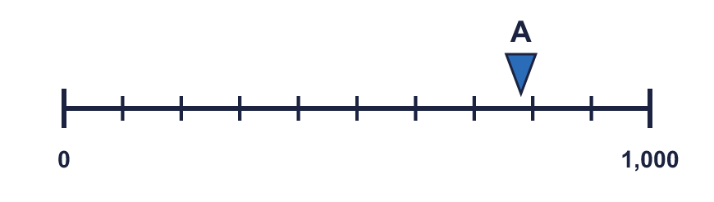  a) 800 b) 400 c) 500  Answer:
  1 | The arrow is between two marks. Which number is it closest to? Write the letter.  a) 800 b) 400 c) 500  Answer:
  2 | The arrow is exactly halfway between two marks. What number is it pointing to?
    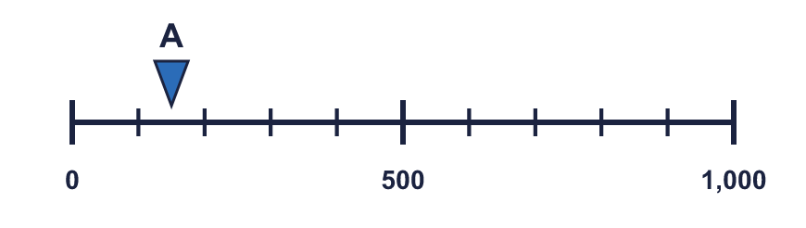
  2 | The arrow is exactly halfway between two marks. What number is it pointing to?
  3 | The arrow is between two marks. Which number is it closest to? Write the letter.  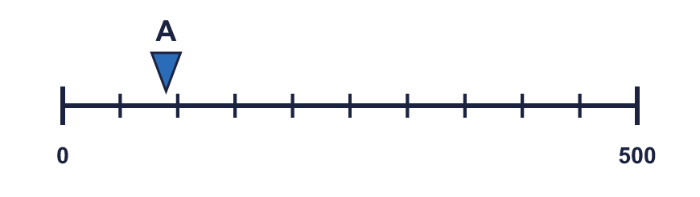  a) 450 b) 100 c) 350  Answer:
  3 | The arrow is between two marks. Which number is it closest to? Write the letter.  a) 450 b) 100 c) 350  Answer:
  4 | The arrow is between two marks. Which number is it closest to? Write the letter.  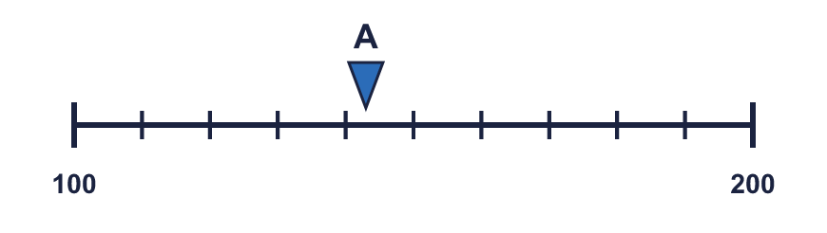  a) 170 b) 140 c) 190  Answer:
  4 | The arrow is between two marks. Which number is it closest to? Write the letter.  a) 170 b) 140 c) 190  Answer:
  5 | Which arrow points to 250? Write its letter.  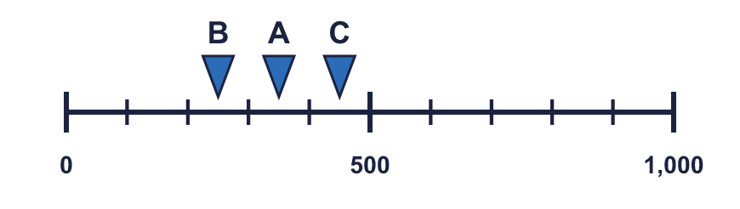  Answer:
  5 | Which arrow points to 250? Write its letter.  Answer:
  6 | What number is the arrow pointing to? The line goes up in 200s.
    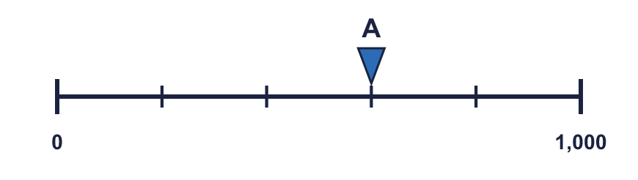
  6 | What number is the arrow pointing to? The line goes up in 200s.
  7 | The arrow is between two marks. Which number is it closest to? Write the letter.  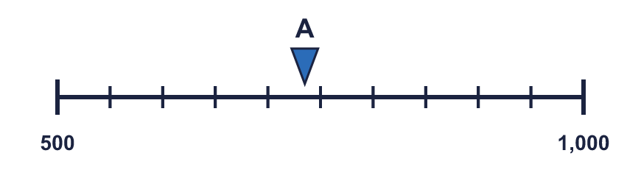  a) 950 b) 500 c) 750  Answer:
  7 | The arrow is between two marks. Which number is it closest to? Write the letter.  a) 950 b) 500 c) 750  Answer:
  8 | Look at the number line.  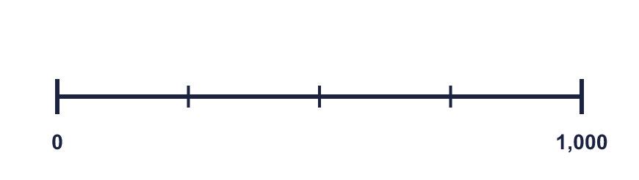  The difference between the start and the end is  The line counts up in
    There are |  | equal intervals.
  8 | Look at the number line.  The difference between the start and the end is  The line counts up in
    There are |  | equal intervals.

  9 | 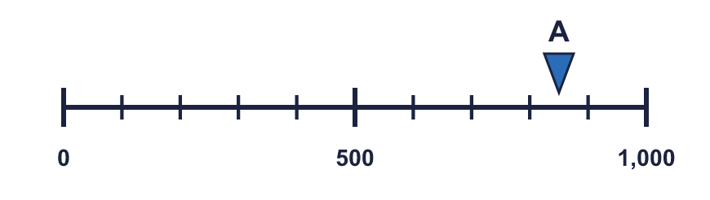  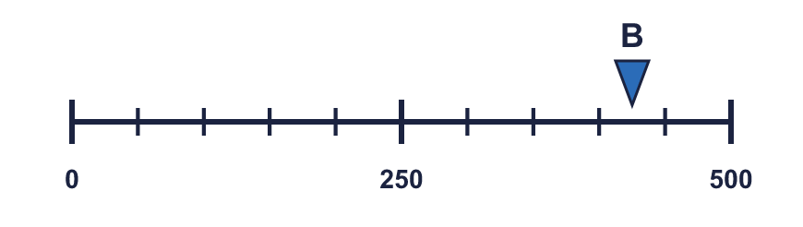  Is Boba correct? Circle yes or no.  Yes / No  Explain how you know.
    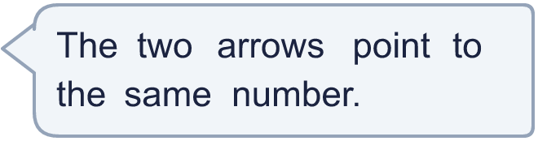
  9 | Is Boba correct? Circle yes or no.  Yes / No  Explain how you know.
  10 | Boba is estimating where the arrow is. Which number is the arrow closest to? Write the letter.  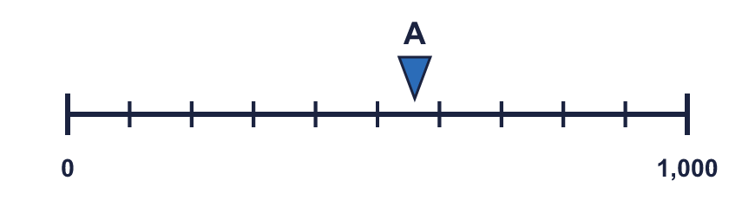  a) 1,000 b) 600 c) 100  Answer:
  10 | Boba is estimating where the arrow is. Which number is the arrow closest to? Write the letter.  a) 1,000 b) 600 c) 100  Answer:
  11 | 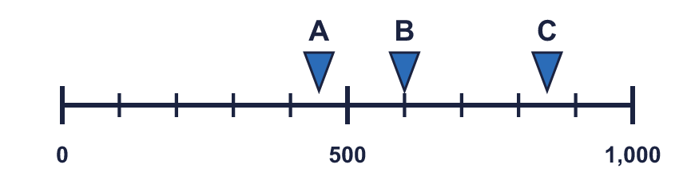  a) What number is arrow A pointing to?  b) What is the difference between B and C?
     | 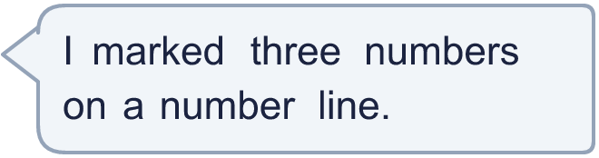
  11 | a) What number is arrow A pointing to?  b) What is the difference between B and C?
  12 | 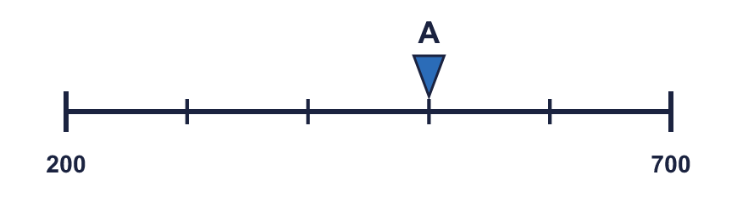  a) What mistake has Boba made?  b) What number is arrow A pointing to?
    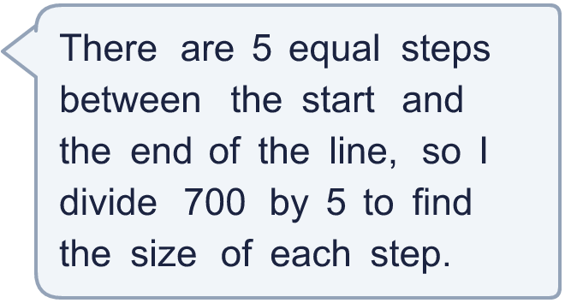
  12 | a) What mistake has Boba made?  b) What number is arrow A pointing to?
  13 | Boba is estimating where the arrow is. Which number is the arrow closest to? Write the letter.  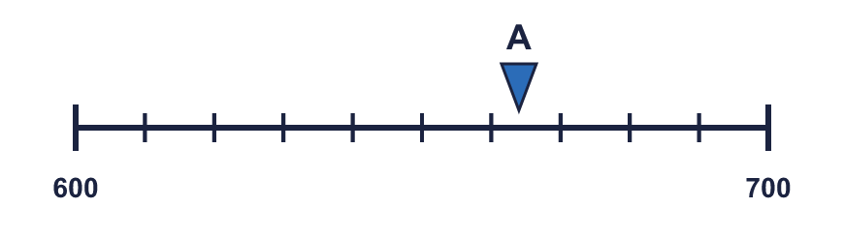  a) 660 b) 630 c) 600  Answer:
  13 | Boba is estimating where the arrow is. Which number is the arrow closest to? Write the letter.  a) 660 b) 630 c) 600  Answer:
  14 | 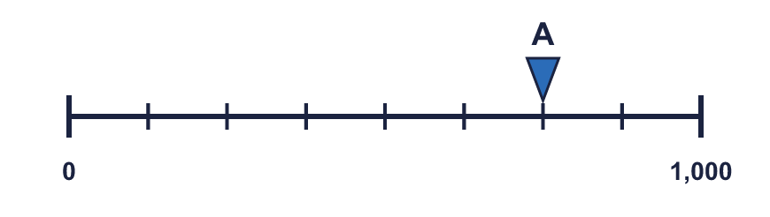  a) What is each step worth?  b) What number is arrow A pointing to?
     | 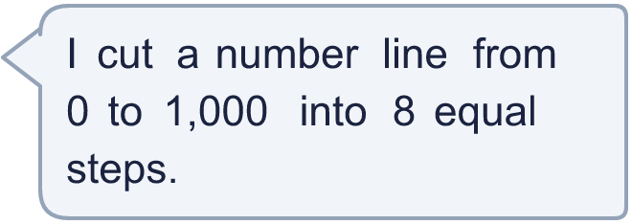
  14 | a) What is each step worth?  b) What number is arrow A pointing to?

Year 3 · Place value · Step 11
Estimate on a number line to 1000
Answers (teacher copy)

  1 | The arrow is between two marks. Which number is it closest to? Write the letter.  a) 800 b) 400 c) 500  Answer: a
  2 | The arrow is exactly halfway between two marks. What number is it pointing to?
    150
  3 | The arrow is between two marks. Which number is it closest to? Write the letter.  a) 450 b) 100 c) 350  Answer: b
  4 | The arrow is between two marks. Which number is it closest to? Write the letter.  a) 170 b) 140 c) 190  Answer: b
  5 | Which arrow points to 250? Write its letter.  Answer: B
  6 | What number is the arrow pointing to? The line goes up in 200s.
    600
  7 | The arrow is between two marks. Which number is it closest to? Write the letter.  a) 950 b) 500 c) 750  Answer: c
  8 | Look at the number line.  The difference between the start and the end is 1,000  There are 4 equal intervals.  The line counts up in 250
  9 | Is Boba correct? Circle yes or no.  Yes / No  Explain how you know.  Arrow A points to 850 and arrow B points to 425. The lines have different scales: line A ends at 1,000 and line B ends at 500.
  10 | Boba is estimating where the arrow is. Which number is the arrow closest to? Write the letter.  a) 1,000 b) 600 c) 100  Answer: b
  11 | a) What number is arrow A pointing to? 450  b) What is the difference between B and C? 250
  12 | a) What mistake has Boba made?  Boba divided the end number. The line does not start at 0, so each step is (700 − 200) ÷ 5 = 100.  b) What number is arrow A pointing to? 500
  13 | Boba is estimating where the arrow is. Which number is the arrow closest to? Write the letter.  a) 660 b) 630 c) 600  Answer: a
  14 | a) What is each step worth? 125  b) What number is arrow A pointing to? 750

