  Year 3 · Place value · Step 14  Count in 50s | 
  Year 3 · Place value · Step 14
  Count in 50s
  1 | Count in 50s. Write the missing numbers.
    0, | 50, |  | , | 150, |  | , | 250
  1 | Count in 50s. Write the missing numbers.
    0, | 50, |  | , | 150, |  | , | 250
  2 | Count back in 50s. Write the missing numbers.
    750, | 700, | 650, | 600, |  | ,
  2 | Count back in 50s. Write the missing numbers.
    750, | 700, | 650, | 600, |  | ,
  3 | Write the numbers you say when you count in 50s from 0.  25 120 250 300 150  Numbers:
  3 | Write the numbers you say when you count in 50s from 0.  25 120 250 300 150  Numbers:
  4 | What number is the arrow pointing to? The line goes up in 50s.
    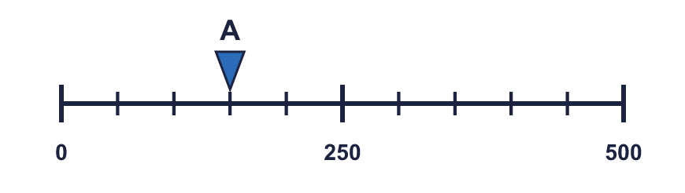
  4 | What number is the arrow pointing to? The line goes up in 50s.
  5 | Work out each answer.  a) 50 more than 550 =  b) 50 less than 450 =  c) 50 more than 50 =
  5 | Work out each answer.  a) 50 more than 550 =  b) 50 less than 450 =  c) 50 more than 50 =
  6 | Amir has 3 coins. Each coin is worth 50p.
    How many pence does Amir have in total?
    p
  6 | Amir has 3 coins. Each coin is worth 50p.
    How many pence does Amir have in total?
    p
  7 | Count in 50s. Write the missing numbers.
    70, | 120, |  | , | 220,
  7 | Count in 50s. Write the missing numbers.
    70, | 120, |  | , | 220,
  8 | Write the missing number.  a) [ ] + 50 = 150:  b) 150 - [ ] = 100:
  8 | Write the missing number.  a) [ ] + 50 = 150:  b) 150 - [ ] = 100:

  9 | Is Leo correct? Circle yes or no.  Yes / No  Explain how you know.
     | 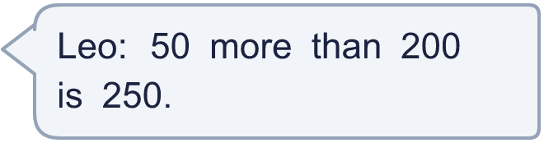
  9 | Is Leo correct? Circle yes or no.  Yes / No  Explain how you know.
  10 | Count in 50s. Write the missing numbers.
    750, |  | , | 850, |  | , | 950
  10 | Count in 50s. Write the missing numbers.
    750, |  | , | 850, |  | , | 950
  11 | How many multiples of 50 are greater than 120 and less than 450?
    There are |  | numbers
  11 | How many multiples of 50 are greater than 120 and less than 450?
    There are |  | numbers
  12 | Zach saves 50p each week. After 6 weeks Zach has saved 300p. Zach saves for 4 more weeks.
    How many pence has Zach saved in total?
    p
  12 | Zach saves 50p each week. After 6 weeks Zach has saved 300p. Zach saves for 4 more weeks.
    How many pence has Zach saved in total?
    p
  13 | Aaron counts in 50s from 30. Write the numbers he says.  80 130 55 180 105  Numbers:
  13 | Aaron counts in 50s from 30. Write the numbers he says.  80 130 55 180 105  Numbers:
  14 | Challenge  Ron is thinking of a 3-digit number. It is a multiple of 50. It is greater than 300 and less than 460. The tens digit is 5.  Write a number Ron could be thinking of:
  14 | Challenge  Ron is thinking of a 3-digit number. It is a multiple of 50. It is greater than 300 and less than 460. The tens digit is 5.  Write a number Ron could be thinking of:

Year 3 · Place value · Step 14
Count in 50s
Answers (teacher copy)

  1 | Count in 50s. Write the missing numbers.  0, 50, 100 , 150, 200 , 250
  2 | Count back in 50s. Write the missing numbers.  750, 700, 650, 600, 550 , 500
  3 | Write the numbers you say when you count in 50s from 0.  25 120 250 300 150  Numbers: 250, 300, 150
  4 | What number is the arrow pointing to? The line goes up in 50s.
    150
  5 | Work out each answer.  a) 50 more than 550 = 600  b) 50 less than 450 = 400  c) 50 more than 50 = 100
  6 | Amir has 3 coins. Each coin is worth 50p.  How many pence does Amir have in total? 150 p
  7 | Count in 50s. Write the missing numbers.  70, 120, 170 , 220, 270
  8 | Write the missing number.  a) [ ] + 50 = 150: 100  b) 150 - [ ] = 100: 50
  9 | Is Leo correct? Circle yes or no.  Yes / No  Explain how you know.  Yes. 200 + 50 = 250.
  10 | Count in 50s. Write the missing numbers.  750, 800 , 850, 900 , 950
  11 | How many multiples of 50 are greater than 120 and less than 450?  There are 6 numbers
  12 | Zach saves 50p each week. After 6 weeks Zach has saved 300p. Zach saves for 4 more weeks.  How many pence has Zach saved in total? 500 p
  13 | Aaron counts in 50s from 30. Write the numbers he says.  80 130 55 180 105  Numbers: 80, 130, 180
  14 | Challenge  Ron is thinking of a 3-digit number. It is a multiple of 50. It is greater than 300 and less than 460. The tens digit is 5.  Write a number Ron could be thinking of: 350

