  Year 3 · Place value · Step 12  Compare numbers to 1000 | 
  Year 3 · Place value · Step 12
  Compare numbers to 1000
  1 | Write <, > or = in each box.
    a) | 869 |  | 833
    b) | 457 |  | 452
    c) | 442 |  | 446
  1 | Write <, > or = in each box.
    a) | 869 |  | 833
    b) | 457 |  | 452
    c) | 442 |  | 446
  2 | Write <, > or = in each box.
    a) | 759 |  | 700 + 60 + 8
    b) | 200 + 60 + 6 |  | 266
    c) | 200 + 60 + 8 |  | 268
  2 | Write <, > or = in each box.
    a) | 759 |  | 700 + 60 + 8
    b) | 200 + 60 + 6 |  | 266
    c) | 200 + 60 + 8 |  | 268
  3 | Ron has 237 stickers. Alex has 273 stickers. Leo has 372 stickers.
    Who has the most stickers?
  3 | Ron has 237 stickers. Alex has 273 stickers. Leo has 372 stickers.
    Who has the most stickers?
  4 | Compare the two pictures. Write <, > or = in the box.  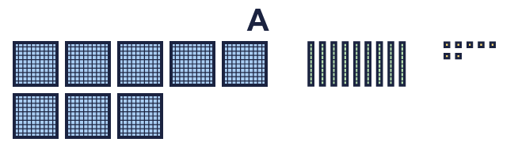  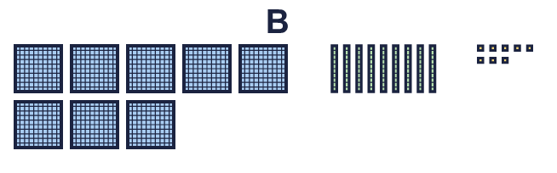
    Picture A |  | Picture B
  4 | Compare the two pictures. Write <, > or = in the box.
    Picture A |  | Picture B
  5 | Write the numbers that are greater than 330.  220 321 290 331 440  Numbers:
  5 | Write the numbers that are greater than 330.  220 321 290 331 440  Numbers:
  6 | Leo walks 812 steps. Mia walks 218 steps. Ron walks 506 steps.
    Who walks the fewest steps?
  6 | Leo walks 812 steps. Mia walks 218 steps. Ron walks 506 steps.
    Who walks the fewest steps?
  7 | Write a number that is between 270 and 370.  A number between them:
  7 | Write a number that is between 270 and 370.  A number between them:
  8 | Write the numbers that are less than 590.  589 740 550 480 640  Numbers:
  8 | Write the numbers that are less than 590.  589 740 550 480 640  Numbers:

  9 | Write <, > or = in each box. Think about the parts.
    a) | 400 + 70 + 2 |  | 400 + 40 + 8
    b) | 700 + 70 + 5 |  | 700 + 30 + 7
    c) | 800 + 70 + 9 |  | 800 + 70 + 8
  9 | Write <, > or = in each box. Think about the parts.
    a) | 400 + 70 + 2 |  | 400 + 40 + 8
    b) | 700 + 70 + 5 |  | 700 + 30 + 7
    c) | 800 + 70 + 9 |  | 800 + 70 + 8
  10 | How many multiples of 10 are greater than 740 and less than 800?
    There are |  | numbers
  10 | How many multiples of 10 are greater than 740 and less than 800?
    There are |  | numbers
  11 | Sam has three digit cards: 2 8 4. Sam uses all three cards to make a 3-digit number.
    What is the largest number Sam can make?
  11 | Sam has three digit cards: 2 8 4. Sam uses all three cards to make a 3-digit number.
    What is the largest number Sam can make?
  12 | Amir has 715 points. Eva has 751 points. Dora has 175 points. They all use the same three digits.
    Who has the most points?
  12 | Amir has 715 points. Eva has 751 points. Dora has 175 points. They all use the same three digits.
    Who has the most points?
  13 | Write a number that is between 595 and 601. It must be a multiple of 100.  A number between them:
  13 | Write a number that is between 595 and 601. It must be a multiple of 100.  A number between them:
  14 | Challenge  Amir is thinking of a 3-digit number. It is greater than 730 and less than 790. It is odd. The tens digit is 4.  Write a number Amir could be thinking of:
  14 | Challenge  Amir is thinking of a 3-digit number. It is greater than 730 and less than 790. It is odd. The tens digit is 4.  Write a number Amir could be thinking of:

Year 3 · Place value · Step 12
Compare numbers to 1000
Answers (teacher copy)

  1 | Write <, > or = in each box.  a) 869 > 833  b) 457 > 452  c) 442 < 446
  2 | Write <, > or = in each box.  a) 759 < 700 + 60 + 8  b) 200 + 60 + 6 = 266  c) 200 + 60 + 8 = 268
  3 | Ron has 237 stickers. Alex has 273 stickers. Leo has 372 stickers.  Who has the most stickers? Leo
  4 | Compare the two pictures. Write <, > or = in the box.  Picture A < Picture B
  5 | Write the numbers that are greater than 330.  220 321 290 331 440  Numbers: 331, 440
  6 | Leo walks 812 steps. Mia walks 218 steps. Ron walks 506 steps.  Who walks the fewest steps? Mia
  7 | Write a number that is between 270 and 370.  A number between them: 320
  8 | Write the numbers that are less than 590.  589 740 550 480 640  Numbers: 589, 550, 480
  9 | Write <, > or = in each box. Think about the parts.  a) 400 + 70 + 2 > 400 + 40 + 8  b) 700 + 70 + 5 > 700 + 30 + 7  c) 800 + 70 + 9 > 800 + 70 + 8
  10 | How many multiples of 10 are greater than 740 and less than 800?  There are 5 numbers
  11 | Sam has three digit cards: 2 8 4. Sam uses all three cards to make a 3-digit number.  What is the largest number Sam can make? 842
  12 | Amir has 715 points. Eva has 751 points. Dora has 175 points. They all use the same three digits.  Who has the most points? Eva
  13 | Write a number that is between 595 and 601. It must be a multiple of 100.  A number between them: 600
  14 | Challenge  Amir is thinking of a 3-digit number. It is greater than 730 and less than 790. It is odd. The tens digit is 4.  Write a number Amir could be thinking of: 743

