  Year 3 · Multiplication and division A · Step 2  Use arrays | 
  Year 3 · Multiplication and division A · Step 2
  Use arrays
  1 | Look at the array of counters.  
    There are |  | rows.
    There are
    counters in each row.
    There are
    counters altogether.
  1 | Look at the array of counters.
    There are |  | rows.
    There are
    counters in each row.
    There are
    counters altogether.
  2 | Work out the multiplications.  a) 4 × 4 =  b) 4 × 2 =
  2 | Work out the multiplications.  a) 4 × 4 =  b) 4 × 2 =
  3 | Complete the number sentences to describe the array.  
     | × |  | =
     | × |  | =
     | ÷ |  | =
     | ÷ |  | =
  3 | Complete the number sentences to describe the array.
     | × |  | =
     | × |  | =
     | ÷ |  | =
     | ÷ |  | =
  4 | Write the missing number in each calculation.
    a) |  | ÷ 5 | = | 4
    b) | 5 × |  | = | 40
    c) |  | × 5 | = | 25
  4 | Write the missing number in each calculation.
    a) |  | ÷ 5 | = | 4
    b) | 5 × |  | = | 40
    c) |  | × 5 | = | 25
  5 | Work out the multiplications.  a) 4 × 10 =  b) 3 × 10 =
  5 | Work out the multiplications.  a) 4 × 10 =  b) 3 × 10 =
  6 | A baker makes 7 trays of buns. Each tray has 3 buns.  a) How many buns are there?  b) 6 buns are eaten. How many buns are left?
  6 | A baker makes 7 trays of buns. Each tray has 3 buns.  a) How many buns are there?  b) 6 buns are eaten. How many buns are left?
  7 | Complete the number track. It counts up in 5s.  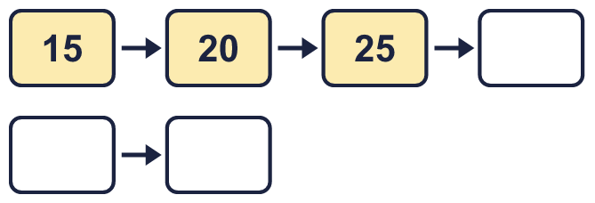
  7 | Complete the number track. It counts up in 5s.
  8 | Work out the multiplications.  a) 9 × 5 =  b) 12 × 5 =
  8 | Work out the multiplications.  a) 9 × 5 =  b) 12 × 5 =

  9 | Write true or false for each statement.
    a) | 7 × 5 = 5 × 8
    b) | 7 × 5 = 8 × 5 - 5
    c) | 7 × 5 = 6 × 5 + 7
    d) | 7 × 5 = 5 × 7
  9 | Write true or false for each statement.
    a) | 7 × 5 = 5 × 8
    b) | 7 × 5 = 8 × 5 - 5
    c) | 7 × 5 = 6 × 5 + 7
    d) | 7 × 5 = 5 × 7
  10 | Is Boba correct? Circle yes or no.  Yes / No  What is the correct answer?  Explain Boba’s mistake.
    
  10 | Is Boba correct? Circle yes or no.  Yes / No  What is the correct answer?  Explain Boba’s mistake.
  11 | a) How long is the yellow ribbon?  b) How much longer is the yellow ribbon than the red ribbon?
     | 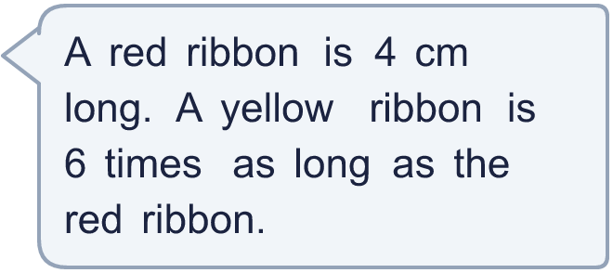
  11 | a) How long is the yellow ribbon?  b) How much longer is the yellow ribbon than the red ribbon?
  12 | There are 3 players in a team. 4 teams have signed up for a tournament.  a) How many players have signed up?  b) The tournament needs 21 players. How many more teams are needed?
  12 | There are 3 players in a team. 4 teams have signed up for a tournament.  a) How many players have signed up?  b) The tournament needs 21 players. How many more teams are needed?
  13 | Write three different multiples of 3 that are between 40 and 70.
  13 | Write three different multiples of 3 that are between 40 and 70.
  14 | Write <, > or = in each box.
    a) | 6 × 5 |  | 11 × 5
    b) | 5 × 4 |  | 4 × 5
    c) | 30 ÷ 5 |  | 55 ÷ 5
  14 | Write <, > or = in each box.
    a) | 6 × 5 |  | 11 × 5
    b) | 5 × 4 |  | 4 × 5
    c) | 30 ÷ 5 |  | 55 ÷ 5

Year 3 · Multiplication and division A · Step 2
Use arrays
Answers (teacher copy)

  1 | Look at the array of counters.  There are 5 rows.  There are 2 counters in each row.  There are 10 counters altogether.
  2 | Work out the multiplications.  a) 4 × 4 = 16  b) 4 × 2 = 8
  3 | Complete the number sentences to describe the array.  3 × 5 = 15  5 × 3 = 15  15 ÷ 5 = 3  15 ÷ 3 = 5
  4 | Write the missing number in each calculation.  a) 20 ÷ 5 = 4  b) 5 × 8 = 40  c) 5 × 5 = 25
  5 | Work out the multiplications.  a) 4 × 10 = 40  b) 3 × 10 = 30
  6 | A baker makes 7 trays of buns. Each tray has 3 buns.  a) How many buns are there? 21  b) 6 buns are eaten. How many buns are left? 15
  7 | Complete the number track. It counts up in 5s.  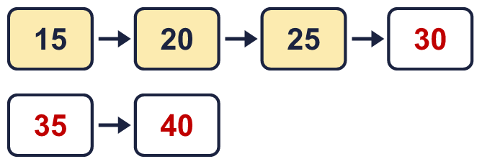
  8 | Work out the multiplications.  a) 9 × 5 = 45  b) 12 × 5 = 60
  9 | Write true or false for each statement.  a) 7 × 5 = 5 × 8 False  b) 7 × 5 = 8 × 5 - 5 True  c) 7 × 5 = 6 × 5 + 7 False  d) 7 × 5 = 5 × 7 True
  10 | Is Boba correct? Circle yes or no.  Yes / No  What is the correct answer? 18  Explain Boba’s mistake.  6 × 3 = 18. Boba’s answer is not 6 groups of 3: 6 groups of 3 make 18.
  11 | a) How long is the yellow ribbon? 24 cm  b) How much longer is the yellow ribbon than the red ribbon? 20 cm
  12 | There are 3 players in a team. 4 teams have signed up for a tournament.  a) How many players have signed up? 12  b) The tournament needs 21 players. How many more teams are needed? 3
  13 | Write three different multiples of 3 that are between 40 and 70.  for example 42, 45, 48
  14 | Write <, > or = in each box.  a) 6 × 5 < 11 × 5  b) 5 × 4 = 4 × 5  c) 30 ÷ 5 < 55 ÷ 5

