  Year 3 · Multiplication and division A · Step 14  The 8 times-table | 
  Year 3 · Multiplication and division A · Step 14
  The 8 times-table
  1 | Complete the number sentences to describe the array.  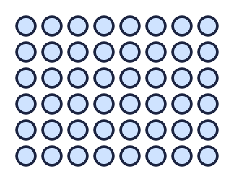
     | × |  | =
     | × |  | =
     | ÷ |  | =
     | ÷ |  | =
  1 | Complete the number sentences to describe the array.
     | × |  | =
     | × |  | =
     | ÷ |  | =
     | ÷ |  | =
  2 | Complete the number track. It counts up in 8s.  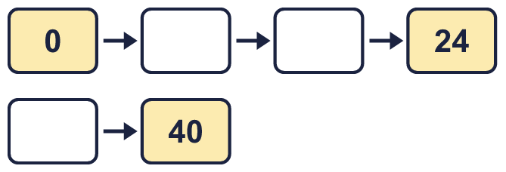
  2 | Complete the number track. It counts up in 8s.
  3 | Work out the multiplications.  a) 8 × 8 =  b) 8 × 6 =  c) 7 × 8 =
  3 | Work out the multiplications.  a) 8 × 8 =  b) 8 × 6 =  c) 7 × 8 =
  4 | Work out the divisions.  a) 80 ÷ 8 =  b) 32 ÷ 8 =  c) 64 ÷ 8 =
  4 | Work out the divisions.  a) 80 ÷ 8 =  b) 32 ÷ 8 =  c) 64 ÷ 8 =
  5 | Write the missing number in each calculation.
    a) |  | ÷ 8 | = | 7
    b) |  | × 8 | = | 32
    c) | 64 ÷ 8 | =
  5 | Write the missing number in each calculation.
    a) |  | ÷ 8 | = | 7
    b) |  | × 8 | = | 32
    c) | 64 ÷ 8 | =
  6 | Circle the multiples of 8. Write them below.  49 32 76 52 40 16
  6 | Circle the multiples of 8. Write them below.  49 32 76 52 40 16
  7 | Work out the calculations.  a) 7 × 8 =  b) 8 × 9 =  c) 64 ÷ 8 =
  7 | Work out the calculations.  a) 7 × 8 =  b) 8 × 9 =  c) 64 ÷ 8 =
  8 | Complete the number track. It counts down in 8s.  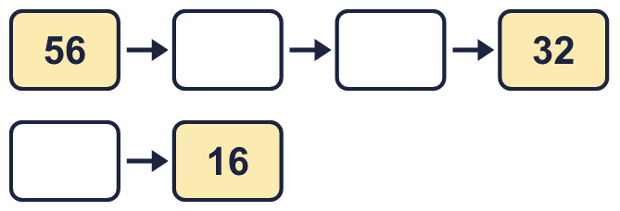
  8 | Complete the number track. It counts down in 8s.

  9 | Write true or false for each statement.
    a) | 8 × 8 = 9 × 8 - 8
    b) | 8 × 8 = 8 × 9
    c) | 8 × 8 = 9 × 8 + 8
    d) | 8 × 8 = 8 × 8
  9 | Write true or false for each statement.
    a) | 8 × 8 = 9 × 8 - 8
    b) | 8 × 8 = 8 × 9
    c) | 8 × 8 = 9 × 8 + 8
    d) | 8 × 8 = 8 × 8
  10 | Is Boba correct? Circle yes or no.  Yes / No  What is the correct answer?  Explain Boba’s mistake.
    
  10 | Is Boba correct? Circle yes or no.  Yes / No  What is the correct answer?  Explain Boba’s mistake.
  11 | Which number is the odd one out?  21 96 64 32  The odd one out is  Explain why it is the odd one out.
  11 | Which number is the odd one out?  21 96 64 32  The odd one out is  Explain why it is the odd one out.
  12 | a) How long is the yellow ribbon?  b) How much longer is the yellow ribbon than the red ribbon?
     | 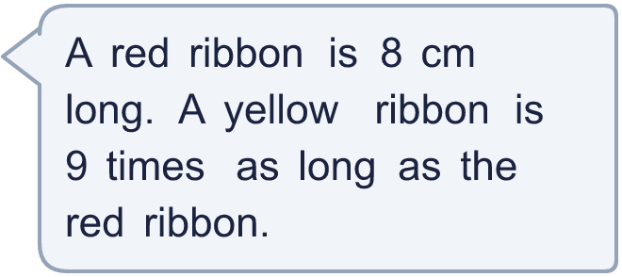
  12 | a) How long is the yellow ribbon?  b) How much longer is the yellow ribbon than the red ribbon?
  13 | There are 8 players in a team. 6 teams have signed up for a tournament.  a) How many players have signed up?  b) The tournament needs 80 players. How many more teams are needed?
  13 | There are 8 players in a team. 6 teams have signed up for a tournament.  a) How many players have signed up?  b) The tournament needs 80 players. How many more teams are needed?
  14 | Write three different multiples of 8 that are between 40 and 80.
  14 | Write three different multiples of 8 that are between 40 and 80.

Year 3 · Multiplication and division A · Step 14
The 8 times-table
Answers (teacher copy)

  1 | Complete the number sentences to describe the array.  6 × 8 = 48  8 × 6 = 48  48 ÷ 8 = 6  48 ÷ 6 = 8
  2 | Complete the number track. It counts up in 8s.  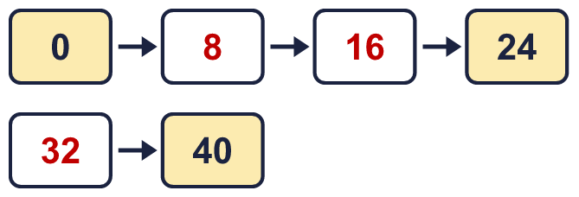
  3 | Work out the multiplications.  a) 8 × 8 = 64  b) 8 × 6 = 48  c) 7 × 8 = 56
  4 | Work out the divisions.  a) 80 ÷ 8 = 10  b) 32 ÷ 8 = 4  c) 64 ÷ 8 = 8
  5 | Write the missing number in each calculation.  a) 56 ÷ 8 = 7  b) 4 × 8 = 32  c) 64 ÷ 8 = 8
  6 | Circle the multiples of 8. Write them below.  49 32 76 52 40 16  16, 32, 40
  7 | Work out the calculations.  a) 7 × 8 = 56  b) 8 × 9 = 72  c) 64 ÷ 8 = 8
  8 | Complete the number track. It counts down in 8s.  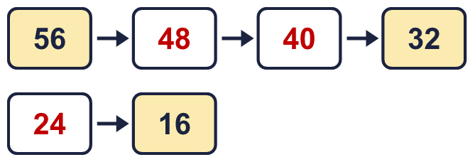
  9 | Write true or false for each statement.  a) 8 × 8 = 9 × 8 - 8 True  b) 8 × 8 = 8 × 9 False  c) 8 × 8 = 9 × 8 + 8 False  d) 8 × 8 = 8 × 8 True
  10 | Is Boba correct? Circle yes or no.  Yes / No  What is the correct answer? 40  Explain Boba’s mistake.  5 × 8 = 40. Boba’s answer is not 5 groups of 8: 5 groups of 8 make 40.
  11 | Which number is the odd one out?  21 96 64 32  The odd one out is 21  Explain why it is the odd one out.  21 is not a multiple of 8. The other three numbers are multiples of 8.
  12 | a) How long is the yellow ribbon? 72 cm  b) How much longer is the yellow ribbon than the red ribbon? 64 cm
  13 | There are 8 players in a team. 6 teams have signed up for a tournament.  a) How many players have signed up? 48  b) The tournament needs 80 players. How many more teams are needed? 4
  14 | Write three different multiples of 8 that are between 40 and 80.  for example 48, 56, 64

