  Year 3 · Multiplication and division A · Step 11  The 4 times-table | 
  Year 3 · Multiplication and division A · Step 11
  The 4 times-table
  1 | Complete the number sentences to describe the array.  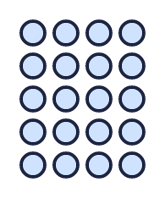
     | × |  | =
     | × |  | =
     | ÷ |  | =
     | ÷ |  | =
  1 | Complete the number sentences to describe the array.
     | × |  | =
     | × |  | =
     | ÷ |  | =
     | ÷ |  | =
  2 | Complete the number track. It counts up in 4s.  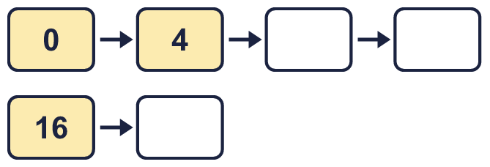
  2 | Complete the number track. It counts up in 4s.
  3 | Work out the multiplications.  a) 2 × 4 =  b) 4 × 6 =  c) 11 × 4 =
  3 | Work out the multiplications.  a) 2 × 4 =  b) 4 × 6 =  c) 11 × 4 =
  4 | Work out the divisions.  a) 12 ÷ 4 =  b) 16 ÷ 4 =  c) 20 ÷ 4 =
  4 | Work out the divisions.  a) 12 ÷ 4 =  b) 16 ÷ 4 =  c) 20 ÷ 4 =
  5 | Write the missing number in each calculation.
    a) |  | ÷ 4 | = | 7
    b) | 48 ÷ 4 | =
    c) | 4 × |  | = | 24
  5 | Write the missing number in each calculation.
    a) |  | ÷ 4 | = | 7
    b) | 48 ÷ 4 | =
    c) | 4 × |  | = | 24
  6 | Circle the multiples of 4. Write them below.  26 27 12 15 80 32
  6 | Circle the multiples of 4. Write them below.  26 27 12 15 80 32
  7 | Work out the calculations.  a) 24 ÷ 4 =  b) 12 ÷ 3 =  c) 4 × 4 =
  7 | Work out the calculations.  a) 24 ÷ 4 =  b) 12 ÷ 3 =  c) 4 × 4 =
  8 | Complete the number track. It counts down in 4s.  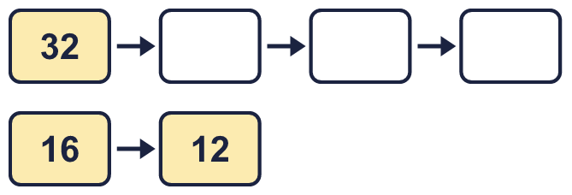
  8 | Complete the number track. It counts down in 4s.

  9 | Write true or false for each statement.
    a) | 4 × 4 = 3 × 4 + 4
    b) | 4 × 4 = 4 × 5
    c) | 4 × 4 = 4 × 4
    d) | 4 × 4 = 5 × 4 + 4
  9 | Write true or false for each statement.
    a) | 4 × 4 = 3 × 4 + 4
    b) | 4 × 4 = 4 × 5
    c) | 4 × 4 = 4 × 4
    d) | 4 × 4 = 5 × 4 + 4
  10 | Is Boba correct? Circle yes or no.  Yes / No  What is the correct answer?  Explain Boba’s mistake.
    
  10 | Is Boba correct? Circle yes or no.  Yes / No  What is the correct answer?  Explain Boba’s mistake.
  11 | Which number is the odd one out?  17 20 12 48  The odd one out is  Explain why it is the odd one out.
  11 | Which number is the odd one out?  17 20 12 48  The odd one out is  Explain why it is the odd one out.
  12 | a) How long is the yellow ribbon?  b) How much longer is the yellow ribbon than the red ribbon?
     | 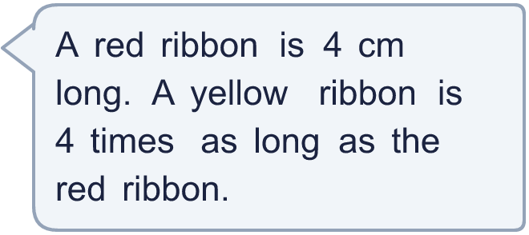
  12 | a) How long is the yellow ribbon?  b) How much longer is the yellow ribbon than the red ribbon?
  13 | There are 4 players in a team. 6 teams have signed up for a tournament.  a) How many players have signed up?  b) The tournament needs 40 players. How many more teams are needed?
  13 | There are 4 players in a team. 6 teams have signed up for a tournament.  a) How many players have signed up?  b) The tournament needs 40 players. How many more teams are needed?
  14 | Write three different multiples of 4 that are between 20 and 60.
  14 | Write three different multiples of 4 that are between 20 and 60.

Year 3 · Multiplication and division A · Step 11
The 4 times-table
Answers (teacher copy)

  1 | Complete the number sentences to describe the array.  5 × 4 = 20  4 × 5 = 20  20 ÷ 4 = 5  20 ÷ 5 = 4
  2 | Complete the number track. It counts up in 4s.  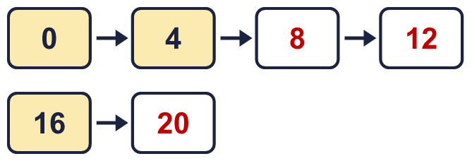
  3 | Work out the multiplications.  a) 2 × 4 = 8  b) 4 × 6 = 24  c) 11 × 4 = 44
  4 | Work out the divisions.  a) 12 ÷ 4 = 3  b) 16 ÷ 4 = 4  c) 20 ÷ 4 = 5
  5 | Write the missing number in each calculation.  a) 28 ÷ 4 = 7  b) 48 ÷ 4 = 12  c) 4 × 6 = 24
  6 | Circle the multiples of 4. Write them below.  26 27 12 15 80 32  12, 32, 80
  7 | Work out the calculations.  a) 24 ÷ 4 = 6  b) 12 ÷ 3 = 4  c) 4 × 4 = 16
  8 | Complete the number track. It counts down in 4s.  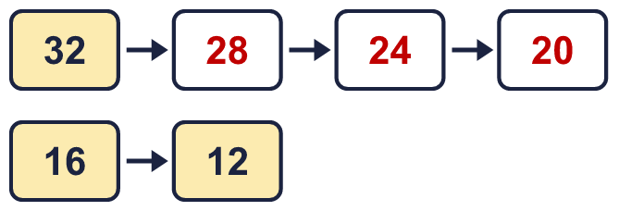
  9 | Write true or false for each statement.  a) 4 × 4 = 3 × 4 + 4 True  b) 4 × 4 = 4 × 5 False  c) 4 × 4 = 4 × 4 True  d) 4 × 4 = 5 × 4 + 4 False
  10 | Is Boba correct? Circle yes or no.  Yes / No  What is the correct answer? 32  Explain Boba’s mistake.  8 × 4 = 32. Boba’s answer is not 8 groups of 4: 8 groups of 4 make 32.
  11 | Which number is the odd one out?  17 20 12 48  The odd one out is 17  Explain why it is the odd one out.  17 is not a multiple of 4. The other three numbers are multiples of 4.
  12 | a) How long is the yellow ribbon? 16 cm  b) How much longer is the yellow ribbon than the red ribbon? 12 cm
  13 | There are 4 players in a team. 6 teams have signed up for a tournament.  a) How many players have signed up? 24  b) The tournament needs 40 players. How many more teams are needed? 4
  14 | Write three different multiples of 4 that are between 20 and 60.  for example 24, 28, 32

