  Year 3 · Multiplication and division A · Step 8  The 3 times-table | 
  Year 3 · Multiplication and division A · Step 8
  The 3 times-table
  1 | Complete the number sentences to describe the array.  
     | × |  | =
     | × |  | =
     | ÷ |  | =
     | ÷ |  | =
  1 | Complete the number sentences to describe the array.
     | × |  | =
     | × |  | =
     | ÷ |  | =
     | ÷ |  | =
  2 | Complete the number track. It counts up in 3s.  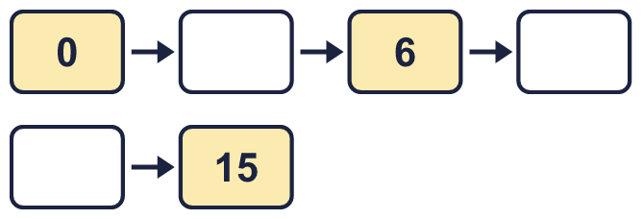
  2 | Complete the number track. It counts up in 3s.
  3 | Work out the multiplications.  a) 8 × 3 =  b) 3 × 3 =  c) 5 × 3 =
  3 | Work out the multiplications.  a) 8 × 3 =  b) 3 × 3 =  c) 5 × 3 =
  4 | Work out the divisions.  a) 24 ÷ 3 =  b) 15 ÷ 3 =  c) 30 ÷ 3 =
  4 | Work out the divisions.  a) 24 ÷ 3 =  b) 15 ÷ 3 =  c) 30 ÷ 3 =
  5 | Write the missing number in each calculation.
    a) |  | × 3 | = | 9
    b) |  | ÷ 3 | = | 2
    c) | 21 ÷ 3 | =
  5 | Write the missing number in each calculation.
    a) |  | × 3 | = | 9
    b) |  | ÷ 3 | = | 2
    c) | 21 ÷ 3 | =
  6 | Find the digit sum of each number. Is the number a multiple of the number shown?
    a) | 135: digit sum
    multiple of 3?
    b) | 178: digit sum
    multiple of 3?
    c) | 103: digit sum
    multiple of 3?
  6 | Find the digit sum of each number. Is the number a multiple of the number shown?
    a) | 135: digit sum
    multiple of 3?
    b) | 178: digit sum
    multiple of 3?
    c) | 103: digit sum
    multiple of 3?
  7 | Work out the calculations.  a) 24 ÷ 3 =  b) 3 × 3 =  c) 36 ÷ 12 =
  7 | Work out the calculations.  a) 24 ÷ 3 =  b) 3 × 3 =  c) 36 ÷ 12 =
  8 | Complete the number track. It counts down in 3s.  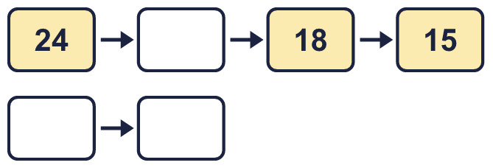
  8 | Complete the number track. It counts down in 3s.

  9 | Write true or false for each statement.
    a) | 9 × 3 = 10 × 3 + 3
    b) | 9 × 3 = 8 × 3 + 3
    c) | 9 × 3 = 9 × 4 - 3
    d) | 9 × 3 = 10 × 3 - 3
  9 | Write true or false for each statement.
    a) | 9 × 3 = 10 × 3 + 3
    b) | 9 × 3 = 8 × 3 + 3
    c) | 9 × 3 = 9 × 4 - 3
    d) | 9 × 3 = 10 × 3 - 3
  10 | Is Boba correct? Circle yes or no.  Yes / No  What is the correct answer?  Explain Boba’s mistake.
    
  10 | Is Boba correct? Circle yes or no.  Yes / No  What is the correct answer?  Explain Boba’s mistake.
  11 | Which number is the odd one out?  36 18 76 24  The odd one out is  Explain why it is the odd one out.
  11 | Which number is the odd one out?  36 18 76 24  The odd one out is  Explain why it is the odd one out.
  12 | a) Use this fact to work out 3 × 28.  b) Now work out 84 ÷ 3.
     | 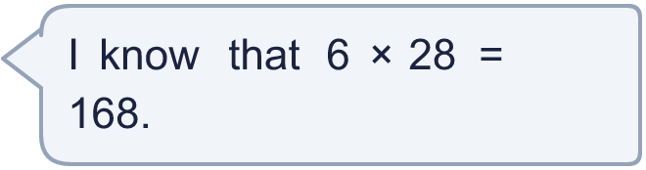
  12 | a) Use this fact to work out 3 × 28.  b) Now work out 84 ÷ 3.
  13 | There are 3 players in a team. 6 teams have signed up for a tournament.  a) How many players have signed up?  b) The tournament needs 30 players. How many more teams are needed?
  13 | There are 3 players in a team. 6 teams have signed up for a tournament.  a) How many players have signed up?  b) The tournament needs 30 players. How many more teams are needed?
  14 | Write three different multiples of 3 that are between 40 and 80.
  14 | Write three different multiples of 3 that are between 40 and 80.

Year 3 · Multiplication and division A · Step 8
The 3 times-table
Answers (teacher copy)

  1 | Complete the number sentences to describe the array.  3 × 3 = 9  3 × 3 = 9  9 ÷ 3 = 3  9 ÷ 3 = 3
  2 | Complete the number track. It counts up in 3s.  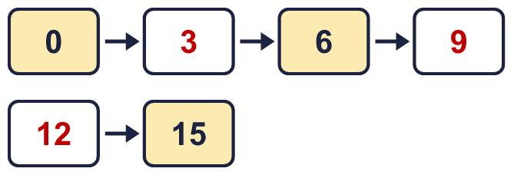
  3 | Work out the multiplications.  a) 8 × 3 = 24  b) 3 × 3 = 9  c) 5 × 3 = 15
  4 | Work out the divisions.  a) 24 ÷ 3 = 8  b) 15 ÷ 3 = 5  c) 30 ÷ 3 = 10
  5 | Write the missing number in each calculation.  a) 3 × 3 = 9  b) 6 ÷ 3 = 2  c) 21 ÷ 3 = 7
  6 | Find the digit sum of each number. Is the number a multiple of the number shown?  a) 135: digit sum 9 multiple of 3? Yes  b) 178: digit sum 16 multiple of 3? No  c) 103: digit sum 4 multiple of 3? No
  7 | Work out the calculations.  a) 24 ÷ 3 = 8  b) 3 × 3 = 9  c) 36 ÷ 12 = 3
  8 | Complete the number track. It counts down in 3s.  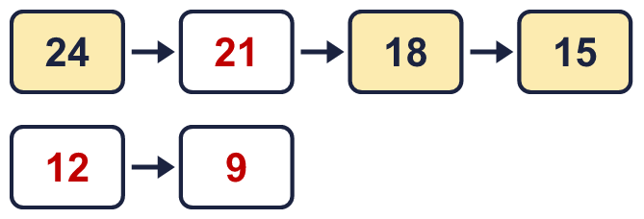
  9 | Write true or false for each statement.  a) 9 × 3 = 10 × 3 + 3 False  b) 9 × 3 = 8 × 3 + 3 True  c) 9 × 3 = 9 × 4 - 3 False  d) 9 × 3 = 10 × 3 - 3 True
  10 | Is Boba correct? Circle yes or no.  Yes / No  What is the correct answer? 9  Explain Boba’s mistake.  3 × 3 = 9. Boba’s answer is not 3 groups of 3: 3 groups of 3 make 9.
  11 | Which number is the odd one out?  36 18 76 24  The odd one out is 76  Explain why it is the odd one out.  76 is not a multiple of 3. The other three numbers are multiples of 3.
  12 | a) Use this fact to work out 3 × 28. 84  b) Now work out 84 ÷ 3. 28
  13 | There are 3 players in a team. 6 teams have signed up for a tournament.  a) How many players have signed up? 18  b) The tournament needs 30 players. How many more teams are needed? 4
  14 | Write three different multiples of 3 that are between 40 and 80.  for example 42, 45, 48

