  Year 3 · Multiplication and division A · Step 15  The 2, 4 and 8 times-tables | 
  Year 3 · Multiplication and division A · Step 15
  The 2, 4 and 8 times-tables
  1 | Work out the multiplications.  a) 8 × 2 =  b) 2 × 3 =  c) 9 × 2 =
  1 | Work out the multiplications.  a) 8 × 2 =  b) 2 × 3 =  c) 9 × 2 =
  2 | Work out the multiplications.  a) 9 × 4 =  b) 4 × 2 =  c) 8 × 4 =
  2 | Work out the multiplications.  a) 9 × 4 =  b) 4 × 2 =  c) 8 × 4 =
  3 | Work out the multiplications.  a) 2 × 8 =  b) 8 × 4 =  c) 9 × 8 =
  3 | Work out the multiplications.  a) 2 × 8 =  b) 8 × 4 =  c) 9 × 8 =
  4 | Complete the number sentences to describe the array.  
     | × |  | =
     | × |  | =
     | ÷ |  | =
     | ÷ |  | =
  4 | Complete the number sentences to describe the array.
     | × |  | =
     | × |  | =
     | ÷ |  | =
     | ÷ |  | =
  5 | Write the missing number in each calculation.
    a) | 4 × |  | = | 24
    b) | 8 ÷ 4 | =
    c) |  | ÷ 4 | = | 9
  5 | Write the missing number in each calculation.
    a) | 4 × |  | = | 24
    b) | 8 ÷ 4 | =
    c) |  | ÷ 4 | = | 9
  6 | Work out the calculations.  a) 40 ÷ 5 =  b) 11 × 8 =  c) 80 ÷ 8 =
  6 | Work out the calculations.  a) 40 ÷ 5 =  b) 11 × 8 =  c) 80 ÷ 8 =
  7 | Dani buys 8 packs of stickers. There are 2 stickers in each pack.  a) How many stickers does Dani buy?  b) She gives 4 stickers to a friend. How many does she have now?
  7 | Dani buys 8 packs of stickers. There are 2 stickers in each pack.  a) How many stickers does Dani buy?  b) She gives 4 stickers to a friend. How many does she have now?
  8 | A farm has 8 boxes. Each box holds 4 eggs.  a) How many eggs are there altogether?  b) 7 eggs are sold. How many eggs are left?
  8 | A farm has 8 boxes. Each box holds 4 eggs.  a) How many eggs are there altogether?  b) 7 eggs are sold. How many eggs are left?

  9 | Write true or false for each statement.
    a) | 7 × 8 = 8 × 7
    b) | 7 × 8 = 6 × 8 + 8
    c) | 7 × 8 = 8 × 8
    d) | 7 × 8 = 7 × 9 - 8
  9 | Write true or false for each statement.
    a) | 7 × 8 = 8 × 7
    b) | 7 × 8 = 6 × 8 + 8
    c) | 7 × 8 = 8 × 8
    d) | 7 × 8 = 7 × 9 - 8
  10 | Write <, > or = in each box.
    a) | 8 × 4 |  | 2 × 4
    b) | 4 × 3 |  | 3 × 4
    c) | 32 ÷ 4 |  | 8 ÷ 4
  10 | Write <, > or = in each box.
    a) | 8 × 4 |  | 2 × 4
    b) | 4 × 3 |  | 3 × 4
    c) | 32 ÷ 4 |  | 8 ÷ 4
  11 | Is Boba correct? Circle yes or no.  Yes / No  What is the correct answer?  Explain Boba’s mistake.
    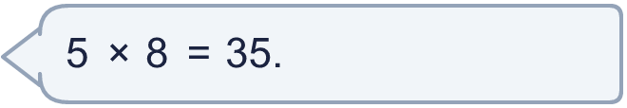
  11 | Is Boba correct? Circle yes or no.  Yes / No  What is the correct answer?  Explain Boba’s mistake.
  12 | a) How long is the yellow ribbon?  b) How much longer is the yellow ribbon than the red ribbon?
     | 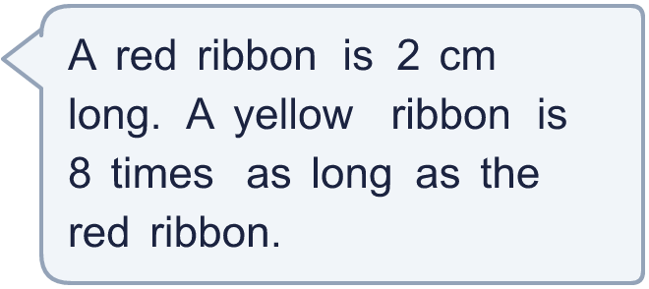
  12 | a) How long is the yellow ribbon?  b) How much longer is the yellow ribbon than the red ribbon?
  13 | There are 8 players in a team. 6 teams have signed up for a tournament.  a) How many players have signed up?  b) The tournament needs 64 players. How many more teams are needed?
  13 | There are 8 players in a team. 6 teams have signed up for a tournament.  a) How many players have signed up?  b) The tournament needs 64 players. How many more teams are needed?
  14 | Huan is thinking of three different multiples of 4 that are less than 40. The sum of the numbers is 56.  What could the numbers be?
  14 | Huan is thinking of three different multiples of 4 that are less than 40. The sum of the numbers is 56.  What could the numbers be?

Year 3 · Multiplication and division A · Step 15
The 2, 4 and 8 times-tables
Answers (teacher copy)

  1 | Work out the multiplications.  a) 8 × 2 = 16  b) 2 × 3 = 6  c) 9 × 2 = 18
  2 | Work out the multiplications.  a) 9 × 4 = 36  b) 4 × 2 = 8  c) 8 × 4 = 32
  3 | Work out the multiplications.  a) 2 × 8 = 16  b) 8 × 4 = 32  c) 9 × 8 = 72
  4 | Complete the number sentences to describe the array.  3 × 2 = 6  2 × 3 = 6  6 ÷ 2 = 3  6 ÷ 3 = 2
  5 | Write the missing number in each calculation.  a) 4 × 6 = 24  b) 8 ÷ 4 = 2  c) 36 ÷ 4 = 9
  6 | Work out the calculations.  a) 40 ÷ 5 = 8  b) 11 × 8 = 88  c) 80 ÷ 8 = 10
  7 | Dani buys 8 packs of stickers. There are 2 stickers in each pack.  a) How many stickers does Dani buy? 16  b) She gives 4 stickers to a friend. How many does she have now? 12
  8 | A farm has 8 boxes. Each box holds 4 eggs.  a) How many eggs are there altogether? 32  b) 7 eggs are sold. How many eggs are left? 25
  9 | Write true or false for each statement.  a) 7 × 8 = 8 × 7 True  b) 7 × 8 = 6 × 8 + 8 True  c) 7 × 8 = 8 × 8 False  d) 7 × 8 = 7 × 9 - 8 False
  10 | Write <, > or = in each box.  a) 8 × 4 > 2 × 4  b) 4 × 3 = 3 × 4  c) 32 ÷ 4 > 8 ÷ 4
  11 | Is Boba correct? Circle yes or no.  Yes / No  What is the correct answer? 40  Explain Boba’s mistake.  5 × 8 = 40. Boba’s answer is not 5 groups of 8: 5 groups of 8 make 40.
  12 | a) How long is the yellow ribbon? 16 cm  b) How much longer is the yellow ribbon than the red ribbon? 14 cm
  13 | There are 8 players in a team. 6 teams have signed up for a tournament.  a) How many players have signed up? 48  b) The tournament needs 64 players. How many more teams are needed? 2
  14 | Huan is thinking of three different multiples of 4 that are less than 40. The sum of the numbers is 56.  What could the numbers be?  for example 12 + 20 + 24

