  Year 3 · Multiplication and division A · Step 12  Multiply by 8 | 
  Year 3 · Multiplication and division A · Step 12
  Multiply by 8
  1 | How many are there in total?  a) 10 equal groups of 8 =  b) 4 equal groups of 8 =  c) 5 equal groups of 8 =
  1 | How many are there in total?  a) 10 equal groups of 8 =  b) 4 equal groups of 8 =  c) 5 equal groups of 8 =
  2 | Work out each answer.  a) 8 + 8 + 8 + 8 =  b) 4 × 8 =  c) 8 + 8 + 8 + 8 + 8 + 8 =  d) 6 × 8 =
  2 | Work out each answer.  a) 8 + 8 + 8 + 8 =  b) 4 × 8 =  c) 8 + 8 + 8 + 8 + 8 + 8 =  d) 6 × 8 =
  3 | Look at the array of counters.  
    There are |  | rows.
    There are
    counters in each row.
    There are
    counters altogether.
  3 | Look at the array of counters.
    There are |  | rows.
    There are
    counters in each row.
    There are
    counters altogether.
  4 | Complete the number sentences to describe the array.  
     | × |  | =
     | × |  | =
     | ÷ |  | =
     | ÷ |  | =
  4 | Complete the number sentences to describe the array.
     | × |  | =
     | × |  | =
     | ÷ |  | =
     | ÷ |  | =
  5 | Work out the multiplications.  a) 5 × 8 =  b) 8 × 4 =  c) 10 × 8 =
  5 | Work out the multiplications.  a) 5 × 8 =  b) 8 × 4 =  c) 10 × 8 =
  6 | Write the missing number in each calculation.
    a) |  | × 8 | = | 24
    b) | 8 × |  | = | 56
    c) | 96 ÷ 8 | =
  6 | Write the missing number in each calculation.
    a) |  | × 8 | = | 24
    b) | 8 × |  | = | 56
    c) | 96 ÷ 8 | =
  7 | Dani buys 9 packs of stickers. There are 8 stickers in each pack.  a) How many stickers does Dani buy?  b) She gives 3 stickers to a friend. How many does she have now?
  7 | Dani buys 9 packs of stickers. There are 8 stickers in each pack.  a) How many stickers does Dani buy?  b) She gives 3 stickers to a friend. How many does she have now?
  8 | Circle the multiples of 8. Write them below.  32 45 88 42 38 40
  8 | Circle the multiples of 8. Write them below.  32 45 88 42 38 40

  9 | Write true or false for each statement.
    a) | 6 × 8 = 6 × 9 - 8
    b) | 6 × 8 = 5 × 8 + 6
    c) | 6 × 8 = 5 × 8 + 8
    d) | 12 × 8 = 6 × 16
  9 | Write true or false for each statement.
    a) | 6 × 8 = 6 × 9 - 8
    b) | 6 × 8 = 5 × 8 + 6
    c) | 6 × 8 = 5 × 8 + 8
    d) | 12 × 8 = 6 × 16
  10 | Write <, > or = in each box.
    a) | 7 × 8 |  | 4 × 8
    b) | 8 × 5 |  | 5 × 8
    c) | 56 ÷ 8 |  | 32 ÷ 8
  10 | Write <, > or = in each box.
    a) | 7 × 8 |  | 4 × 8
    b) | 8 × 5 |  | 5 × 8
    c) | 56 ÷ 8 |  | 32 ÷ 8
  11 | Is Boba correct? Circle yes or no.  Yes / No  What is the correct answer?  Explain Boba’s mistake.
    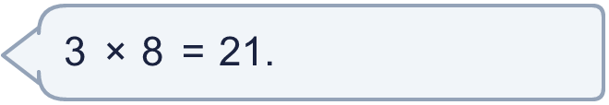
  11 | Is Boba correct? Circle yes or no.  Yes / No  What is the correct answer?  Explain Boba’s mistake.
  12 | a) How long is the yellow ribbon?  b) How much longer is the yellow ribbon than the red ribbon?
     | 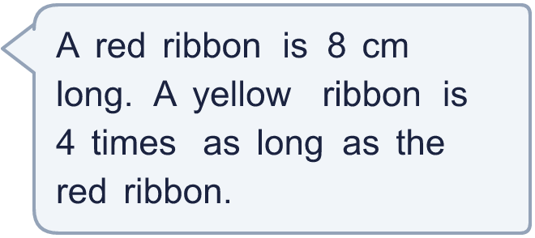
  12 | a) How long is the yellow ribbon?  b) How much longer is the yellow ribbon than the red ribbon?
  13 | There are 8 players in a team. 3 teams have signed up for a tournament.  a) How many players have signed up?  b) The tournament needs 40 players. How many more teams are needed?
  13 | There are 8 players in a team. 3 teams have signed up for a tournament.  a) How many players have signed up?  b) The tournament needs 40 players. How many more teams are needed?
  14 | Mia is thinking of three different multiples of 8 that are less than 80. The sum of the numbers is 152.  What could the numbers be?
  14 | Mia is thinking of three different multiples of 8 that are less than 80. The sum of the numbers is 152.  What could the numbers be?

Year 3 · Multiplication and division A · Step 12
Multiply by 8
Answers (teacher copy)

  1 | How many are there in total?  a) 10 equal groups of 8 = 80  b) 4 equal groups of 8 = 32  c) 5 equal groups of 8 = 40
  2 | Work out each answer.  a) 8 + 8 + 8 + 8 = 32  b) 4 × 8 = 32  c) 8 + 8 + 8 + 8 + 8 + 8 = 48  d) 6 × 8 = 48
  3 | Look at the array of counters.  There are 2 rows.  There are 8 counters in each row.  There are 16 counters altogether.
  4 | Complete the number sentences to describe the array.  3 × 8 = 24  8 × 3 = 24  24 ÷ 8 = 3  24 ÷ 3 = 8
  5 | Work out the multiplications.  a) 5 × 8 = 40  b) 8 × 4 = 32  c) 10 × 8 = 80
  6 | Write the missing number in each calculation.  a) 3 × 8 = 24  b) 8 × 7 = 56  c) 96 ÷ 8 = 12
  7 | Dani buys 9 packs of stickers. There are 8 stickers in each pack.  a) How many stickers does Dani buy? 72  b) She gives 3 stickers to a friend. How many does she have now? 69
  8 | Circle the multiples of 8. Write them below.  32 45 88 42 38 40  32, 40, 88
  9 | Write true or false for each statement.  a) 6 × 8 = 6 × 9 - 8 False  b) 6 × 8 = 5 × 8 + 6 False  c) 6 × 8 = 5 × 8 + 8 True  d) 12 × 8 = 6 × 16 True
  10 | Write <, > or = in each box.  a) 7 × 8 > 4 × 8  b) 8 × 5 = 5 × 8  c) 56 ÷ 8 > 32 ÷ 8
  11 | Is Boba correct? Circle yes or no.  Yes / No  What is the correct answer? 24  Explain Boba’s mistake.  3 × 8 = 24. Boba’s answer is not 3 groups of 8: 3 groups of 8 make 24.
  12 | a) How long is the yellow ribbon? 32 cm  b) How much longer is the yellow ribbon than the red ribbon? 24 cm
  13 | There are 8 players in a team. 3 teams have signed up for a tournament.  a) How many players have signed up? 24  b) The tournament needs 40 players. How many more teams are needed? 2
  14 | Mia is thinking of three different multiples of 8 that are less than 80. The sum of the numbers is 152.  What could the numbers be?  for example 32 + 56 + 64

