  Year 3 · Multiplication and division A · Step 6  Multiply by 3 | 
  Year 3 · Multiplication and division A · Step 6
  Multiply by 3
  1 | How many are there in total?  a) 2 equal groups of 3 =  b) 3 equal groups of 3 =  c) 6 equal groups of 3 =
  1 | How many are there in total?  a) 2 equal groups of 3 =  b) 3 equal groups of 3 =  c) 6 equal groups of 3 =
  2 | Work out each answer.  a) 3 + 3 + 3 + 3 + 3 =  b) 5 × 3 =  c) 3 + 3 + 3 =  d) 3 × 3 =
  2 | Work out each answer.  a) 3 + 3 + 3 + 3 + 3 =  b) 5 × 3 =  c) 3 + 3 + 3 =  d) 3 × 3 =
  3 | Look at the array of counters.  
    There are |  | rows.
    There are
    counters in each row.
    There are
    counters altogether.
  3 | Look at the array of counters.
    There are |  | rows.
    There are
    counters in each row.
    There are
    counters altogether.
  4 | Complete the number sentences to describe the array.  
     | × |  | =
     | × |  | =
     | ÷ |  | =
     | ÷ |  | =
  4 | Complete the number sentences to describe the array.
     | × |  | =
     | × |  | =
     | ÷ |  | =
     | ÷ |  | =
  5 | Work out the multiplications.  a) 12 × 3 =  b) 3 × 3 =  c) 8 × 3 =
  5 | Work out the multiplications.  a) 12 × 3 =  b) 3 × 3 =  c) 8 × 3 =
  6 | Write the missing number in each calculation.
    a) |  | ÷ 3 | = | 11
    b) | 6 ÷ 3 | =
    c) | 3 × |  | = | 9
  6 | Write the missing number in each calculation.
    a) |  | ÷ 3 | = | 11
    b) | 6 ÷ 3 | =
    c) | 3 × |  | = | 9
  7 | Dani buys 4 packs of stickers. There are 3 stickers in each pack.  a) How many stickers does Dani buy?  b) She gives 7 stickers to a friend. How many does she have now?
  7 | Dani buys 4 packs of stickers. There are 3 stickers in each pack.  a) How many stickers does Dani buy?  b) She gives 7 stickers to a friend. How many does she have now?
  8 | Circle the multiples of 3. Write them below.  12 46 71 40 93 87
  8 | Circle the multiples of 3. Write them below.  12 46 71 40 93 87

  9 | Write true or false for each statement.
    a) | 6 × 3 = 5 × 3 + 6
    b) | 6 × 3 = 7 × 3 + 3
    c) | 6 × 3 = 3 × 6
    d) | 6 × 3 = 5 × 3 + 3
  9 | Write true or false for each statement.
    a) | 6 × 3 = 5 × 3 + 6
    b) | 6 × 3 = 7 × 3 + 3
    c) | 6 × 3 = 3 × 6
    d) | 6 × 3 = 5 × 3 + 3
  10 | Write <, > or = in each box.
    a) | 4 × 3 |  | 7 × 3
    b) | 3 × 6 |  | 6 × 3
    c) | 12 ÷ 3 |  | 21 ÷ 3
  10 | Write <, > or = in each box.
    a) | 4 × 3 |  | 7 × 3
    b) | 3 × 6 |  | 6 × 3
    c) | 12 ÷ 3 |  | 21 ÷ 3
  11 | Is Boba correct? Circle yes or no.  Yes / No  What is the correct answer?  Explain Boba’s mistake.
    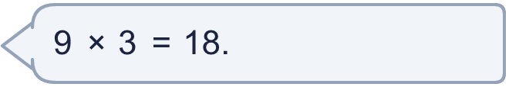
  11 | Is Boba correct? Circle yes or no.  Yes / No  What is the correct answer?  Explain Boba’s mistake.
  12 | a) How long is the yellow ribbon?  b) How much longer is the yellow ribbon than the red ribbon?
     | 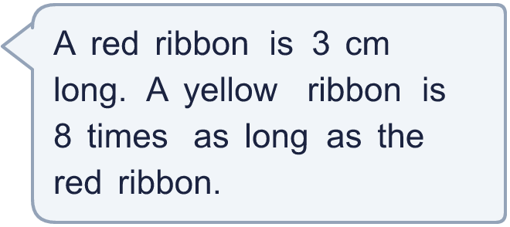
  12 | a) How long is the yellow ribbon?  b) How much longer is the yellow ribbon than the red ribbon?
  13 | There are 3 players in a team. 3 teams have signed up for a tournament.  a) How many players have signed up?  b) The tournament needs 24 players. How many more teams are needed?
  13 | There are 3 players in a team. 3 teams have signed up for a tournament.  a) How many players have signed up?  b) The tournament needs 24 players. How many more teams are needed?
  14 | Omar is thinking of three different multiples of 3 that are less than 30. The sum of the numbers is 54.  What could the numbers be?
  14 | Omar is thinking of three different multiples of 3 that are less than 30. The sum of the numbers is 54.  What could the numbers be?

Year 3 · Multiplication and division A · Step 6
Multiply by 3
Answers (teacher copy)

  1 | How many are there in total?  a) 2 equal groups of 3 = 6  b) 3 equal groups of 3 = 9  c) 6 equal groups of 3 = 18
  2 | Work out each answer.  a) 3 + 3 + 3 + 3 + 3 = 15  b) 5 × 3 = 15  c) 3 + 3 + 3 = 9  d) 3 × 3 = 9
  3 | Look at the array of counters.  There are 5 rows.  There are 3 counters in each row.  There are 15 counters altogether.
  4 | Complete the number sentences to describe the array.  3 × 3 = 9  3 × 3 = 9  9 ÷ 3 = 3  9 ÷ 3 = 3
  5 | Work out the multiplications.  a) 12 × 3 = 36  b) 3 × 3 = 9  c) 8 × 3 = 24
  6 | Write the missing number in each calculation.  a) 33 ÷ 3 = 11  b) 6 ÷ 3 = 2  c) 3 × 3 = 9
  7 | Dani buys 4 packs of stickers. There are 3 stickers in each pack.  a) How many stickers does Dani buy? 12  b) She gives 7 stickers to a friend. How many does she have now? 5
  8 | Circle the multiples of 3. Write them below.  12 46 71 40 93 87  12, 87, 93
  9 | Write true or false for each statement.  a) 6 × 3 = 5 × 3 + 6 False  b) 6 × 3 = 7 × 3 + 3 False  c) 6 × 3 = 3 × 6 True  d) 6 × 3 = 5 × 3 + 3 True
  10 | Write <, > or = in each box.  a) 4 × 3 < 7 × 3  b) 3 × 6 = 6 × 3  c) 12 ÷ 3 < 21 ÷ 3
  11 | Is Boba correct? Circle yes or no.  Yes / No  What is the correct answer? 27  Explain Boba’s mistake.  9 × 3 = 27. Boba’s answer is not 9 groups of 3: 9 groups of 3 make 27.
  12 | a) How long is the yellow ribbon? 24 cm  b) How much longer is the yellow ribbon than the red ribbon? 21 cm
  13 | There are 3 players in a team. 3 teams have signed up for a tournament.  a) How many players have signed up? 9  b) The tournament needs 24 players. How many more teams are needed? 5
  14 | Omar is thinking of three different multiples of 3 that are less than 30. The sum of the numbers is 54.  What could the numbers be?  for example 12 + 15 + 27

