  Year 3 · Multiplication and division A · Step 4  Multiples of 5 and 10 | 
  Year 3 · Multiplication and division A · Step 4
  Multiples of 5 and 10
  1 | Complete the number track. It counts up in 5s.  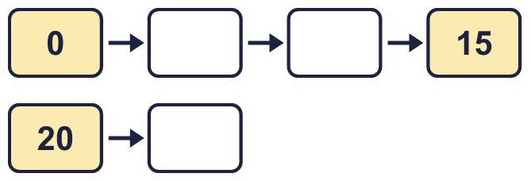
  1 | Complete the number track. It counts up in 5s.
  2 | Complete the number track. It counts up in 10s.  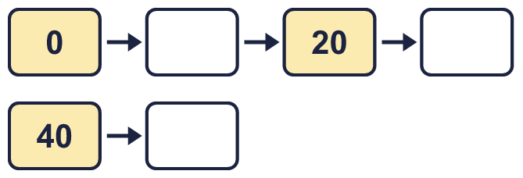
  2 | Complete the number track. It counts up in 10s.
  3 | Circle the multiples of 5. Write them below.  50 95 15 93 91 54
  3 | Circle the multiples of 5. Write them below.  50 95 15 93 91 54
  4 | Circle the multiples of 10. Write them below.  15 30 55 80 50 65
  4 | Circle the multiples of 10. Write them below.  15 30 55 80 50 65
  5 | List the multiples of 5 that are between 10 and 70.
  5 | List the multiples of 5 that are between 10 and 70.
  6 | How many multiples of 10 are there from 10 up to 110?
  6 | How many multiples of 10 are there from 10 up to 110?
  7 | Work out the multiplications.  a) 7 × 5 =  b) 5 × 9 =  c) 2 × 5 =
  7 | Work out the multiplications.  a) 7 × 5 =  b) 5 × 9 =  c) 2 × 5 =
  8 | Work out the multiplications.  a) 8 × 10 =  b) 7 × 10 =  c) 12 × 10 =
  8 | Work out the multiplications.  a) 8 × 10 =  b) 7 × 10 =  c) 12 × 10 =

  9 | Which number is the odd one out?  50 20 33 30  The odd one out is  Explain why it is the odd one out.
  9 | Which number is the odd one out?  50 20 33 30  The odd one out is  Explain why it is the odd one out.
  10 | Which number is the odd one out?  120 80 70 92  The odd one out is  Explain why it is the odd one out.
  10 | Which number is the odd one out?  120 80 70 92  The odd one out is  Explain why it is the odd one out.
  11 | Write three different multiples of 5 that are between 40 and 70.
  11 | Write three different multiples of 5 that are between 40 and 70.
  12 | Write three different multiples of 10 that are between 20 and 70.
  12 | Write three different multiples of 10 that are between 20 and 70.
  13 | Is Boba correct? Circle yes or no.  Yes / No  What is the correct answer?  Explain Boba’s mistake.
    
  13 | Is Boba correct? Circle yes or no.  Yes / No  What is the correct answer?  Explain Boba’s mistake.
  14 | A farm has 8 boxes. Each box holds 10 eggs.  a) How many eggs are there altogether?  b) 8 eggs are sold. How many eggs are left?
  14 | A farm has 8 boxes. Each box holds 10 eggs.  a) How many eggs are there altogether?  b) 8 eggs are sold. How many eggs are left?

Year 3 · Multiplication and division A · Step 4
Multiples of 5 and 10
Answers (teacher copy)

  1 | Complete the number track. It counts up in 5s.  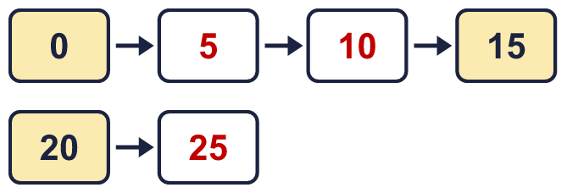
  2 | Complete the number track. It counts up in 10s.  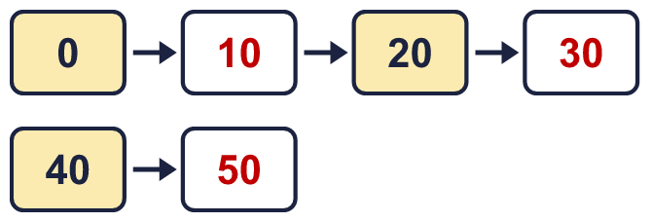
  3 | Circle the multiples of 5. Write them below.  50 95 15 93 91 54  15, 50, 95
  4 | Circle the multiples of 10. Write them below.  15 30 55 80 50 65  30, 50, 80
  5 | List the multiples of 5 that are between 10 and 70.  15, 20, 25, 30, 35, 40, 45, 50, 55, 60, 65
  6 | How many multiples of 10 are there from 10 up to 110?  11
  7 | Work out the multiplications.  a) 7 × 5 = 35  b) 5 × 9 = 45  c) 2 × 5 = 10
  8 | Work out the multiplications.  a) 8 × 10 = 80  b) 7 × 10 = 70  c) 12 × 10 = 120
  9 | Which number is the odd one out?  50 20 33 30  The odd one out is 33  Explain why it is the odd one out.  33 is not a multiple of 5. The other three numbers are multiples of 5.
  10 | Which number is the odd one out?  120 80 70 92  The odd one out is 92  Explain why it is the odd one out.  92 is not a multiple of 10. The other three numbers are multiples of 10.
  11 | Write three different multiples of 5 that are between 40 and 70.  for example 45, 50, 55
  12 | Write three different multiples of 10 that are between 20 and 70.  for example 30, 40, 50
  13 | Is Boba correct? Circle yes or no.  Yes / No  What is the correct answer? 15  Explain Boba’s mistake.  3 × 5 = 15. Boba’s answer is not 3 groups of 5: 3 groups of 5 make 15.
  14 | A farm has 8 boxes. Each box holds 10 eggs.  a) How many eggs are there altogether? 80  b) 8 eggs are sold. How many eggs are left? 72

