  Year 3 · Multiplication and division A · Step 3  Multiples of 2 | 
  Year 3 · Multiplication and division A · Step 3
  Multiples of 2
  1 | Complete the number track. It counts up in 2s.  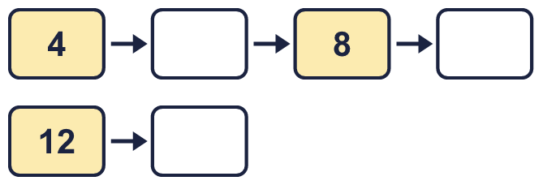
  1 | Complete the number track. It counts up in 2s.
  2 | Complete the number track. It counts down in 2s.  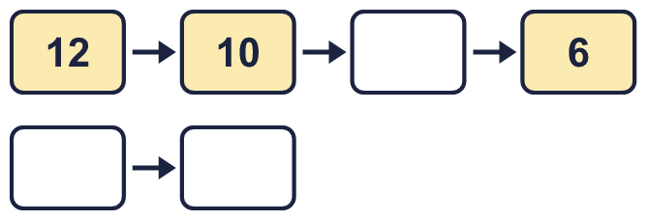
  2 | Complete the number track. It counts down in 2s.
  3 | Circle the multiples of 2. Write them below.  56 100 75 58 23 27
  3 | Circle the multiples of 2. Write them below.  56 100 75 58 23 27
  4 | List the multiples of 2 that are between 20 and 80.
  4 | List the multiples of 2 that are between 20 and 80.
  5 | How many multiples of 2 are there from 2 up to 50?
  5 | How many multiples of 2 are there from 2 up to 50?
  6 | Work out the multiplications.  a) 4 × 2 =  b) 2 × 11 =  c) 8 × 2 =
  6 | Work out the multiplications.  a) 4 × 2 =  b) 2 × 11 =  c) 8 × 2 =
  7 | Write the missing number in each calculation.
    a) | 6 ÷ 2 | =
    b) |  | × 2 | = | 12
    c) | 2 × |  | = | 22
  7 | Write the missing number in each calculation.
    a) | 6 ÷ 2 | =
    b) |  | × 2 | = | 12
    c) | 2 × |  | = | 22
  8 | Complete the number sentences to describe the array.  
     | × |  | =
     | × |  | =
     | ÷ |  | =
     | ÷ |  | =
  8 | Complete the number sentences to describe the array.
     | × |  | =
     | × |  | =
     | ÷ |  | =
     | ÷ |  | =

  9 | Which number is the odd one out?  6 47 14 20  The odd one out is  Explain why it is the odd one out.
  9 | Which number is the odd one out?  6 47 14 20  The odd one out is  Explain why it is the odd one out.
  10 | Write three different multiples of 2 that are between 30 and 70.
  10 | Write three different multiples of 2 that are between 30 and 70.
  11 | Mia is thinking of three different multiples of 2 that are less than 20. The sum of the numbers is 28.  What could the numbers be?
  11 | Mia is thinking of three different multiples of 2 that are less than 20. The sum of the numbers is 28.  What could the numbers be?
  12 | Write true or false for each statement.
    a) | 7 × 2 = 2 × 7
    b) | 14 × 2 = 7 × 4
    c) | 7 × 2 = 7 × 3 - 2
    d) | 7 × 2 = 2 × 8
  12 | Write true or false for each statement.
    a) | 7 × 2 = 2 × 7
    b) | 14 × 2 = 7 × 4
    c) | 7 × 2 = 7 × 3 - 2
    d) | 7 × 2 = 2 × 8
  13 | Is Boba correct? Circle yes or no.  Yes / No  What is the correct answer?  Explain Boba’s mistake.
    
  13 | Is Boba correct? Circle yes or no.  Yes / No  What is the correct answer?  Explain Boba’s mistake.
  14 | Dani buys 9 packs of stickers. There are 2 stickers in each pack.  a) How many stickers does Dani buy?  b) She gives 3 stickers to a friend. How many does she have now?
  14 | Dani buys 9 packs of stickers. There are 2 stickers in each pack.  a) How many stickers does Dani buy?  b) She gives 3 stickers to a friend. How many does she have now?

Year 3 · Multiplication and division A · Step 3
Multiples of 2
Answers (teacher copy)

  1 | Complete the number track. It counts up in 2s.  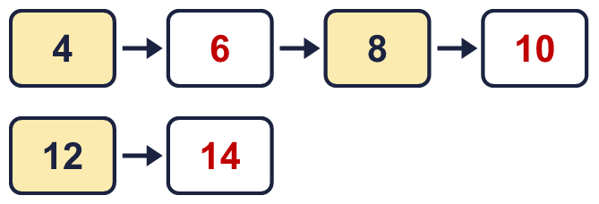
  2 | Complete the number track. It counts down in 2s.  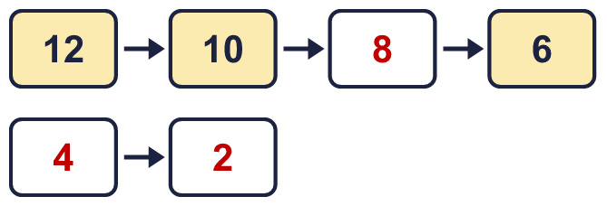
  3 | Circle the multiples of 2. Write them below.  56 100 75 58 23 27  56, 58, 100
  4 | List the multiples of 2 that are between 20 and 80.  22, 24, 26, 28, 30, 32, 34, 36, 38, 40, 42, 44, 46, 48, 50, 52, 54, 56, 58, 60, 62, 64, 66, 68, 70, 72, 74, 76, 78
  5 | How many multiples of 2 are there from 2 up to 50?  25
  6 | Work out the multiplications.  a) 4 × 2 = 8  b) 2 × 11 = 22  c) 8 × 2 = 16
  7 | Write the missing number in each calculation.  a) 6 ÷ 2 = 3  b) 6 × 2 = 12  c) 2 × 11 = 22
  8 | Complete the number sentences to describe the array.  2 × 2 = 4  2 × 2 = 4  4 ÷ 2 = 2  4 ÷ 2 = 2
  9 | Which number is the odd one out?  6 47 14 20  The odd one out is 47  Explain why it is the odd one out.  47 is not a multiple of 2. The other three numbers are multiples of 2.
  10 | Write three different multiples of 2 that are between 30 and 70.  for example 32, 34, 36
  11 | Mia is thinking of three different multiples of 2 that are less than 20. The sum of the numbers is 28.  What could the numbers be?  for example 4 + 8 + 16
  12 | Write true or false for each statement.  a) 7 × 2 = 2 × 7 True  b) 14 × 2 = 7 × 4 True  c) 7 × 2 = 7 × 3 - 2 False  d) 7 × 2 = 2 × 8 False
  13 | Is Boba correct? Circle yes or no.  Yes / No  What is the correct answer? 12  Explain Boba’s mistake.  6 × 2 = 12. Boba’s answer is not 6 groups of 2: 6 groups of 2 make 12.
  14 | Dani buys 9 packs of stickers. There are 2 stickers in each pack.  a) How many stickers does Dani buy? 18  b) She gives 3 stickers to a friend. How many does she have now? 15

