  Year 3 · Multiplication and division A · Step 13  Divide by 8 | 
  Year 3 · Multiplication and division A · Step 13
  Divide by 8
  1 | Share equally into 8 groups.  a) 40 shared equally into 8 groups =  b) 24 shared equally into 8 groups =  c) 56 shared equally into 8 groups =
  1 | Share equally into 8 groups.  a) 40 shared equally into 8 groups =  b) 24 shared equally into 8 groups =  c) 56 shared equally into 8 groups =
  2 | Make groups of 8.  a) 32 grouped into groups of 8 =  b) 24 grouped into groups of 8 =  c) 56 grouped into groups of 8 =
  2 | Make groups of 8.  a) 32 grouped into groups of 8 =  b) 24 grouped into groups of 8 =  c) 56 grouped into groups of 8 =
  3 | Complete the number sentences to describe the array.  
     | × |  | =
     | × |  | =
     | ÷ |  | =
     | ÷ |  | =
  3 | Complete the number sentences to describe the array.
     | × |  | =
     | × |  | =
     | ÷ |  | =
     | ÷ |  | =
  4 | Work out the divisions.  a) 56 ÷ 8 =  b) 64 ÷ 8 =  c) 16 ÷ 8 =
  4 | Work out the divisions.  a) 56 ÷ 8 =  b) 64 ÷ 8 =  c) 16 ÷ 8 =
  5 | Write the missing number in each calculation.
    a) | 56 ÷ 8 | =
    b) |  | ÷ 8 | = | 6
    c) |  | × 8 | = | 16
  5 | Write the missing number in each calculation.
    a) | 56 ÷ 8 | =
    b) |  | ÷ 8 | = | 6
    c) |  | × 8 | = | 16
  6 | 40 strawberries are shared equally between 8 bowls.  a) How many strawberries are in each bowl?  32 children sit in rows. There are 8 children in each row.  b) How many rows are there?
  6 | 40 strawberries are shared equally between 8 bowls.  a) How many strawberries are in each bowl?  32 children sit in rows. There are 8 children in each row.  b) How many rows are there?
  7 | Complete the number track. It counts down in 8s.  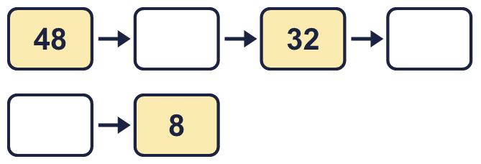
  7 | Complete the number track. It counts down in 8s.
  8 | Alex has 48 cubes. Alex puts the same number in each of 8 plates.  a) How many cubes are in each of the plates?  b) How many cubes are in two of the plates?
  8 | Alex has 48 cubes. Alex puts the same number in each of 8 plates.  a) How many cubes are in each of the plates?  b) How many cubes are in two of the plates?

  9 | Write true or false for each statement.
    a) | 7 × 8 = 6 × 8 + 7
    b) | 14 × 8 = 7 × 16
    c) | 7 × 8 = 8 × 8
    d) | 7 × 8 = 8 × 7
  9 | Write true or false for each statement.
    a) | 7 × 8 = 6 × 8 + 7
    b) | 14 × 8 = 7 × 16
    c) | 7 × 8 = 8 × 8
    d) | 7 × 8 = 8 × 7
  10 | Write <, > or = in each box.
    a) | 2 × 8 |  | 7 × 8
    b) | 8 × 9 |  | 9 × 8
    c) | 16 ÷ 8 |  | 56 ÷ 8
  10 | Write <, > or = in each box.
    a) | 2 × 8 |  | 7 × 8
    b) | 8 × 9 |  | 9 × 8
    c) | 16 ÷ 8 |  | 56 ÷ 8
  11 | Is Boba correct? Circle yes or no.  Yes / No  What is the correct answer?  Explain Boba’s mistake.
    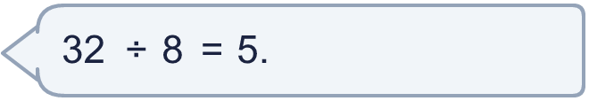
  11 | Is Boba correct? Circle yes or no.  Yes / No  What is the correct answer?  Explain Boba’s mistake.
  12 | There are 8 players in a team. 6 teams have signed up for a tournament.  a) How many players have signed up?  b) The tournament needs 88 players. How many more teams are needed?
  12 | There are 8 players in a team. 6 teams have signed up for a tournament.  a) How many players have signed up?  b) The tournament needs 88 players. How many more teams are needed?
  13 | a) How long is the yellow ribbon?  b) How much longer is the yellow ribbon than the red ribbon?
     | 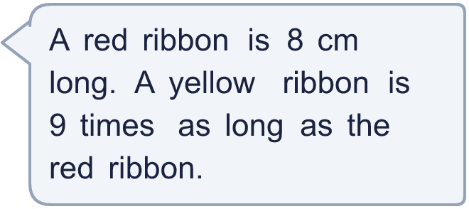
  13 | a) How long is the yellow ribbon?  b) How much longer is the yellow ribbon than the red ribbon?
  14 | Mia is thinking of three different multiples of 8 that are less than 80. The sum of the numbers is 136.  What could the numbers be?
  14 | Mia is thinking of three different multiples of 8 that are less than 80. The sum of the numbers is 136.  What could the numbers be?

Year 3 · Multiplication and division A · Step 13
Divide by 8
Answers (teacher copy)

  1 | Share equally into 8 groups.  a) 40 shared equally into 8 groups = 5  b) 24 shared equally into 8 groups = 3  c) 56 shared equally into 8 groups = 7
  2 | Make groups of 8.  a) 32 grouped into groups of 8 = 4  b) 24 grouped into groups of 8 = 3  c) 56 grouped into groups of 8 = 7
  3 | Complete the number sentences to describe the array.  2 × 8 = 16  8 × 2 = 16  16 ÷ 8 = 2  16 ÷ 2 = 8
  4 | Work out the divisions.  a) 56 ÷ 8 = 7  b) 64 ÷ 8 = 8  c) 16 ÷ 8 = 2
  5 | Write the missing number in each calculation.  a) 56 ÷ 8 = 7  b) 48 ÷ 8 = 6  c) 2 × 8 = 16
  6 | 40 strawberries are shared equally between 8 bowls.  a) How many strawberries are in each bowl? 5  32 children sit in rows. There are 8 children in each row.  b) How many rows are there? 4
  7 | Complete the number track. It counts down in 8s.  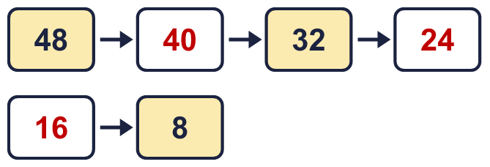
  8 | Alex has 48 cubes. Alex puts the same number in each of 8 plates.  a) How many cubes are in each of the plates? 6  b) How many cubes are in two of the plates? 12
  9 | Write true or false for each statement.  a) 7 × 8 = 6 × 8 + 7 False  b) 14 × 8 = 7 × 16 True  c) 7 × 8 = 8 × 8 False  d) 7 × 8 = 8 × 7 True
  10 | Write <, > or = in each box.  a) 2 × 8 < 7 × 8  b) 8 × 9 = 9 × 8  c) 16 ÷ 8 < 56 ÷ 8
  11 | Is Boba correct? Circle yes or no.  Yes / No  What is the correct answer? 4  Explain Boba’s mistake.  32 ÷ 8 = 4, because 4 groups of 8 make 32.
  12 | There are 8 players in a team. 6 teams have signed up for a tournament.  a) How many players have signed up? 48  b) The tournament needs 88 players. How many more teams are needed? 5
  13 | a) How long is the yellow ribbon? 72 cm  b) How much longer is the yellow ribbon than the red ribbon? 64 cm
  14 | Mia is thinking of three different multiples of 8 that are less than 80. The sum of the numbers is 136.  What could the numbers be?  for example 16 + 48 + 72

